SKILLS & EMPLOYMENT SURVEY 2017
Technical Report

Prepared by: | Richard Glendinning, Viv Young, Alexandra Bogdan, GfK UK Social Research
Issue: | Draft 2
Date: | 22 March 2018

Table of Contents

1 Introduction 4
2 Timetable 5
3 Research design 6
3.1 Survey objectives 6
3.2 Aims of this report 6
4 Sample design 7
4.1 Sampling approach 7
4.2 Sampling population and sampling frame 7
4.3 Stratification and selection 7
5 Questionnaire development 9
5.1 Dress Rehearsal 9
5.2 Coverage and structure 9
5.2.1 CAPI programming package 10
5.2.2 Changes in questionnaire coverage: 2012 to 2017 10
6 Data Collection and Fieldwork Management 11
6.1 Interviewer briefings 11
6.2 Fieldwork dates 12
6.3 Re-issues 12
6.4 Advance communications and documents used to support survey 13
6.5 Introducing the survey and incentives 14
6.6 Self-completion questions 14
6.7 Length of interview 14
6.8 Supervision and quality control 15
7 Response rate 16
8 Data Preparation and Data File 17
8.1 Coding of open questions and other answers 17
8.2 Data files 18
8.3 Design weighting 18
8.4 Derived variables 18
8.5 Additional variables included with the data file 19
9 Appendices 20

Introduction

The Skills and Employment Survey (SES) is a survey series which can be traced back to the mid-1980s. It provides information for academics and policy makers looking at working life in Britain today and provides insights into how the situation has changed over time. The 2017 version of the survey (SES2017) was funded by the Economic and Social Research Council (ESRC), Cardiff University and the Department for Education (DfE) with the Welsh Government providing additional funding for a Welsh boost.
The overarching aim of SES2017 was to provide survey data on the skills and employment experiences of those working in Britain, which will serve as a resource for academic and policy analysts who wish to examine these issues and assess and explain changes in skills and the experience of work. There were four further objectives stemming from this overarching aim. These were as follows:
- Chart the level and distribution of, and changes to, some of the key drivers of productivity such as work organisation, job-related well-being, the skills requirements of jobs, and the incidence, volume and quality of training and learning.
- Describe and analyse the level and distribution of key aspects of job quality in 2017 – such as employee involvement, work intensity, insecurity and well-being at work – and make comparisons with earlier data points in the series.
- Use the data to develop distinctive, original and substantive contributions to scholarship surrounding job quality and job skill, and the connections these aspects of work have with productivity and innovation.
- Make the data available and provide the necessary documentary material to allow further analyses by academic and policy-based researchers in the field of skills and job quality.
The survey data provides continuity with the previous work (e.g. the same sample design, largely the same questionnaire), sets a new benchmark for future research and also allows comparisons with other studies taking place around the world.
The questionnaire was developed by Professor Alan Felstead (Cardiff University), Professor Duncan Gallie (Nuffield College, Oxford), Professor Francis Green (LLAKES, UCL Institute of London) and Dr Golo Henseke (also of LLAKES, UCL Institute of Education, London). GfK Research was commissioned by Cardiff University to carry out the survey, which was conducted using Computer-Assisted Personal Interviewing (CAPI), including two sections administered using Computer-Assisted Self-Interviewing or CASI.
The sample comprised both a core and boost element (Wales only) with 2926 core interviews being achieved along with 324 boost interviews. For the core GB survey element, it was found that the percentage of addresses at which there was an eligible adult (aged 20 to 65 and in paid work) was 51%, versus 48% in 2012. A further 56 interviews were conducted during the Dress Rehearsal. One core interview conducted during the main stage of fieldwork was conducted using the dress rehearsal CAPI script and is therefore coded as a dress rehearsal interview in the dataset. In total, 3250 interviews were conducted during the main stage of fieldwork.
This report provides methodological details for SES2017, including the development of the research design, details of the fieldwork management processes and response rates. Copies of all of the fieldwork documents used during the survey are provided in the Appendices.

Timetable
Table 1 shows the timetable for the project.
Table 1 Timetable
Period | Task
February 2017 | Start-up meeting
April/May 2017 | Dress rehearsal pilot
May 2017 | Debrief on dress rehearsal, final changes to questionnaire
 | Data from DR
May to August 2017 | Tranche 1 fieldwork
July 2017 | First interim datafile for core and boost samples
July to October 2017 | Tranche 2 Fieldwork
July to December 2017 | Reissue fieldwork
January 2018 | Second interim datafile
January 2018 | Tranche 3 fieldwork
February 2018 | Delivery of clean core and boost sample survey data
February 2018 | Delivery of technical report

Research design

Survey objectives
The Cardiff University-led team secured funds to carry out a survey on the skills of the employed British workforce. The project was funded by the Economic and Social Research Council (ESRC), Cardiff University and the Department for Education (DfE) with the Welsh Government providing additional funding for a Welsh boost.
The Skills and Employment Survey 2017 (SES2017) is the seventh in a series of representative sample surveys of workers in Britain stretching back over 30 years. These cross-sectional surveys have provided the means to chart and explain the changing pattern of job quality and job skills over time, and have left a lasting and valuable legacy resource for others to use. The series is not underwritten by any particular funding stream, although a new survey has been carried out around every five years over the last quarter of a century – in 1986, 1992, 1997, 2001, 2006 and 2012. Indeed, the sample sizes of each survey have varied according to the level of funding secured. So, sample sizes have ranged from a low of 2,467 workers in 1997 to a high of 7,787 in 2006 (in 2012 the figure was 3,200). Also the geographical profile of the sample has varied according to the success of the campaign to raise additional funds. In 2006, for example, additional funds were levered-in to raise sample sizes in Wales, the East Midlands and Scotland, and extend the boundaries of the survey (to the Highlands and Islands, and to Northern Ireland for the first time). However, boosts were more modest in 2012. Nevertheless, additional funds were secured in order to more than double the sample for Wales. Again in 2017 additional funding was secured to boost the same size for Wales.
The four specific objectives for SES2017, stemming from the overarching aim (to provide data on the skills and employment experiences of working life in Britain in 2017) were as follows:
- To chart the level and distribution of, and changes to, some of the key drivers of productivity such as work organisation, job-related well-being, the skills requirements of jobs, and the incidence, volume and quality of training and learning.
- To describe and analyse the level and distribution of key aspects of job quality in 2017 – such as employee involvement, work intensity, insecurity and well-being at work – and make comparisons with earlier data points in the series.
- To use the data to develop distinctive, original and substantive contributions to scholarship surrounding job quality and job skill, and the connections these aspects of work have with productivity and innovation.
- To make the data available and provide the necessary documentary material to allow further analyses by academic and policy-based researchers in the field of skills and job quality.
As was the case in 2006 and 2012, the word 'skills' was not used in the approach to households. Instead, when contacting respondents, the research study was titled: "You and Your Work: a Study of Working Life in Britain Today". One reason for this was that some members of the workforce consider their job to be 'unskilled', while others may associate the term with 'skilled craft' occupations.
The development of the computer-assisted interviewing version of the questionnaire, managing data collection and data preparation, collating the final data files and preparing this report was the responsibility of GfK UK Social Research.

Aims of this report
This report provides documentation for SES2017. This is intended primarily for analysts who wish to make use of the data, who will need to understand the sample design, the details of occupation and industry coding and the actual questions asked.

Sample design

Sampling approach
In summary, the basis for the core survey was a nationally representative (face-to-face, probability) sample of 2,926 people in paid employment in Great Britain, south of the Caledonian Canal. Sampled households were screened to identify those in paid employment and in the qualifying age band of 20-65. Where more than one eligible individual was identified, one was selected at random to participate using a Kish selection process.
The sample comprised two elements: the core sample - the nationally representative sample of people in paid employment in Great Britain and a boost for Wales.
The sample was drawn in a two-stage process using a stratified, random probability approach and with 302 postcode sectors as the Primary Sampling Unit (PSU), which was the same approach as that used most recently in 2012. The same approach to sampling was used in the Wales boost (36 sample points).
Due to sample shortfall driven by a lower than expected incidence, a further sample of 23 points was drawn. The same sampling approach was used.

Sampling population and sampling frame
The sample needed to be representative of people of working age living in private households in Great Britain. The eligibility criteria were as follows (these applied at the time of selection):
- aged between 20 and 65 years of age inclusive
- currently have a paid job at which they work for at least 1 hour a week
Both employees and self-employed workers were eligible as long as they met the above criteria.
The latest version of the small user Postcode Address File (PAF) was used as the sampling frame for the survey, as was also the case in 1997, 2001, 2006 and 2012.

Stratification and selection
As in 2012, a conventional multi-stage sample design was employed using postcode sectors as PSUs. In order to improve the precision of survey estimates, the sample of postcode sectors in the whole of Great Britain was proportionately stratified, as follows:
- By Sub-Region (101 sub-regions). Definitions of sub-regions can be found in Appendix H.
- Within sub-region, sectors were listed in increasing order by the percentage of household heads in non-manual NS-SEC operational categories (1, 2, 3.1, 3.2, 3.3, 3.4, 4.1, 4.2, 4.3, 5, 6, 7.1, 7.2, 7.3, 8.1, 8.2, 12.1, 12.6). Cut-off points were then drawn approximately one third and two thirds (in terms of delivery points) down the ordered list, to create three bands of roughly equal size.
- Within NS-SEC strata, sectors were sorted by the percentage of males of working age who were unemployed.
The selection of the PSUs for the survey was made using the cumulated address count via a systematic fixed-interval process, from a random start point and reflecting a probability proportional to size (i.e. the number of residential addresses).
The core sample consisted of 15,267 addresses across 302 points and the sample for the Welsh boost consisted of 1,836 addresses across 36 points. Addresses for both core and boost samples were selected systematically from each sector. Additional core sample was issued to overcome a shortfall due to a lower than expected incidence. The additional sample consisted of 1,185 addresses across 23 points.
When interviewers made contact with sampled addresses they had to select one dwelling, then one household and finally one eligible individual within the selected household. In the vast majority of cases, no dwelling or household selection was necessary, but where multiple dwellings or households or eligible individuals were found, interviewers used a 'Kish grid' for selection purposes one. The selection process was included on reference sheets for each address (see Appendix D).
Because there are differences in the probability of selection, depending on the number of dwelling units or households at the address and the number of eligible workers in the selected dwelling unit, weights are used in the analysis. With the weights, the data file is representative of adults in Great Britain and each individual in the file has a known chance of selection.

Questionnaire development
In order to build up a time-series of research findings, the questionnaire content was largely based upon the 2012 survey. However, some new questions were included to complement existing questions and to explore other issues. A full dress rehearsal phase was used to test the survey instruments and administrative processes.

Dress Rehearsal
The questionnaire was programmed as a computer-assisted interview for the dress rehearsal survey. The dress rehearsal was conducted to test the survey procedures, to anticipate any problems that could arise in the field, establish effective ways of introducing the questionnaire, and further evaluate the questionnaire and its flow. The team of 7 interviewers, working in a range of locations across Great Britain, achieved a total of 56 pilot interviews. The clients accompanied two interviewers during the dress rehearsal.
Following the dress rehearsal exercise, the GfK research team and the interviewing team met with the client for a debriefing session. Following this, further modifications were agreed as follows:
- Addition of a new question relating to demotion within job
- Additional response option added to ethnicity question
- Altering the scale of a battery of questions relating to the fairness in which organisations treat their employees
- Further interviewer instructions added to the CAPI script for clarification purposes
- Amendment to the Electronic Contact Sheet (e.g. additional outcome codes for soft and hard appointment)
- Refinement of some interviewer materials (e.g. calling/ appointment cards)

Coverage and structure
As in 2006 and 2012, SES2017 comprised two different modes of interviewing:
- CAPI (computer-assisted personal interviewing, administered by interviewers)
- CASI (computer-assisted self-interviewing, completed by respondents)
The questionnaire was organised into the following blocks of questions:
BLOCK A: Checking eligibility (age and whether in paid work in the last 7 days)
BLOCK B: Broad questions about the current job
BLOCK C: Detailed job analysis questions
BLOCK D: Computing skills and Qualifications questions
BLOCK F: Work attitudes
BLOCK E: The Organisation
BLOCK G: Pay questions
BLOCK J: Recent skill changes and future perspectives
BLOCK I: Well-being at work
BLOCK K: Personal details
BLOCK Q: Follow-up and Conclusion
Blocks C and I were designated as the CASI sections of the questionnaire. However, interviewers were permitted to administer these sections in the normal way if the respondent preferred: the CAPI script included a question where the interviewer could state whether or not the respondent used a self-completion method and, if not, the reasons why they chose not to complete it themselves.
A copy of the questionnaire is included in Appendix A.

CAPI programming package
GfK developed the SES2017 CAPI script using the IBM SPSS Data Collection Family Suite of interviewing software, referred to as Dimensions. The script was written by a Senior CAPI Programmer in GfK Technology and Services team. Initial testing was carried out by the programmer before the CAPI script was passed to the GfK research team for testing.
GfK has stringent quality procedures for checking CAPI questionnaires before they are released into the field. The script was systematically checked by the GfK research team to ensure that question wordings, filtering, text fills and logic checks had all been scripted correctly.
A copy of the CAPI script was also sent to the academic team to ensure they were satisfied with the instrument prior to releasing it to interviewers. In addition, topline data was generated very early into the data collection period, as a further assurance that the questionnaire was working as intended.

Changes in questionnaire coverage: 2012 to 2017
The complete questionnaire is included as Appendix A. In order to ensure comparability between survey years, much of the questionnaire remained the same as in 2012. However, some new questions were added to the survey and a small number were removed from the questionnaire – amounting to around a 10% change.

Appendix B shows which questions have been either added or removed since 2012.

Data Collection and Fieldwork Management

Interviewer briefings
All GfK interviewers and supervisors are fully trained to the guidelines in the ISO 20252:2006 market, opinion and social research standard. These guidelines mirror the Market Research industry’s Interviewer Quality Control Standards (IQCS) to which we also adhere.
All interviewers working on the survey were personally briefed via webinars before starting their assignment(s). Briefings are used to improve interviewer motivation by equipping interviewers with practical information regarding how to administer the survey, as well as the skills to ‘sell’ the survey to potential respondents and answer their queries. Briefings also serve to remind interviewers of key skills such as avoidance of doorstep refusal.
A total of 18 briefings were held starting with a ‘master briefing’ on Thursday 11th May 2017, which the client attended. All the researchers who were involved in the subsequent briefings attended this session as the master briefing acted as the template for the other briefings in terms of the order of the session, instructions on the use of the survey materials and the scenario adopted for the ‘dummy’ interview. Three further briefings were scheduled in August for interviewers who had not worked on Tranche 1 points.
The briefings were designed in conjunction with the client team, and each half day session was led by the GfK research team. Each session followed the format detailed below:
Task | Content
Introduction to day and agenda | Introduction of speaker, agenda for the day
Introduction to SES | Introduction to the survey, its history and how the data will be used
Summary of the interviewer’s task | Overview of task, including eligibility for interview
The sample and documentation | How the sample was drawn (dealing with respondent queries about choice of their address), how updates on preselected addresses will be communicated; introducing the survey materials (e.g. advance letter and leaflet) and when these should be used.
Making contact and planning work | Call patterns and working efficiently, sending out advance letters, identifying vacant properties and other deadwood
Response maximisation | Response rates on earlier survey waves (to show what is achievable); refusal avoidance strategies and recording reasons for refusal (to assist with reissues); gaining cooperation/ building rapport and providing answers to common queries.
Reference sheet | How to complete the address reference sheet, using dummy examples and different outcomes; further discussion regarding eligibility.
Introduction to the questionnaire (on paper) | Broad overview of the questionnaire, making general definitional points; reminder of SIC and SOC coding procedures and level of detail required.
Dummy interviews (CAPI) | Dummy interview using a pre-planned route, drawing interviewers’ attention to potential pitfalls/other possible survey routes.  (Interviewers were paid to conduct two further dummy interviews at home before starting work: one as an employed person and one as a self-employed person).
Field administration | Progress chasing and use of the Electronic Contact Sheet).

The definition of the target population (between 20 and 65 years of age inclusive and in paid work for at least one hour per week) was given particular attention at all of the briefing sessions to ensure that interviewers understood the eligibility criteria. A number of examples were also worked through to prepare interviewers for a variety of possible situations that they could encounter on the doorstep; this part of the briefing often generated many questions, some of which required further client clarification. The examples were included in the Interviewer Instructions document, which interviewers held for the duration of their assignment as a reference tool.

Fieldwork dates
Main stage interviewing began on 12th May 2017 and ended on 22nd January 2018.
Table 2 shows the monthly breakdown of interviews over fieldwork period.
Table 2 Month of interview
Month of interview | Number of interviews | Percentage of total interviews (%)
May 2017 | 350 | 11%
June | 808 | 25%
July | 513 | 16%
August | 424 | 13%
September | 357 | 11%
October | 377 | 12%
November | 183 | 6%
December | 20 | 1%
January 2018 | 218 | 7%

Re-issues
As well as reviewing progress during first issue, the Field team were responsible for reviewing performance on completed assignments at a micro level to determine whether there was a case for reissue. Decisions were based on information gathered via the CAPI progress reporting tool. Reissue was triggered by a higher than expected level of non-contact or refusal amongst screened addresses, i.e. addresses where it was already known that there was an eligible respondent, and there were also a proportion of reissues in cases where there had been no household contact or no screening due to refusal to answer the screening questions (labelled as ‘Unknown eligibility’ in the table below).
The decision to reissue was therefore based on a lower than expected conversion rate of screened addresses and on a lower than expected level of screening (high rates of refusal or non-contact at the household level). In all cases, addresses were only reissued where it made sense to do so, i.e. where there was a sufficiently high number of leads to make the task efficient and where there was an interviewer within reasonable travel time (as well as being an interviewer who had performed well on their first assignment). Interviewer notes on contact sheets were also taken into consideration, so, for example, if the interviewer had marked the box ‘do not re-contact’, this address would not have been selected for reissue.
In total, 2,572 addresses were re-issued resulting in an additional 202 interviews being achieved (8%). The original outcome of reissued addresses is shown in Table 3, below, and the final outcome after reissue is shown in Table 4.
Table 3 Re-issued addresses – original outcome
Outcome category | All cases
 | n | %
Base: Re-issued addresses from core sample | 2,572 | 100
No Contact
No contact with selected respondent | 812 | 32%
Unknown eligibility (unscreened address) | 921 | 36%
Refusals
Selected respondent refusal (including. proxy) | 839 | 33%

Table 4 Re-issued addresses – outcome of re-contact attempts
Outcome category | N | %
Base: Re-issued addresses | 2,572 | 100
Vacant and non-residential  No contact made at address at re-issue  Refusal before screening  Screened ineligible  Refusal by/on behalf of selected respondent  No final contact with selected respondent  Other screened but non-productive (ill, away)  Successful interviews | 81  893  446  242  470  190  41  202 | 3  35  17  9  18  7  2  8

Advance communications and documents used to support survey
A number of items were used to inform households and respondents about the survey and all such documentation was provided bilingually for the sample points in Wales.
Household letter and leaflet
All households sampled for the survey were sent a letter about the survey in advance of the interviewer calling. The letter provided information about the survey, who was managing the survey, the survey sponsors and the fieldwork agency. A dedicated Freephone number and email address were also included in the letter as a means of easily reaching the fieldwork agency. The letters all carried the GfK logo and were badged according to the location of the preselected address, as follows:
England - ESRC and DfE logos
Scotland – ESRC logo
Wales – ESRC and Welsh Government logos
Interviewers were instructed to send the letters in batches which they could follow-up personally within a couple of days, so that the information remained fresh in people’s minds. The envelope containing the letter also included a colour printed leaflet, which was designed by GfK and the client team, and provided more information about the survey including a link to a webpage dedicated to the survey on the Cardiff University website. The leaflet bore the logos of the ESRC, the Department for Education, the Welsh Government and Cardiff University as well as the GfK logo.
Copies of the advance letters and leaflet are included as Appendix E.
Selected respondent letter
Because PAF was used as the sample frame, the initial letter was necessarily addressed to 'The Householder’. Following the same procedure as the 2001, 2006 and 2012 surveys, a letter to introduce the survey personally addressed to the selected respondent was also included in interviewers’ packs, to be used at their discretion. This letter was left by the interviewer when the selected person was not present at the time of selection and where the interviewer felt that this would be beneficial for response. The aim of the letter was to reinforce the importance of taking part in the survey to the person selected in the absence of the interviewer and to avoid the purpose of the interview not being explained adequately by others in the household.
Copies of the selected respondent letters are included as Appendix F.

Introducing the survey and incentives
As already mentioned, as part of their training/ briefing, interviewers were given guidelines on how best to introduce the survey and answer questions on the doorstep, i.e. how to ‘sell’ the survey.
As an acknowledgement of the time burden of the survey, all those completing a full interview were offered an incentive for doing so, which took the form of £10 of High Street vouchers and £15 for address in London. In order to encourage respondents to participate in the research the conditional incentive was mentioned in the advance communications.

Self-completion questions
Two sections of the CAPI script (the ‘Detailed job analysis’ and ‘Well-being at work’ sections) contained questions which respondents were encouraged to answer by self-completion, keying a numeric answer on the computer. If the respondent did not wish to complete the sections themselves, the interviewer was able to do so on their behalf. The script was programmed to capture whether the respondent or interviewer completed the sections (and in the first section, if the interviewer was completing the survey on the respondents’ behalf, they were asked why this was the case).
Four in five respondents completed the self-completion sections (85% Block C and 81% Block I). Those who did not wish to complete Block C were asked to say why, the main reasons were that they didn’t like the computer (30% of refusers), couldn’t be bothered (18%), there were children present (9%) or they preferred the interviewer to complete the section for them (9%).

Length of interview
In estimating the workloads of interviewers, it was planned that interviews should have an average length of 60 minutes. As with any survey, some variation in the length of interview was expected because of questionnaire routing and respondent speed. As Table 5 shows, the mean and median lengths of interview were slightly lower than expected at 58 minutes and 56 minutes respectively.
The table also shows interview length broken down by a number of variables. These show that those who were not in paid work 5/4/3 years ago and those who were self-employed tended to have shorter interview lengths on average. These findings are in line with expectations as questionnaire routing meant that they were asked fewer questions overall.
As observed in 2006 and 2012, self-completion does not appear to shorten the questionnaire length. Respondents who self-completed Blocks C and I had a mean interview length of 58, while those who had the entire interview administered by the interviewer had a mean interview length of 57.

Table 5 Length of interview for the main survey
Type of interview | Mean length (minutes) | Median length (minutes) | Unweighted base
Full productive interviews | 58 | 56 | 3,250
Block C and I self-completion | 58 | 57 | 2,653
One self-completion block only | 56 | 53 | 133
Block C and I administered by interviewer | 57 | 55 | 464
Respondent in same job 5/4/3/2/1 years ago | 58 | 56 | 2,000
Respondent in different job 5/4/3/2/1 years ago | 58 | 56 | 1,199
Respondent was not in work 5/4/3/2/1 years ago | 53 | 48 | 51
Employee | 59 | 57 | 2,762
Self-employed | 52 | 49 | 488

Supervision and quality control
The two key elements of fieldwork quality control for the survey were interviewer accompaniment and validation. Each of these is discussed in turn below.
Accompaniment
All interviewers new to random probability work were accompanied at least once during fieldwork by a more senior interviewer to ensure that they were conducting their assignment in the correct way. The first accompaniment happened on their first day working to make sure they were happy with respondent selection procedures (i.e. using the Kish grid approach). More experienced interviewers were accompanied later in fieldwork according to the GfK quality checking schedule.
Validation
Validation involves re-contacting respondents after they have been interviewed to check that interviews actually took place, roughly how long the interview took, that correct procedures were followed and also that the required questions were asked and the answers were recorded correctly. A systematic, representative method is used for selecting interviewers for validation to ensure that all interviewers are regularly validated.
Telephone validation is the preferred method and GfK’s dedicated team of trained and monitored telephone validators contact respondents to validate selected interviews.
In total, 10% of productive interviews were back-checked, all of which were conducted by telephone. No cases were considered unsatisfactory.

Response rate
The response rate obtained was 50% of screened eligible respondents. The full sample break down is shown in Table 6.
Table 6 Response rate after re-issue process on main fieldwork
Outcome category | Contact sheet Code | Number | % | % | % | %
Issued addresses |  | 18288 | 100
Deadwood: |  | 1066 | 6
- Property vacant | 615 | 630 | 3
- Property demolished/derelict | 614 | 34 | *
- Property not yet built | 613 | 13 | *
- Non-residential property | 616 | 233 | 1
- Institution – no private households | 617 | 19 | *
- Not found – no trace of address | 622 | 137 | 1
In scope addresses |  | 17222 | 94 | 100
Not screened: |  | 4,254 |  | 25
- household non-contact | 17, 58, 232, 234, 62, 620 | 2,370 |  | 14
- refusal (including head office) | 15, 18, 28 | 1884 |  | 11
Screened |  | 12,968 |  | 75 | 100
No eligible individuals | 208, 209 | 6,405 |  |  | 49
Selected eligible respondent |  | 6,563 |  |  | 51 | 100
Non-contact after screening | 63, 64 | 754 |  |  |  | 11
Refusal after screening: |  | 2,383 |  |  |  | 36
- personal refusal | 16, 20, 29 | 1,979 |  |  |  | 30
- proxy refusal | 19 | 404 |  |  |  | 6
Other unproductive: |  | 176 |  |  |  | 3
- Selected respondent too ill | 228 | 33 |  |  |  | *
- Selected respondent away | 229 | 84 |  |  |  | 1
- Selected respondent requires mother-tongue interview | 230 | 59 |  |  |  | 1
Productive interview | 1 | 3,250 |  |  |  | 50

Data Preparation and Data File

Coding of open questions and other answers
All coding on SES2017 was carried out by GfK’s team of experienced coders. Much of the coding requirement was for occupation and industry coding as interviewers had to code verbatim responses to the following (variable names shown in brackets):
- current job SOC2000 in numeric 4 digit format (soc2000)
- current job SOC2010 in numeric 4 digit format (soc2010)
- standard classification of occupations ISCO88 (isco88code) and ISCO08 (isco08code)
- industries according to 3-digit SIC92 (sic92)
- industries according to 4-digit SIC2003 (sic03)
- industries according to 4-digit SIC2007 (sic07)
- social class according to the National Statistics Socio-Economic Classification (NS-SEC) based on SOC2010 (nssec2010code)
- social class according to NS-SEC based on SOC2000 (nssec2000code)
Clearly, for a survey about skills and employment it is important to ensure that information about occupations and industries is recorded and coded accurately. The quality of the coding is dependent upon the quality of the verbatim responses recorded in the CAPI script. As such, a considerable amount of time was spent briefing interviewers about the importance of these sections of the questionnaire to ensure that the correct level of information was recorded for each respondent. The time spent discussing the importance of this information paid dividends as only one respondent could not be coded to the above classifications.
Experienced GfK coders used CASCOT software to code SIC and SOC. This software is designed to make the coding of text information to standard classifications simpler, quicker and more reliable by assigning a code to a piece of text (i.e. an industry for SIC or a job title for SOC). The software is capable of occupational coding and industrial coding to the UK standards developed by the Office for National Statistics (ONS).
Cascot has been designed to perform a complicated analysis of the words in the text, comparing them to the words in the classification, in order to provide a list of recommendations. If the input text is not sufficiently distinctive it may not be the top most recommendation that is the correct code.
When Cascot suggests a code to a piece of text it also calculates a score from 1 to 100 which represents the degree of certainty that the given code is correct. When Cascot encounters a word or phrase that is descriptive of occupation or industry but lacks sufficient information to distinguish it from other categories (i.e. without any further qualifying terms) Cascot will attempt to suggest a code but the score is limited to below 40 to indicate the uncertainty associated with the suggestion. For example 'Teacher' or 'Engineer'. The coders, in all cases, reviewed the recommended codes and decided whether or not to accept the suggested codes or whether to assign the correct codes manually.
The performance of Cascot has been compared to a selection of high quality manually coded data. The overall results show that 80% of records receive a score greater than 40 and of these 80% are matched to manually coded data.
Coding for ISCO88 and NS-SEC was carried out manually using look-up tables provided by the ONS. ISCO88 is directly comparable with SOC 2000, while NS SEC coding is based upon the respondent’s occupation and employment status information.
Other coding requirements included 12 ‘other specify’ questions. These were also coded by GfK’s team of coders. The answers provided at the open question DUniv were preserved as a listing, rather than being coded.
The coded data (and listing at DUniv) were included in the data sets supplied to the academic team.

Data files
The following anonymised SPSS data files were transferred to the academic team using a secure online portal set up by GfK:
- Dress rehearsal (containing 56 cases)
- Interim GB file (containing 984 cases)
- 2nd interim GB file including the main and dress rehearsal cases (containing 3061 cases)
- Final file (containing 3306 cases)

Design weighting
The data files were supplied with design weights to ensure the data was representative of the target population by correcting for differential probabilities of selection. Unequal selection probabilities could occur at three stages:
- The selection of one dwelling per address
- The selection of one household per selected dwelling
- The selection of one eligible adult per (selected) household
Weights were calculated for Wales separately (dwtwales) and for the sample as a whole (deswtgb). Both were calculated in the same way as:

Number of dwellings * Number of households * Number of eligible individuals

Non-response weights will be calculated by the academic team and, so, are not included in the data files supplied by GfK.

Derived variables
The data files supplied to the academic team includes the following derived variables.

Variable name | Description | Values | Definition
Bempsta | employee status variable | - employee or agency worker  - self-employed (all others) | Employee = (BEmpType = Employee) OR (BSelf = Agency OR Sub-contractor)  SelfEmpl = All others  NB If (BEmpType=Employee) AND(BPdWage=No) AND (BSelfEm1-8<>Agency OR Sub-contractor) then compute as SelfEmpl
Gempsta | Employee status variable for pay questions | - employee or agency worker  - self-employed (all others) | Employee = (BEmpType = Employee) OR (BSelf = Agency)  SelfEmpl = All others  NB If (BEmpType=Employee) AND (BPdWage=No) AND (BSelfEm1-8<>Agency) then compute as SelfEmpl

Additional variables included with the data file
The following variables were linked to each respondent via their postcode:
- Government Office Region (GOR)
- Country
- Travel to Work Area (TTWA) – 2011 definitions
- Index of Multiple Deprivation (IMD) – score and rank (note that IMD score is not provided for Welsh cases because the latest release only provides IMD rank for Wales)

The coding of these variables is documented more fully in Appendix I.

Appendices
Appendix A Copy of questionnaire
Appendix B Changes between 2012 and 2017 questionnaires
Appendix C Interviewer instructions
Appendix D Reference sheet
Appendix E Advance letters and leaflet
Appendix F Selected respondent letter
Appendix G Show cards
Appendix H Definition of Sub-region
Appendix I Definitions of Region and Travel to Work Area (2011)

Appendix A Copy of questionnaire

SKILLS AND EMPLOYMENT SURVEY 2017
FINAL VERSION; MAIN STAGE

Contents
BLOCK A: Checking Eligibility 3
BLOCK B: Broad Questions about the Job: Classification, and Skills-Related Aspects 5
BLOCK C: Detailed Job Analysis Questions 29
BLOCK D: Computing Skills and Qualifications Questions 43
BLOCK F: Work Attitudes 49
BLOCK E: The Organisation 52
BLOCK G: Pay Questions 63
BLOCK J: Recent Skills Changes and Future Perspectives 69
BLOCK I: Well-being at Work 81
BLOCK Q: Follow-up and Conclusion 94

BLOCK A: Checking Eligibility

AWork [ASK ALL]
Can I just check, did you do any paid work in the last seven days?

INTERVIEWER:
IF ON HOLIDAY IN LAST 7 DAYS RECORD STATUS IN THE 7 DAYS IMMEDIATELY BEFORE GOING ON HOLIDAY.
IF TEMPORARILY SICK IN LAST 7 DAYS, RECORD STATUS IN THE 7 DAYS IMMEDIATELY BEFORE GOING OFF SICK.
IF ON GOVERNMENT SCHEME ONLY, CODE NOT EMPLOYED.
- In paid work
- Not employed, NODK, NORF

AInElig [ASK IF AWork=2]
INTERVIEWER: THIS PERSON APPEARS INELIGIBLE. YOU MUST NOW…

CHECK - DOES (S)HE WORK ONE WEEK OFF, ONE WEEK ON. IF YES, CODE ‘PERSON IS ELIGIBLE’ AND PROCEED ON BASIS OF JOB WHEN ‘ON’
CHECK – HAS (S)HE DONE EVEN ONE HOUR OF ANY TYPE OF PAID WORK (IN THE LAST 7 DAYS). IF YES, CODE ‘PERSON IS ELIGIBLE’ AND PROCEED ON THE BASIS OF THAT JOB.
CHECK – IS (S)HE IS ONLY ON HOLIDAY OR TEMPORARILY SICK. IF YES, CODE ‘PERSON IS ELIGIBLE’ AND PROCEED ON THE BASIS OF USUAL JOB.
CHECK – WAS (S)HE IN WORK IN THE 7 DAYS BEFORE YOU MADE THE SELECTION? IF YES, CODE ‘PERSON IS ELIGIBLE’ AND PROCEED ON THE BASIS OF THAT JOB, AS THOUGH S(HE) WAS STILL IN IT.
IF NO TO ALL FOUR CHECKS – CODE NOT ELIGIBLE.

- Person is eligible
- Not eligible, NODK, NORF

AStop [IF AlnElig=2]
INTERVIEWER: YOU HAVE ENTERED THAT THE PERSON IS NOT ELIGIBLE. THAT IS, THEY ARE DEFINITELY NOT IN WORK, HALT INTERVIEW WITH CURRENT PERSON!

Asex [ASK ALL]
ENTER SEX OF RESPONDENT

- Male
- Female, NODK,NORF

AAge [ASK ALL]
What was your age last birthday?

NUMERIC RANGE 14…95

ABadAge [IF AAge NOT BETWEEN 20 AND 65]
IF PERSON IS DEFINITELY NOT ELIGIBLE, CLOSE INTERVIEW! SAY…

Thank you very much. This survey is about the paid jobs of people aged 20 to 65

BLOCK B: Broad Questions about the Job: Classification, and Skills-Related Aspects

BJobs [ASK ALL]
Could I check, do you have one job or more than one?

- One
- More than one
- Don’t know
- Refused

BMainjob [ASK IF BJobs<>1]
In this survey we are asking people about their MAIN JOB. So please think only about your main job when answering.

ASK THE RESPONDENT TO DECIDE WHICH IS [IF ASex=1:HIS/IF ASex=2: HER MAIN JOB.
IF A RULE IS NEEDED, MAIN = EARNED MOST IN REFERENCE PERIOD.

BIntro [ASK ALL]
I'd now like to ask you some questions about the job you were doing in the last seven days.

INTERVIEWER: IF ON HOLIDAY/OFF SICK IN THE LAST 7 DAYS:
Your job in the seven days before you went on holiday/were off sick.

BFirmdo [ASK ALL]
What does the firm/organisation you worked for last week mainly make or do
(at the place where you work)?

DESCRIBE FULLY.
PROBE: Manufacturing, processing or distribution, etc; main
goods produced; materials used; wholesale or retail; etc.":

OPEN

{Office use only}
CODE TO INDUSTRIAL CLASSIFICATIONS: 3-digit SIC92; 4-digit SIC2003; 4-digit SIC007

BJobtitl [ASK ALL]
What is the name or title of your job?

OPEN

BWhatUdo [ASK ALL]
What kind of work do you do most of the time?
INTERVIEWER: ASK FOR AS MUCH DETAIL AS POSSIBLE. RECORD THE TYPE OF WORK UNDERTAKEN. PROBE: What does that involve? Can you describe what kind of work do you do day to day? What materials/equipment do you use?

OPEN

{Office use only}
CODE TO OCCUPATIONAL CLASSIFICATIONS: 4-digit SOC2000; 4-digit SOC2010; ISCO88; ISCO08; NS-SEC

H5ago [ASK ALL]
Were you in paid work five years ago, that is in [Month] 2012?

INTERVIEWER: ANY TYPE OF PAID WORK OF AT LEAST ONE HOUR A WEEK = YES

- Yes
- No
- Don’t know
- Refused

H4ago [ASK IF H5ago<>1]
Were you in paid work four years ago, that is in [Month] 2013?

INTERVIEWER: ANY TYPE OF PAID WORK OF AT LEAST ONE HOUR A WEEK = YES

- Yes
- No
- Don’t know
- Refused

H3ago [ASK IF H4ago<>1]
Were you in paid work three years ago, that is in [Month] 2014?

INTERVIEWER: ANY TYPE OF PAID WORK OF AT LEAST ONE HOUR A WEEK = YES

- Yes
- No
- Don’t know
- Refused

B2ago [ASK IF H3ago<>1]
Were you in paid work two years ago, that is in [Month] 2015?

INTERVIEWER: ANY TYPE OF PAID WORK OF AT LEAST ONE HOUR A WEEK = YES

- Yes
- No
- Don’t know
- Refused

B1ago [ASK IF b2ago<>1]
Were you in paid work one year ago, that is in [Month] 2016?

INTERVIEWER: ANY TYPE OF PAID WORK OF AT LEAST ONE HOUR A WEEK = YES

- Yes
- No
- Don’t know
- Refused

HsameAgo1P [ASK IF H5ago=1 OR H4ago=1 OR H3ago=1 OR B2ago=1 OR B1ago=1]
Was this the same job as you have now, with the same employer?

INTERVIEWER NOTE: ONLY CODE 'YES' IF THE SAME JOB WITH THE SAME EMPLOYER.
IF PROMOTED, REGARD AS DIFFERENT JOB WITH SAME EMPLOYER AND CODE AS ‘NO’

- Yes
- No
- Don’t know
- Refused

HsameAgo2P [ASK IF HsameAgo1P=2]
Was this job with a different employer?

- Yes
- No
- Don’t know
- Refused

Coming back to the work you currently do.

BEmpType [ASK ALL]
Are you working as an employee or are you self-employed?

INTERVIEWER: IF NOT SURE/DOES NOT KNOW, ENTER EMPLOYEE

- Employee
- Self-employed, NODK,NORF

BPdWage [ASK IF BEmpType=1]
(Can I check) are you paid a salary or a wage by an employer?

- Yes
- No
- Don’t know
- Refused

BSelfEm1… [ASK IF BEmpType=2 OR BPdWage=2]
BSelfEm8 SHOW CARD B1
Looking at this card, which of these describe your situation at work?

INTERVIEWER: CODE UP TO FOUR ANSWERS IN THE ORDER GIVEN

- Paid a salary or a wage by an agency
- Sole director of own limited business
- Running a business or professional practice
- A partner in a business or professional practice
- Working for yourself
- Working as a sub-contractor
- Doing freelance work
- None of these
NOT ON SHOW CARD
- Don’t know
- Refused

DERIVED STATUS VARIABLE: BEmpStat
Employee = (BEmpType = Employee) OR (BSelfEm = Agency (code 1) OR Sub-contractor (code 6)
SelfEmpl = All others

NB If (BEmpType=Employee) AND(BPdWage=No) AND (BSelfEm1-8<>Agency OR Sub-contractor) then compute as SelfEmpl

BManage [ASK IF BEmpType=1]
Do you supervise other employees or have managerial duties?

- Yes, supervise other employees
- Yes, have managerial duties
- No, neither
- Don’t know
- Refused

BManNo [ASK IF BManage=1 OR 2]
How many people do you (IF BManage=1: supervise/IF BManage=2: manage)?

NUMERIC RANGE 1…9997
Don’t know
Refused

BOthers [ASK IF BEmpType=2]
Do you have others working for you?

- Yes
- No
- Don’t know
- Refused

BHowmany [ASK IF BOthers=1]
How many people?

NUMERIC RANGE 0...9997
Don’t know
Refused

BPerm [ASK IF BEmpStat=1]
Leaving aside your own personal intentions and circumstances, is your job... READ OUT

- a permanent job
- or, is there some way that it is NOT permanent?
DO NOT READ OUT
- Don’t know
- Refused

BTemp [ASK IF BPerm=2]
In what way is the job NOT permanent?
Is it...
READ OUT

- seasonal work
- done under contract for a fixed period or for a fixed task
- agency temping
- casual type of work
- or, was there some other way that it was not permanent? (SPECIFY)
DO NOT READ OUT
- Don’t know
- Refused

BFulTime [ASK ALL]
In your job, are you working full-time or part-time?

- Full-time
- Part-time
- Don’t know
- Refused

BHours [ASK ALL]
How many hours per week do you usually work?

INTERVIEWER: EXCLUDE MEAL BREAKS BUT INCLUDE ‘USUAL’ OVERTIME
IF ‘It varies’ CODE NULL
IF THE NUMBER IS NOT A WHOLE NUMBER (e.g. 37.5 hours), ROUND UP TO THE NEXT HOUR (i.e. 38 hours)

NUMERIC RANGE 1…168
Don’t know
Refused

[If BFulTime=1 and BHours<30]
THIS RESPONDENT SAID THEY WORKED FULL-TIME BUT FOR LESS THAN 30 HOURS PER WEEK. PLEASE CHECK THIS IS CORRECT. IF NOT, PLEASE GO BACK TO BFULTIME AND RECODE.

[If BFulTime=2 and BHours>29]
THIS RESPONDENT SAID THEY WORKED PART-TIME BUT FOR MORE THAN 29 HOURS PER WEEK. PLEASE CHECK THIS IS CORRECT. IF NOT, PLEASE GO BACK TO BFULTIME AND RECODE.

[If BHours>99]
YOU HAVE ENTERED THAT THIS RESPONDENT WORKS FOR 100 OR MORE HOURS A WEEK. IS THIS CORRECT? IF NOT, PLEASE GO BACK TO BHOURS AND RE-ENTER NUMBER OF HOURS WORKED.

BHrsdec [ASK ALL]
How much do you agree or disagree with the following statement?

“I can decide the time I start and finish work”

- Strongly agree
- Agree
- Disagree
- Strongly disagree
- Don’t know
- Refused

BTimeOff [ASK ALL]
Would you say that for you arranging to take an hour or two off during working hours to take care of personal or family matters is….?

- Not difficult at all
- Not too difficult
- Somewhat difficult
- Very difficult
- Don’t know
- Refused

BNotice [IF EmpStat=1]
Does your employer ever reduce your weekly hours of work at short notice?

- Yes
- No

BNotice2 [ASK IF BNotice=1]
How frequently does this happen? READ OUT

- Often
- Sometimes
- Rarely

BNotPay [ASK IF BNotice=1].
Does this affect your pay?

- Yes
- No

BUnder [IF EmpStat=1]
Would you prefer to work longer hours at your current basic rate of pay – that is, not overtime or enhanced pay rates – if you were given the opportunity?
- Yes
- No
DO NOT READ OUT
- DK
- REF

BWorkNo [ASK ALL]
How many people work at, or from, the place where you work?

INTERVIEWER: PROBE FOR BEST ESTIMATE, IF UNABLE TO SAY, CODE DK AND USE BANDS AT NEXT QUESTION

INTERVIEWER: We want to record the total number of employees at the site where the respondent works or reports into (not just those in their section or department). We do not wish to know the total number of people working for the organisation if it consists of multiple sites

NUMERIC RANGE 1…99997
Don’t know
Refused

[If BWorkNo < BManNo + 1]
THIS RESPONDENT SAID THAT THE NUMBER OF PEOPLE HE/SHE SUPERVISES/MANAGES IS THE SAME AS OR GREATER THAN THE NUMBER OF PEOPLE WHO WORK AT THEIR WORKPLACE. PLEASE CHECK THIS WITH RESPONDENT AND GO BACK TO BMANNO TO RECODE IF NECESSARY.

[If BWorkNo < BHowMany + 1]
THIS RESPONDENT SAID THAT THE NUMBER OF PEOPLE WHO WORK FOR THEM IS THE SAME AS OR GREATER THAN THE NUMBER OF PEOPLE WHO WORK AT THEIR WORKPLACE. PLEASE CHECK THIS WITH RESPONDENT AND GO BACK TO BHOWMAN TO RECODE IF NECESSARY.

BManyWrk [ASK IF BWorkNo=DK OR REF]
INTERVIEWER: IF DOESN'T KNOW THE NUMBER OF PEOPLE WHERE THEY WORK, PROMPT TO SEE IF THEY CAN GIVE AN ANSWER IN THE FOLLOWING SIZE BANDS:

- 1 to 2
- 3 to 9
- 10 to 24
- 25 to 49
- 50 to 99
- 100 to 199
- 200 to 499
- 500 to 999
- 1000 or more
- Don’t know but less than 25
- Don’t know but more than 25
12. Refused

BGender [ASK ALL]
In your workplace, is your type of job done...
READ OUT

- almost exclusively by men
- mainly by men
- by a fairly equal mixture of men and women
- mainly by women
- or, almost exclusively by women
- Don’t know
- Refused

BWhere [ASK ALL]
SHOW CARD B2
In your job, where do you mainly work? Please answer from this card.

CODE ONE ONLY

- At home
- In the same grounds and buildings as home (eg, in adjoining property or surrounding land)
- At a single workplace away from home (eg, office, factory or shop)
- In a variety of different places of work (eg, working on clients' premises or in their homes
- Working on the move (eg, delivering products or people to different places)
NOT ON SHOW CARD
- Don’t know
- Refused

BPlace1… [ASK ALL]
BPlace6 SHOW CARD B2.
Still looking at Card B2, in the last seven days have you spent at least ONE FULL DAY working in any of the other places on this card?
INTERVIEWER – the full day may be split over several days
CODE ALL THAT APPLY
(NB: response list excludes answer given at BWhere)

- At home
- In the same grounds and buildings as home (eg, in adjoining property or surrounding land)
- At a single workplace away from home (eg, office, factory or shop)
- In a variety of different places of work (eg, working on clients' premises or in their homes
- Working on the move (eg, delivering products or people to different places)
NOT ON SHOW CARD
- None of these
- Don’t know
- Refused

The next set of questions are about the importance of certain activities in your job. When answering, please think about what you personally do in your job.

BUpto [ASK ALL]
In your job, how important is keeping up-to-date with and applying new knowledge to your job?’
SHOW CARD B2a

1. Essential
2. Very important
3. Fairly important
4. Not very important
5. Not at all important/Does not apply
NOT ON SHOWCARD
6. DK
7.REF

BIdeas [ASK ALL]
In your job, how important is developing new or improved work processes, products or services?
IF NECESSARY: please think about your personal contribution to developing new or improved work processes, products or services.
SHOW CARD B2a
1. Essential
2. Very important
3. Fairly important
4. Not very important
5. Not at all important/Does not apply
NOT ON SHOWCARD
6. DK
7.REF

BImpl [ASK ALL]
In your job, how important is developing plans to put new ideas into practice?
IF NECESSARY: please think about your personal contribution to developing plans to put new ideas into practice.

SHOWCARD B2a

1. Essential
2. Very important
3. Fairly important
4. Not very important
5. Not at all important/Does not apply
NOT ON SHOWCARD
6. DK
7.REF

BWorkWit [IF BEmpStat=1]
Do you usually work on your own or does your work involve working together as a group with one or more other employees in a similar position to yours?

INTERVIEWER: IF YES, PROBE FOR ONE OR TWO+ GROUPS

- Usually work on own
- Work in one work group
- Work in two or more different work groups
- Other (SPECIFY)
- Don’t know
- Refused

BLearnGrp [ASK IF BWorkWit=2 OR 3]
SHOW CARD B3
How much do you agree or disagree with the following statement?

“I am able to learn new skills through working with other members of my work group?"

- Strongly agree
- Agree
- Disagree
- Strongly disagree
NOT ON SHOW CARD
- Don’t know
- Refused

BGrpinit [ASK if HsameAgo1P=1]
SHOW CARD B3a

In the last [IF H5ago=1:five years/IF H4ago=1:four years/IF H3ago=1:three years/IF B2ago=1: 2 years/ IF B1ago=1; year], how often, if at all, have you [if BWorkWit==1]/your team [if BWorkWit==2 or BWorkWit==3] taken the initiative in making improvements to work processes, products or services?

- Never
- Once
- More than once
NOT ON SHOWCARD
- Don’t know
- Refused

BCircle [IF BEmpStat=1]Some organisations have groups of employees who meet regularly to think about improvements that could be made within the organisation. These are sometimes called Quality Circles.

Are you involved in a Quality Circle or a similar group at work?

- Yes
- No
- Don’t know
- Refused

BCircle2 [if BCircle=1 AND HsameAgo1P=1]
In the last [IF H5ago=1:five years/IF H4ago=1:four years/IF H3ago=1:three years/IF B2ago=1: 2 years/ IF B1ago=1; year], to what extent have these groups contributed to improvements being made to work processes, products or services?
INTERVIEWER: If respondent has been in job for less than five/four/three years/two years/one year, they should answer for the time period in which they have been in the quality circle.

SHOW CARD B4
1. A great deal
2. A fair amount
3. Not much
4. Not at all

NOT ON SHOW CARD
5. Don’t know
6. Refused

BUseSkil [ASK ALL]
How much do you agree or disagree with the following statement:

“In my current job I have enough opportunity to use the knowledge and skills that I have"

- Strongly agree
- Agree
- Disagree
- Strongly disagree
- Don’t know
- Refused

BQuals01… [ASK ALL]
BQuals20 SHOW CARD B5
If they were applying today, what qualifications, if any, would someone need to get the type of job you have now?

INTERVIEWER: CODE ALL MENTIONED

- None/no qualifications
- GCSE D-G/CSE below Grade 1/GNVQ Foundation
- GCSE A*-C/GNVQ Intermediate/GCE 'O' Level/CSE Grade 1/School Certificate of Matriculation
- GCE 'A' Level/GNVQ Advanced
- SCE Standard (4-7)/Ordinary (below C)
- SCE Standard (1-3)/Ordinary (A-C) or SLC/SUPE Lower
- SCE Higher or SLC/SUPE Higher
- Certificate of Sixth Year Studies
- NVQ level 1 (or SNVQ1)
- NVQ level 2 (or SNVQ 2)
- NVQ level 3 (or SNVQ 3) or ONC/OND (or SNC/SND)
- NVQ level 4 (or SNVQ 4) or HNC/HND (or SHNC/SHND)
- University Certificate/Diploma (Not Degree)
- SCOTVEC National Certificate
- SCOTBEC/SCOTEC Certificate/Diploma
- Clerical/commercial (eg typing or book-keeping)
- Nursing (eg SCM, RGN, SRN, SEN)
- Teaching
- Other Professional (eg law, medicine)
- University or CNAA Degree
- Masters or PhD Degree
- Completion of Trade Apprenticeship
- Professional qualification without sitting exam
- Other (SPECIFY)
NOT ON SHOW CARD
- Don’t know
- Refused

BPossess [ASK IF BQuals=2-24]
SHOW CARD B6
How necessary do you think it is to possess those qualifications to do your job competently?

- Totally unnecessary
- Not really necessary
- Fairly necessary
- Essential
NOT ON SHOW CARD
- Don’t know
- Refused

BLearn [ASK ALL]
SHOWCARD B8
How long did it take for you, after you first started doing this type of job, to learn to do it well?

INTERVIEWER: IF ANSWERS 'STILL LEARNING’, ASK: 'How long do you think it will take?’:

- Less than 1 week
- Less than 1 month
- 1 month and over, up to 3 months
- 3 months and over, up to 6 months
- 6 months and over, up to 1 year
- 1 year and over, up to 2 years
- 2 years and over
NOT ON SHOW CARD
- Don’t know
- Refused

BTrained [ASK ALL]
Since completing full-time education, have you ever had, or are you currently undertaking, training for the type of work that you currently do?
INTERVIEWER NOTE: If the respondent is still in full time education, this question still applies. Read out the question without the phrase ‘Since completing fulltime education’. They should answer in terms of the work they are currently doing

- Yes
- No
- Don’t know
- Refused

BFinished [ASK IF BTrained=1]
Has this training now finished?

- Yes
- No
- Don’t know
- Refused

BTLast [ASK IF BTrained=1]
SHOW CARD B8a
How long, in total, (IF BFinished=1: did/IF BFinished=2: will) that training last?

INTERVIEWER: IF MORE THAN ONE PERIOD OF TRAINING, CODE TOTAL LENGTH OF TIME TRAINING SESSIONS (IF BFinished=1: LASTED/IF BFinished=2: WILL LAST)

- Less than 1 week
- Less than 1 month
- 1 month or more, up to 3 months
- 3 months or more, up to 6 months
- 6 months or more, up to 1 year
- 1 year or more, up to 2 years
- 2 years or more
NOT ON SHOW CARD
- Don’t know
- Refused

BTLast2 [ASK IF BFinished=2]
SHOW CARD B8a
How long, in total, has it lasted so far?

IF MORE THAN ONE PERIOD OF TRAINING, CODE TOTAL LENGTH OF TIME TRAINING SESSIONS HAVE LASTED SO FAR

- Less than 1 week
- Less than 1 month
- 1 month or more, up to 3 months
- 3 months or more, up to 6 months
- 6 months or more, up to 1 year
- 1 year or more, up to 2 years
- 2 years or more
NOT ON SHOW CARD
- Don’t know
- Refused

BWorkHr1… [ASK ALL]
BWorkHr7 SHOW CARD B9
Which, if any, of the things on this card are important in determining how hard you work in your job?

CODE ALL MENTIONED

- A machine or assembly line
- Clients or customers
- A supervisor or boss
- Your fellow workers or colleagues
- Your own discretion
- Pay incentives
- Reports and appraisals
- None of these
NOT ON SHOWCARD
- Don’t know
- Refused

BEffort [ASK ALL]
How much effort do you put into your job beyond what is required?

Is it...
READ OUT

- a lot,
- some,
- only a little
- or none?
DO NOT READ OUT
- Don’t know
- Refused

BTargets [ASK ALL]
Are any targets set for improving the quality of your work?

- Yes
- No
3. Don’t know
4. Refused

IntroB1 [ASK ALL]
SHOW CARD B10
I am now going to read out a number of statements about your job.

For each one, please tell me how much you agree or disagree with the statement:

BHard [ASK ALL]
SHOW CARD B10
“My job requires that I work very hard”

- Strongly agree
- Agree
- Disagree
- Strongly disagree
NOT ON SHOW CARD
- Don’t know
- Refused

BTension [ASK ALL]
SHOW CARD B10
“I work under a great deal of tension”

- Strongly agree
- Agree
- Disagree
- Strongly disagree
NOT ON SHOW CARD
- Don’t know
- Refused

BNewThin [ASK ALL]
SHOW CARD B10
“My job requires that I keep learning new things”

- Strongly agree
- Agree
- Disagree
- Strongly disagree
NOT ON SHOW CARD
- Don’t know
- Refused

BLearnEn1/ [ASK IF BNewThin=1 OR 2]
BLearnEn4 SHOW CARD B11

BLearnEn1
To what extent do these new things that you learn …
RANDOMIZE STATEMENT ORDER

‘make you think harder about different ways of doing your job’

BLearnEn4
To what extent do these new things …
RANDOMIZE STATEMENT ORDER

‘give you more independence in how you do your job’

IF RESPONDENT SAYS THEY ARE ‘INDEPENDENT ALREADY’ CODE ‘NOT APPLICABLE’

- A great deal
- Quite a lot
- To some extent
- A little
- Not at all
NOT ON SHOW CARD
- Don’t know
- Refused
- Not applicable [ONLY APPLIES TO BLEARNEN4]

BHelpOth [ASK IF BWorkNo>1 OR DK OR REF]
SHOW CARD B11a
“My job requires that I help my colleagues to learn new things”

- Strongly agree
- Agree
- Disagree
- Strongly disagree
NOT ON SHOW CARD
- Don’t know
- Refused

BChoice [ASK ALL]
How much choice do you have over the way in which you do your job…
READ OUT

- a great deal of choice,
- some choice,
- hardly any choice,
- or no choice at all?
DO NOT READ OUT
- Don’t know
- Refused

BRepeat [ASK ALL]
How often does your work involve carrying out short, repetitive tasks...
READ OUT

- never,
- rarely,
- sometimes,
- often,
- or always?
DO NOT READ OUT
- Don’t know
- Refused

BVariety [ASK ALL]
How much variety is there in your job? Is there...
READ OUT

- a great deal,
- quite a lot,
- some,
- a little,
- or none at all?
DO NOT READ OUT
- Don’t know
- Refused

BOTime [ASK ALL]
SHOW CARD B13
(How true would you say each of the following statements is about your job?)

‘I often have to work extra time, over and above the formal hours of my job, to get through the work or to help out':

- Very True
- True
- Somewhat true
- Not at all true
NOT ON SHOW CARD
- Don’t know
- Refused

BSpeed [ASK ALL]
SHOW CARD B14
How often does your work involve working at very high speed?

- All the time
- Almost all the time
- Around three quarters of the time
- Around half the time
- Around quarter of the time
- Almost never
- Never
NOT ON SHOW CARD
- Don’t know
- Refused

BDeadL [ASK ALL]
SHOW CARD B14
How often does your work involve working to tight deadlines?

- All the time
- Almost all the time
- Around three quarters of the time
- Around half the time
- Around quarter of the time
- Almost never
- Never
NOT ON SHOW CARD
- Don’t know
- Refused

BMe1 [ASK ALL]
SHOW CARD B15
How much influence do you personally have on how hard you work?

- A great deal
- A fair amount
- Not much
- None at all
NOT ON SHOW CARD
- Don’t know
- Refused

BMe2 [ASK ALL]
SHOW CARD B15
And how much influence do you personally have on…

‘deciding what tasks you are to do?’

- A great deal
- A fair amount
- Not much
- None at all
NOT ON SHOW CARD
- Don’t know
- Refused

BMe3 [ASK ALL]
SHOW CARD B15
(And how much influence do you personally have on …)

‘deciding how you are to do the task?’

- A great deal
- A fair amount
- Not much
- None at all
NOT ON SHOW CARD
- Don’t know
- Refused

BMe4 [ASK ALL]
SHOW CARD B15
(And how much influence do you personally have on …)

‘deciding the quality standards to which you work?’

- A great deal
- A fair amount
- Not much
- None at all
NOT ON SHOW CARD
- Don’t know
- Refused

BMeSat [ASK ALL]
Thinking about the influence you personally have on the way you are able to do your job, would you like to have more influence, about the same as you have now, or would you prefer to have less influence?

- Much more influence
- Somewhat more influence
- About the same influence as now
- Less influence
- Don’t know
- Refused

BGroup1 [ASK IF BWorkWit=2 OR 3]
SHOW CARD B15
Earlier, you said you work as part of a group.
[IF BWorkWit=3: Thinking about the group in which you spend most time, and excluding/If BWorkwit=2: Excluding] the supervisor if there is one, how much influence do the others in this group have on…

‘how hard you work?’

- A great deal
- A fair amount
- Not much
- None at all
NOT ON SHOW CARD
- Don’t know
- Refused

BGroup2 [ASK IF BWorkWit=2 OR 3]
SHOW CARD B15
And how much influence does your work group have on…

‘deciding what tasks you are to do?’

NOTE: EXCLUDNG THE SUPERVISOR, IF THERE IS ONE

- A great deal
- A fair amount
- Not much
- None at all
NOT ON SHOW CARD
- Don’t know
- Refused

BGroup3 [ASK IF BWorkWit=2 OR 3]
SHOW CARD B15
(And how much influence does your work group have on…)

‘deciding how you are to do the task?’

NOTE: EXCLUDNG THE SUPERVISOR, IF THERE IS ONE

- A great deal
- A fair amount
- Not much
- None at all
NOT ON SHOW CARD
- Don’t know
- Refused

BGroup4 [ASK IF BWorkWit=2 OR 3]
SHOW CARD B15
And how much influence does your work group have on…

‘deciding the quality standards to which you work?’

NOTE: EXCLUDNG THE SUPERVISOR, IF THERE IS ONE

- A great deal
- A fair amount
- Not much
- None at all
NOT ON SHOW CARD
- Don’t know
- Refused

BGroup5 [ASK IF BWorkWit=2 OR 3]
SHOW CARD B15
And how much influence does your work group have on…

‘selecting group members?’

NOTE: EXCLUDING THE SUPERVISOR, IF THERE IS ONE

- A great deal
- A fair amount
- Not much
- None at all
NOT ON SHOW CARD
- Don’t know
- Refused

BGroup6 [ASK IF BWorkWit=2 OR 3]
SHOW CARD B15
And how much influence does your work group have on…

‘selecting group leaders?’

NOTE: EXCLUDNG THE SUPERVISOR, IF THERE IS ONE

- A great deal
- A fair amount
- Not much
- None at all
NOT ON SHOW CARD
- Don’t know
- Refused

BGroup7 [ASK IF BWorkWit=2 OR 3]
SHOW CARD B15
And how much influence does your work group have on…

‘setting targets for the group?’

NOTE: EXCLUDNG THE SUPERVISOR, IF THERE IS ONE

- A great deal
- A fair amount
- Not much
- None at all
NOT ON SHOW CARD
- Don’t know
- Refused

BExhaust [ASK ALL]
How often do you come home from work exhausted…
READ OUT

- always,
- often,
- sometimes,
- hardly ever,
- or never?
DO NOT READ OUT
- Don’t know
- Refused

BLookFor [ASK ALL]
SHOW CARD B16
If you were looking for work today, how easy or difficult do you think it would be for you to find as good a job as your current one?

- Very easy
- Quite easy
- Quite difficult
- Very difficult
NOT ON SHOW CARD
- Don’t know
- Refused

BEmpLong [ASK ALL]
IF EMPLOYEE (IF BEmpstat=1): How long, in total, have you been working for your current employer?

IF SELF-EMPLOYED (IF BEmpstat=2): How long have you been self-employed in this job?

[IF BSelfEm=1 OR 6: INTERVIEWER NOTE: IF AGENCY WORKER OR SELF-EMPLOYED AS CONTRACTOR WORKING FOR AN ORGANISATION WITH OTHER EMPLOYEES, CURRENT JOB = CURRENT CONTRACT.]

INTERVIEWER: RECORD YEARS HERE AND MONTHS AT NEXT QUESTION.

IF LESS THAN 1 YEAR, CODE 0 AND SPECIFY MONTHS AT THE NEXT QUESTION
IF 5 YEARS OR MORE – NO NEED TO ASK FOR MONTHS

NUMERIC RANGE 0…90
Don’t know
Refused

NEW LOGIC CHECK[If Aage-15<BEmpLong
THIS RESPONDENT SAID THAT HE/SHE HAS BEEN WORKING WITH THE SAME EMPLOYER FOR MORE YEARS THAN HIS/ HER AGE AND COMPULSORY SCHOOLING LAWS SUGGEST IS POSSIBLE. CHECK THIS WITH RESPONDENT AND GO BACK TO BEmpLong TO RECODE IF NECESSARY.

BMonths [ASK IF BempLong<5 OR DK OR REF]
INTERVIEWER: RECORD MONTHS (UP TO 11)

IF LESS THAN 2 WEEKS IN THE JOB, CODE 0;

NUMERIC RANGE 0…11
Don’t know
Refused

[If BEmpLong=>45 years AND Aage <=60
THIS RESPONDENT SAID THAT HE/SHE HAS BEEN WORKING SINCE THEY WERE AGE 15 OR YOUNGER. CHECK THIS WITH RESPONDENT AND GO BACK TO BEmpLong TO RECODE IF NECESSARY.

BLoseJob [ASK ALL]
Do you think there is any chance at all of you losing your job and becoming unemployed in the next twelve months?

- Yes
- No
- Don’t know
- Refused

BLoseLik [ASK IF BLoseJob=1]
SHOW CARD B17
From this card, how would you rate the likelihood of this happening?

- Very likely
- Quite likely
- Evens
- Quite unlikely
- Very unlikely
NOT ON SHOWCARD
- Don’t know
- Refused

BLeave1 [IF BEmpStat=1]

How likely are you to voluntarily leave your current employer in the next 12 months?

SHOW CARD B17
- Very likely
- Quite likely
- Evens
- Quite unlikely
- Very unlikely
NOT ON SHOWCARD
- Don’t know
- Refused

BLeave2 [ASK ALL]
How likely are you to give up paid work altogether in the next 12 months?

SHOW CARD B17

- Very likely
- Quite likely
- Evens
- Quite unlikely
- Very unlikely
    - NOT ON SHOWCARD
- Don’t know
- Refused

BLOCK C: Detailed Job Analysis Questions

CAcce [ASK ALL]

The next questions are about things which may or may not be part of your job. At this stage, we are interested in finding out what types of activities your job involves and how important these are.

My computer is set up so that you can look at the questions on the screen and type the answers in yourself. Instructions about which keys you need to press to answer the questions will be shown on the screen.

INTERVIEWER: HAS THE RESPONDENT ACCEPTED THE SELF-COMPLETION?

- Respondent completion
- Interviewer completion, NO DK, NO REF

CArint [ASK IF CAcce=1]

INTERVIEWER: HAND RESPONDENT THE LAPTOP.

The following questions all ask you to choose one answer from those listed on the screen.

Please choose your answer by PRESSING THE NUMBER NEXT TO THE ANSWER YOU WANT TO GIVE and then PRESSING THE SPACE BAR (THE LARGE BAR AT THE BOTTOM OF THE KEYBOARD) to see your answer on the screen. TO MOVE ON TO THE NEXT QUESTION, PRESS THE KEY WITH THE RED STICKER. Please ask the interviewer if you want any help.

PRESS 1 AND THE KEY WITH THE RED STICKER TO MOVE ON.

  - Continue

CSelf [ASK IF CAcce=1]

You will now be asked about different activities which may or may not be part of your job. We are interested in finding out what activities your job involves and how important these are.

If the activity is NOT part of your job, please use number 5.

PRESS 1 AND THE KEY WITH THE RED STICKER TO MOVE ON

- Continue

CNoac [IF CAcce=2]
INTERVIEWER - CODE REASON(S) WHY RESPONDENT REFUSED OR WANTED INTERVIEWER TO COMPLETE

- Didn’t like computer
- Eyesight problems
- Other disability
- Objected to study
- Worried about confidentiality
- Problems reading/writing
- Ran out of time
- Language problems
- Couldn’t be bothered
- Children present/tending to children
- Other people present in room
- Other (SPECIFY)
- Don’t know
- Refused

CAIntI [IF CAcce=2]
AS THIS SECTION IS TO BE COMPLETED BY YOU, PLEASE READ OUT THE QUESTIONS AS NORMAL. IF AN ACTIVITY IS NOT PART OF THE RESPONDENT’S JOB, THEY CAN CHOOSE CODE 5 FROM CARD C1, WHICH MEANS ‘NOT APPLICABLE’

- Continue

CPeople [ASK ALL]
(IF CAcce=2: SHOW CARD C1)

In your job, how important is dealing with people?

- Essential
- Very important
- Fairly important
- Not very important
- Not at all important/Does not apply
NO DK, NO REF

CTeach [ASK ALL]
(IF CAcce=2: SHOW CARD C1)
(And how important is…)
‘instructing, training or teaching people, individually or in groups?’

- Essential
- Very important
- Fairly important
- Not very important
- Not at all important/Does not apply
NO DK, NO REF

CSpeech [ASK ALL]
(IF CAcce=2: SHOW CARD C1)
How important is making speeches or presentations?

- Essential
- Very important
- Fairly important
- Not very important
- Not at all important/Does not apply
NO DK, NO REF

CPersuad [ASK ALL]
(IF CAcce=2: SHOW CARD C1)
(And how important is…)

‘persuading or influencing others?’

- Essential
- Very important
- Fairly important
- Not very important
- Not at all important/Does not apply
NO DK, NO REF

CSelling [ASK ALL]
(IF CAcce=2: SHOW CARD C1)
(And how important is…)

‘selling a product or service?’

- Essential
- Very important
- Fairly important
- Not very important
- Not at all important/Does not apply
NO DK, NO REF

CCaring [ASK ALL]
(IF CAcce=2: SHOW CARD C1)
In your job, how important is counselling, advising or caring for customers or clients?

- Essential
- Very important
- Fairly important
- Not very important
- Not at all important/Does not apply
NO DK, NO REF

CTeamwk [ASK ALL]
(IF CAcce=2: SHOW CARD C1)
(And how important is…)

‘working with a team of people?’

- Essential
- Very important
- Fairly important
- Not very important
- Not at all important/Does not apply
NO DK, NO REF

CListen [ASK ALL]
(IF CAcce=2: SHOW CARD C1)
(And how important is…)

‘listening carefully to colleagues?’

- Essential
- Very important
- Fairly important
- Not very important
- Not at all important/Does not apply
NO DK, NO REF

CStrengt [ASK ALL]
(IF CAcce=2: SHOW CARD C1)
(And how important is…)

‘physical strength (for example, to carry, push or pull heavy objects)?’

- Essential
- Very important
- Fairly important
- Not very important
- Not at all important/Does not apply
NO DK, NO REF

CStamina [ASK ALL]
(IF CAcce=2: SHOW CARD C1)
(And how important is…)

‘physical stamina (to work for long periods on physical activities)?’

- Essential
- Very important
- Fairly important
- Not very important
- Not at all important/Does not apply
NO DK, NO REF

CHands [ASK ALL]
(IF CAcce=2: SHOW CARD C1)
(And how important is…)

‘skill or accuracy in using your hands or fingers (for example, to mend, repair, assemble, construct or adjust things)?’

- Essential
- Very important
- Fairly important
- Not very important
- Not at all important/Does not apply
NO DK, NO REF

CTools [ASK ALL]
(IF CAcce=2: SHOW CARD C1)
In your job, how important is knowledge of how to use or operate tools, equipment or machinery?

- Essential
- Very important
- Fairly important
- Not very important
- Not at all important/Does not apply
NO DK, NO REF

CProduct [ASK ALL]
(IF CAcce=2: SHOW CARD C1)
(And how important is…)

‘knowledge of particular products or services?’

- Essential
- Very important
- Fairly important
- Not very important
- Not at all important/Does not apply
NO DK, NO REF

CSpecial [ASK ALL]
(IF CAcce=2: SHOW CARD C1)
(And how important is…)

‘specialist knowledge or understanding?’

- Essential
- Very important
- Fairly important
- Not very important
- Not at all important/Does not apply
NO DK, NO REF

COrgWork [ASK ALL]
(IF CAcce=2: SHOW CARD C1)
(And how important is…)

‘knowledge of how your organisation works?’

- Essential
- Very important
- Fairly important
- Not very important
- Not at all important/Does not apply
NO DK, NO REF

CUsePc [ASK ALL]
(IF CAcce=2: SHOW CARD C1)
(And how important is…)

‘using a computer, 'PC', or other types of computerised equipment?’

- Essential
- Very important
- Fairly important
- Not very important
- Not at all important/Does not apply
NO DK, NO REF

CPcSkil2 [ASK if CUsePc=1 OR CUsePc=2]
(IF CAcce=2: SHOW CARD C1A)

Would it make a significant difference to your job performance if you possessed additional computing skills? If so, how much?:

- “There would be no significant difference”,
- “I would be able to do my job a little better”,
- “I would be able to do my job much better”
NO DK, NO REF

CPcSkil3 [ASK NOT if (CUsePc=1 OR CUsePc=2)]
(IF CAcce=2: SHOW CARD C1B)

How much do you agree or disagree with the statement: “I possess skills in using computers which could be used better in some job other than my current one'?":

- Strongly agree
- Agree
- Disagree
- Strongly disagree
NO DK, NO REF

CFaults [ASK ALL]
(IF CAcce=2: SHOW CARD C2)
(In your job, how important is…)

‘spotting problems or faults?’
The problems or faults could be with your own work, someone else's work or equipment.

- Essential
- Very important
- Fairly important
- Not very important
- Not at all important/Does not apply
NO DK, NO REF

CCause [ASK ALL]
(IF CAcce=2: SHOW CARD C2)
(And how important is…)

‘working out the cause of problems or faults?’
The problems or faults could be with your own work, someone else's work or equipment.

- Essential
- Very important
- Fairly important
- Not very important
- Not at all important/Does not apply
NO DK, NO REF

CSolutn [ASK ALL]
(IF CAcce=2: SHOW CARD C2)
(And how important is…)

‘thinking of solutions to problems?’
The problems could be with your own work, someone else's work or equipment.

- Essential
- Very important
- Fairly important
- Not very important
- Not at all important/Does not apply
NO DK, NO REF

CAnalyse [ASK ALL]
(IF CAcce=2: SHOW CARD C2)
(And how important is…)

‘analysing complex problems in depth?’

- Essential
- Very important
- Fairly important
- Not very important
- Not at all important/Does not apply
NO DK, NO REF

CPlanMe [ASK ALL]
(IF CAcce=2: SHOW CARD C2)
In your job, how important is planning your own activities?

- Essential
- Very important
- Fairly important
- Not very important
- Not at all important/Does not apply
NO DK, NO REF

CPlanOth [ASK ALL]
(IF CAcce=2: SHOW CARD C2)
(And how important is…)

‘planning the activities of others?’

- Essential
- Very important
- Fairly important
- Not very important
- Not at all important/Does not apply
NO DK, NO REF

CMyTime [ASK ALL]
(IF CAcce=2: SHOW CARD C2)
(And how important is…)

‘organising your own time?’

- Essential
- Very important
- Fairly important
- Not very important
- Not at all important/Does not apply
NO DK, NO REF

CAhead [ASK ALL]
(IF CAcce=2: SHOW CARD C2)
In your job, how important is thinking ahead?

- Essential
- Very important
- Fairly important
- Not very important
- Not at all important/Does not apply
NO DK, NO REF

CRead [ASK ALL]
(IF CAcce=2: SHOW CARD C2)
(And how important is…)

‘reading written information such as forms, notices or signs?’

- Essential
- Very important
- Fairly important
- Not very important
- Not at all important/Does not apply
NO DK, NO REF

CShort [ASK ALL]
(IF CAcce=2: SHOW CARD C2)
(And how important is…)

‘reading short documents such as short reports, letters or memos?’

- Essential
- Very important
- Fairly important
- Not very important
- Not at all important/Does not apply
NO DK, NO REF

CLong [ASK IF (CRead<>5) OR (CShort<>5)]
(IF CAcce=2: SHOW CARD C2)
(And how important is…)

‘reading long documents such as long reports, manuals, articles or books?’

- Essential
- Very important
- Fairly important
- Not very important
- Not at all important/Does not apply
NO DK, NO REF

CWrite [ASK ALL]
(IF CAcce=2: SHOW CARD C2)
In your job, how important is writing material such as forms, notices or signs?

- Essential
- Very important
- Fairly important
- Not very important
- Not at all important/Does not apply
NO DK, NO REF

CWritesh [ASK ALL]
(IF CAcce=2: SHOW CARD C2)
(And how important is…)

‘writing short documents (for example, short reports, letters or memos)?’

- Essential
- Very important
- Fairly important
- Not very important
- Not at all important/Does not apply
NO DK, NO REF

CWritelg [ASK IF (CWrite<>5) OR (CWritesh<>5)]
(IF CAcce=2: SHOW CARD C2)
(And how important is…)

‘writing long documents with correct spelling and grammar (for example, long reports, manuals, articles or books)?’

- Essential
- Very important
- Fairly important
- Not very important
- Not at all important/Does not apply
NO DK, NO REF

CCalca [ASK ALL]
(IF CAcce=2: SHOW CARD C2)
In your job, how important is adding, subtracting, multiplying or dividing numbers? (Note: Using a calculator or computer if necessary.)

- Essential
- Very important
- Fairly important
- Not very important
- Not at all important/Does not apply
NO DK, NO REF

CPercent [ASK ALL]
(IF CAcce=2: SHOW CARD C2)
(And how important are…)

‘calculations using decimals, percentages or fractions?’ (Note: Using a calculator or computer if necessary.)

- Essential
- Very important
- Fairly important
- Not very important
- Not at all important/Does not apply
NO DK, NO REF

CStats [ASK IF (CCalca<>5) OR (CPercent<>5)]
(IF CAcce=2: SHOW CARD C2)
(And how important are…)
‘calculations using more advanced mathematical or statistical procedures?’ (Note: Using a calculator or computer if necessary.)

- Essential
- Very important
- Fairly important
- Not very important
- Not at all important/Does not apply
NO DK, NO REF

CCoop [ASK ALL]
(IF CAcce=2: SHOW CARD C2)
(And how important is…)

‘cooperating with colleagues?’

- Essential
- Very important
- Fairly important
- Not very important
- Not at all important/Does not apply
NO DK, NO REF

CMotivat [ASK IF (BManage=1 OR 2) OR (BOthers=1)]
(IF CAcce=2: SHOW CARD C2)
In your job, how important is motivating the staff whom you manage or supervise?

- Essential
- Very important
- Fairly important
- Not very important
- Not at all important/Does not apply
NO DK, NO REF

CThings [ASK IF (BManage=1 OR 2) OR (BOthers=1)]
(IF CAcce=2: SHOW CARD C2)
(And how important is…)

‘keeping a close control over resources?’

- Essential
- Very important
- Fairly important
- Not very important
- Not at all important/Does not apply
NO DK, NO REF

CCoach [ASK IF (BManage=1 OR 2) OR (BOthers=1)]
(IF CAcce=2: SHOW CARD C2)
(And how important is…)

‘coaching the staff whom you manage?’

- Essential
- Very important
- Fairly important
- Not very important
- Not at all important/Does not apply
NO DK, NO REF

CCareers [ASK IF (BManage=1 OR 2) OR (BOthers=1)]
(IF CAcce=2: SHOW CARD C2)
(And how important is…)

‘developing the careers of the staff whom you manage?’

- Essential
- Very important
- Fairly important
- Not very important
- Not at all important/Does not apply
NO DK, NO REF

CFuture [ASK IF (BManage=1 OR 2) OR (BOthers=1)]
(IF CAcce=2: SHOW CARD C2)
In your job, how important is making strategic decisions about the future of your organisation?

- Essential
- Very important
- Fairly important
- Not very important
- Not at all important/Does not apply
NO DK, NO REF

CMefeel [ASK ALL]
(IF CAcce=2: SHOW CARD C2)
In your job, how important is managing your own feelings?

- Essential
- Very important
- Fairly important
- Not very important
- Not at all important/Does not apply
NO DK, NO REF

COthfeel [ASK ALL]
(IF CAcce=2: SHOW CARD C2)
In your job, how important is handling the feelings of other people?

- Essential
- Very important
- Fairly important
- Not very important
- Not at all important/Does not apply
NO DK, NO REF

CLookprt [ASK ALL]
(IF CAcce=2: SHOW CARD C2)
In your job, how important is looking the part?

- Essential
- Very important
- Fairly important
- Not very important
- Not at all important/Does not apply
NO DK, NO REF

CSoundprt [ASK ALL]
(IF CAcce=2: SHOW CARD C2)
In your job, how important is sounding the part?

- Essential
- Very important
- Fairly important
- Not very important
- Not at all important/Does not apply
NO DK, NO REF

CEnd [ASK IF CAcce=1]
Thank you.

PLEASE TELL THE INTERVIEWER YOU HAVE FINISHED ANSWERING THIS SET OF QUESTIONS.

- Continue

BLOCK D: Computing Skills and Qualifications Questions

I am now going to ask some more questions about your current job.

DProd [IF BEmpStat=1]
What changes, if any, would make you personally more productive in your current job?

RECORD RESPONSE & PROBE FULLY

Allow:
- Nothing would make me more productive
- DK
- REF

DProd2 [IF DPROD~=NULL RESPONSE/dk/ref/nothing]
Would this change/these changes make you:

READ OUT:

1. A great deal more productive
2. Quite a lot more productive
3. Somewhat more productive
4. A little more productive
NO DK, NO REF

DPastSki [ASK ALL]
How much of your past experience, skill and abilities can you make use of in your present job?

READ OUT

- Very little
- A little
- Quite a lot
- Almost all
DO NOT READ OUT
- Don’t know
- Refused

DUsePC [ASK IF CUsePc=1-4]
SHOW CARD D2
Which of the words in CAPITALS best describes your use of computers or computerised equipment in your job?

CODE NULL IF RESPONDENT SAYS DOESN'T USE PC AT ALL

- ...STRAIGHTFORWARD (for example, using a computer for straightforward routine procedures such as printing out an invoice in a shop)
- ...MODERATE (for example, using a computer for word-processing and/or spreadsheets or communicating with others by 'e-mail')
- ...COMPLEX (for example, using a computer for analysing information or design, including use of computer aided design or statistical analysis packages)
- ...or ADVANCED (for example, using computer syntax and/or formulae for programming)
NOT ON SHOW CARD
- Don’t know
- Refused

DSchool [ASK ALL]
What type of school did you last attend?

- A comprehensive school
- A state grammar school
- A secondary modern school
- A private school
- A City Technology College
- Other (specify)
- Don’t know
- Refused

DTEA [ASK ALL]
How old were you when you finished your continuous full-time education?

INTERVIEWER: RECORD AGE TO NEAREST YEAR UP TO 28.
TREAT A GAP YEAR AS IF IN FULL-TIME EDUCATION.
IF STILL IN FULL TIME EDUCATION code: still in continuous full time education (=97)

NUMERIC RANGE 10…28
97. Still in full time education
98. Don’t know
99. Refused

DPaidWkP [ASK ALL]
Since leaving continuous full-time education, how many years in total have you been in paid work?

INTERVIEWER: RECORD NUMBER OF YEARS IN TOTAL.
EXCLUDE ANY TIME AWAY FROM WORK DUE TO, EG CHILDCARE OR LONG-TERM SICKNESS. EXCLUDE ANY PAID WORK DONE BEFORE LEAVING FULL-TIME EDUCATION.

RECORD TO NEAREST YEAR.

IF LESS THAN SIX MONTHS CODE '0'

NUMERIC RANGE 0…55
Don’t know
Refused

[If DPaidWk>Aage]
YOU HAVE ENTERED THAT THIS RESPONDENT HAS BEEN WORKING FOR MORE YEARS THAN THEIR AGE AT LAST BIRTHDAY! PLEASE GO BACK TO DPAIDWK AND RE-ENTER TOTAL YEARS IN PAID WORK.

[If DPaidWk+Dtea>Aage]
YOU HAVE ENTERED THAT THIS RESPONDENT HAD BEEN STUDYING AND WORKING FOR MORE YEARS THAN THEIR AGE AT LAST BIRTHDAY! PLEASE GO BACK TO DTEA AND/OR DPAIDWK AND RE-ENTER WHEN THEY FINISHED THEIR FULL-TIME EDUCATION AND/OR THEIR NUMBER OF YEARS IN PAID WORK.

DQuals [ASK ALL]
SHOW CARD D4
Which qualifications do you have, starting with the highest qualifications?

CODE UP TO 3 QUALIFICATIONS FROM CARD D4

- None/no qualifications
- GCSE D-G/CSE below Grade 1/GNVQ Foundation
- GCSE A*-C/GNVQ Intermediate/GCE 'O' Level/CSE Grade 1/School Certificate of Matriculation
- GCE 'A' Level/GNVQ Advanced
- SCE Standard (4-7)/Ordinary (below C)
- SCE Standard (1-3)/Ordinary (A-C) or SLC/SUPE Lower
- SCE Higher or SLC/SUPE Higher
- Certificate of Sixth Year Studies
- NVQ level 1 (or SNVQ1)
- NVQ level 2 (or SNVQ 2)
- NVQ level 3 (or SNVQ 3) or ONC/OND (or SNC/SND)
- NVQ level 4 (or SNVQ 4) or HNC/HND (or SHNC/SHND)
- University Certificate/Diploma (Not Degree)
- SCOTVEC National Certificate
- SCOTBEC/SCOTEC Certificate/Diploma
- Clerical/commercial (eg typing or book-keeping)
- Nursing (eg SCM, RGN, SRN, SEN)
- Teaching
- Other Professional (eg law, medicine)
- University or CNAA Degree
- Masters or PhD Degree
- Completion of Trade Apprenticeship
- Professional qualification without sitting exam
- Other (SPECIFY)
NOT ON SHOW CARD
- Don’t know
- Refused

DDegree1… [ASK IF DQuals=20]
DDegree2 What subject was your undergraduate degree
IF NECESSARY SHOW SCREEN
CODE UP TO TWO SUBJECTS

- Mathematics
- Computing
- Physical Sciences and Engineering
- Biological Sciences
- Social Sciences
- English and Cultural Studies
- Art and Design Studies
- Business and Management Studies (include Economics)
- Humanities
- Law
- Medicine
- Other (SPECIFY)
DO NOT READ OUT
- Don’t know
- Refused

DUniv [ASK IF DQuals=20]
Which university or other place of higher education awarded your undergraduate degree?

INTERVIEWER: IF MORE THAN ONE, ASK ABOUT FIRST UNDERGRADUATE DEGREE, IF EXTERNAL DEGREE (E.G. LONDON EXTERNAL) RECORD AS DESCRIBED. IF DEGREE AWARDED OUTSIDE GREAT BRITAIN, WRITE 'FOREIGN’.

OPEN

DMaths [ASK IF (NOT DDegree=1)]
What was the highest qualification, if any, that you obtained in mathematics?

- GCE 'A' level or SCE Higher or SLC/SUPE Higher or Certificate of Sixth Year Studies
- GCSE A*-C or GCE 'O' Level or CSE Grade 1 or SCE Standard Grade 1-3 or SCE Ordinary Grade A-C or SLC/SUPE Lower
- GCSE D-G or CSE below Grade 1 or SCE Standard Grades 4-7 or SCE Ordinary Grade below C
- Other (SPECIFY)
- None of these or no maths qualification
- Don’t know
- Refused

DDegclass [ASK IF DQuals=20]
What was the class of your undergraduate degree?

- First
- Upper Second
- Lower Second
- Third
- Pass
- Ordinary (non-honours) degree
- Don’t know
- Refused

DParint [ASK ALL]
When you were at school, how much interest would you say your parents took in how you were getting on there?

- A lot
- A fair amount
- A little
- None at all
- Don’t know
- Refused

DFinsit [ASK ALL]
Thinking about the financial situation at home when you were a child, how difficult would you say it was?

- Very difficult
- Quite difficult
- Neither easy nor difficult
- Quite easy
- Very easy
- Don’t know/Not applicable
- Refused

DHowDone [ASK ALL]
Thinking back to when you first started work, would you say that so far in your working life you have done…

READ OUT

- Much better than you expected
- A bit better than you expected
- About the same as you expected
- A bit less well than you expected
- Much less well than you expected
- Don’t know
- Refused

BLOCK F: Work Attitudes

FWorkImp [ASK ALL]
How important do you consider the following to be in your life?

‘Work’

- Extremely important
- Very important
- Fairly important
- Not very important
- Not at all important
- Don’t know
- Refused

FFamImp [ASK ALL]
How important do you consider the following to be in your life?

‘Family’

- Extremely important
- Very important
- Fairly important
- Not very important
- Not at all important
- Don’t know
- Refused

FWorkcom [ASK ALL]
If you were to get enough money to live as comfortably as you would like for the rest of your life, would you continue to work, not necessarily in your present job, or would you stop working?

- Continue to work
- Stop working
- Don’t know
- Refused

Fworkcom1 [ASK IF FWorkcom=1]
Ideally, how many hours a week would you like to work if you didn’t need the money?

NUMERIC RANGE 0…168
Don’t know
Refused

[If Fworkcom1>99]
YOU HAVE ENTERED THAT THIS RESPONDENT WOULD LIKE TO WORK FOR 100 OR MORE HOURS A WEEK. IS THIS CORRECT? IF NOT, PLEASE GO BACK TO FWORKCOM1 AND RE-ENTER NUMBER OF HOURS THEY WOULD LIKE TO WORK.

FOrient1… [ASK ALL]
FOrient15 SHOW CARD E0
I am going to read out a list of some of the things people may look for in a job and I would like you to tell me how important you feel each is for you, choosing your answer from the card:

(ROTATE LIST)

Good promotion prospects
Good pay
Good relations with your supervisor or manager [BEmpStat = 1 only]A secure job
A job where you can use your initiative
Work you like doing
Convenient hours of work
Choice in your hours of work
The opportunity to use your abilities
Good fringe benefits
An easy work load
Good training provision
Good physical working conditions
A lot of variety in the type of work
Friendly people to work with

- Essential
- Very important
- Fairly important
- Not very important
NOT ON SHOW CARD
5 Don’t know
6 Refused

BLOCK E: The Organisation

Intro I'd now like to ask some general questions about the organisation
where you work.

EEquip [IF BEmpStat=1]
Do you agree or disagree that at your workplace you have the right equipment to do your job efficiently?
SHOW CARD E1

1. Strongly agree
2. Agree
3. Disagree
4. Strongly disagree
NOT ON SHOWCARD
- DK
- REF

EOrgan [IF BEmpStat=1]
At your workplace, how well is work organised to enable you to work efficiently?
SHOW CARD E2

- Very well organised
- Quite well organised
- Quite poorly organised
- Very poorly organised
NOT ON SHOW CARD
- DK
- REF

EIiP [ASK ALL]
Is your organisation committed to or recognised as an Investor in People (IiP)?

INTERVIEWER: IiP IS A GOVERNMENT SCHEME TO PROMOTE LEARNING IN ORGANISATIONS

- Yes
- No
- Don’t know
- Refused

EApprais [IF BEmpStat=1]
Do you have a formal appraisal system at your workplace?

INTERVIEWER: IF NECESSARY, ADD:
AN APPRAISAL SYSTEM IS A FORMAL ARRANGEMENT WHEREBY AN INDIVIDUAL’S WORK PERFORMANCE IS DISCUSSED BY THE INDIVIDUAL AND HIS OR HER LINE MANAGER.

- Yes
- No
- Don’t know
- Refused

EApp12m [ASK IF EApprais=1]
Have you been formally appraised at work in the last twelve months?

- Yes
- No
- Don’t know
- Refused

EAppearn [ASK IF EApprais=1]
Do appraisals affect your earnings in any way?

- Yes
- No
- Don’t know
- Refused

EAppt [ASK IF EApprais=1]
Do appraisals affect the amount of training you receive?

- Yes
- No
- Don’t know
- Refused

EViews [IF BEmpStat=1]
At your workplace, does management hold meetings in which you can express your views about what is happening in the organisation?

- Yes
- No
- Don’t know
- Refused

EVmoney [ASK IF EViews=1]
At these meetings can you express your views about…

‘the financial position of the organisation?’

- Yes
- No
- Don’t know
- Refused

EVinvest [ASK IF EViews=1]
(At these meetings can you express your views about…)

‘the investment plans of the organisation?’

- Yes
- No
- Don’t know
- Refused

EVprac [ASK IF EViews=1]
(At these meetings can you express your views about…)

‘planned changes in working practices?’

- Yes
- No
- Don’t know
- Refused

EVprod [ASK IF EViews=1]
(At these meetings can you express your views about…)

‘planned changes in products or services?’

- Yes
- No
- Don’t know
- Refused

EVhealth [ASK IF EViews=1]
(At these meetings can you express your views about…)

‘health and safety issues?’

- Yes
- No
- Don’t know
- Refused

EVtrain [ASK IF EViews=1]
(At these meetings can you express your views about…)

‘training plans?’

- Yes
- No
- Don’t know
- Refused

EWelfare [ASK IF EViews=1]
(At these meetings can you express your views about…)

‘staff welfare, staff benefits and the workplace environment?’

- Yes
- No
- Don’t know
- Refused

EProcess [ASK IF EViews=1]
(At these meetings can you express your views about…)

‘making improvements to work processes, products or services?’

- Yes
- No
- Don’t know
- Refused

EProcess2 [ASK IF HsameAgo1P=1 AND EProcess=1]
In the last [IF H5ago=1:five years/IF H4ago=1:four years/IF H3ago=1:three years/IF B2ago=1: 2 years/ IF B1ago=1; year], to what extent have employees’ views at these meetings contributed to improvements being made to work processes, products or services?
INTERVIEWER: If respondent has been in job for less than five/lfour/three years/two years/one year, they should answer for the time period in which they have been in the job

SHOW CARD E3
- A great deal
- A fair amount
- Not much
- Not at all

NOT ON SHOW CARD
- Don’t know
- Refused

EVoth [ASK IF EViews=1]
And still thinking about meetings with management, at these meetings can you express your views about…)

‘other matters?

IF YES, PLEASE SPECIFY IN ‘OTHER’

- No
- Other (SPECIFY)
- Don’t know
- Refused

ESuggest [IF BEmpStat=1]
Over the last year have you ever made suggestions to the people you work with, or to your managers, about ways of improving the efficiency with which work is carried out?

IF YES: 'Is that once or more than once in the last year?'

- Yes, more than once
- Yes, once
- No
- Don’t know
- Refused

ESugg2 [ASK IF ESuggest=1 OR ESuggest=2]
To what extent did any of your suggestions contribute to improvements being made to the efficiency with which work is carried out?

SHOW CARD E3
1. A great deal
2. A fair amount
3. Not much
4. Not at all

NOT ON SHOW CARD
5. Don’t know
6. Refused

EMesay [IF BEmpStat=1]
Suppose there was going to be some decision made at your place of work that changed the way you do your job. Do you think that you personally would have any say in the decision about the change or not?

- Yes
- No
- It depends
- Don’t know
- Refused

EMeinE [ASK IF EMesay=1]
How much say or chance to influence the decision do you think that you personally would have? ...
READ OUT

- a great deal
- quite a lot
- or just a little
DO NOT READ OUT
- Don’t know
- Refused

EMoresay [IF BEmpStat=1]
Do you think that you should have more or less say in the decisions that affect your work, or are you satisfied with the way things are?

- Should have more say
- Satisfied with the way things are
- Should have less say
- Don’t know
- Refused

EFair1-3 [IF BEmpStat=1]
To what extent do you agree or disagree with the following statements?
SHOW CARD E5

‘Overall I am treated fairly by my organization’

‘For the most part, this organization treats its employees fairly’

‘Most of the people who work in your organization would say that they are often treated unfairly’

- Strongly agree
- Agree
- Neither agree nor disagree
- Disagree
- Strongly disagree
NOT ON SHOW CARD
- DK
- REF

EProprt [ASK ALL]
SHOW CARD E6
In your workplace, what proportion of employees work with computerised or automated equipment?

- More than three-quarters
- Half to three-quarters
- About half
- A quarter to half
- Less than a quarter
- None
NOT ON SHOW CARD
- Don’t know
- Refused

EUnions [ASK ALL]
At your place of work, are there unions or staff associations?

- Yes
- No
- Don’t know
- Refused

ERecog [ASK IF EUnions=1]
Is any union or staff association recognised by management for negotiating pay and/or conditions of employment?

- Yes
- No
- Don’t know
- Refused

EJoin [ASK IF EUnions=1]
Is it possible for someone in your job to join a union or a staff association?
- Yes
- No
- Don’t know
- Refused

EMember [ASK ALL]
Are you a member of a trade union or staff association?

- Yes
- No
- Don’t know
- Refused

ETUsay [ASK IF EUnions=1]
How much influence do the trade unions in your establishment have over the way work is organised?

READ OUT

- A great deal
- A fair amount
- Not much
- None at all
- Don’t know
- Refused

ESector [IF BEmpStat=1]
Is your organisation a private sector organisation such as a company, or a public sector body such as local or national government, schools or the health service, or a non-profit organisation such as a charity?

- Private sector
- Public sector
- Non-profit organisation
- Don’t know
- Refused

QBigger [IF BEmpStat=1]
Is your workplace part of a bigger organisation?

- Yes
- No
- Don’t know
- Refused

EOwner [ASK IF ESector=1]
Is this organisation...
READ OUT

- wholly UK-owned
- partly UK-owned, or
- wholly foreign-owned
DO NOT READ OUT
- Don’t know
- Refused

ECompete [ASK ALL]
SHOW CARD E7
Which of the options on this card best describes the degree of competition faced by your organisation?

NOTE CODE 6 = NOT APPLICABLE

- Very high
- High
- Neither high nor low
- Low
- Very low
- Not applicable
NOT ON SHOW CARD
- Don’t know
- Refused

EDoWell [IF BEmpStat=1]
SHOW CARD E8
Thinking about your feelings towards the organisation you work for, I would like to ask you to what extent you agree or disagree with the following statements.

Firstly: 'I am willing to work harder than I have to in order to help this organisation succeed.'

- Strongly agree
- Agree
- Disagree
- Strongly disagree
NOT ON SHOW CARD
- Don’t know
- Refused

ENoLoyal [IF BEmpStat=1]
SHOW CARD E8
I feel very little loyalty to this organisation.

- Strongly agree
- Agree
- Disagree
- Strongly disagree
NOT ON SHOW CARD
- Don’t know
- Refused

EValues [IF BEmpStat=1]
SHOW CARD E8
I find that my values and the organisation's values are very similar.

- Strongly agree
- Agree
- Disagree
- Strongly disagree
NOT ON SHOW CARD
- Don’t know
- Refused

EInspire [IF BEmpStat=1]
SHOW CARD E8
(And to what extent do you agree or disagree that…)
'this organisation really inspires the very best in me in the way of job performance'?

- Strongly agree
- Agree
- Disagree
- Strongly disagree
NOT ON SHOW CARD
Don’t know
Refused

EProud [IF BEmpStat=1]
SHOW CARD E8I am proud to be working for this organisation.

- Strongly agree
- Agree
- Disagree
- Strongly disagree
NOT ON SHOW CARD
- Don’t know
- Refused

Estaying [IF BEmpStat=1]
SHOW CARD E8
(And to what extent do you agree or disagree that…)

'I would take almost any job to keep working for this organisation'

- Strongly agree
- Agree
- Disagree
- Strongly disagree
NOT ON SHOW CARD
- Don’t know
- Refused

ETurnD [IF BEmpStat=1]
SHOW CARD E8
(And to what extent do you agree or disagree that…)

'I would turn down another job with more pay in order to stay with this organisation'

- Strongly agree
- Agree
- Disagree
- Strongly disagree
NOT ON SHOW CARD
- Don’t know
- Refused

EManHelp1-3 [IF BEmpStat=1]
- How helpful is your supervisor or manager in …?
SHOW CARD OF RESPONSES AND READ OUT EACH STATEMENT

 | A Great Deal of Help | Quite a Lot  of Help | Of Some  Help | A Little  Help | Of No Help at All
- enabling you to learn how to do your job better | 1 | 2 | 3 | 4 | 5
- supporting you when you are under pressure | 1 | 2 | 3 | 4 | 5
- recognising the extent of your abilities | 1 | 2 | 3 | 4 | 5

SHOW CARD E9
- A great deal of help
- Quite a lot of help
- Of some help
- A little help
- Of no help at all
NOT ON SHOW CARD
- DK
- REF

ERespect [IF BEmpStat=1]
To what extent do you agree or disagree that your supervisor or manager respects you as a person?
SHOW CARD E10

- Strongly agree
- Agree
- Disagree
- Strongly disagree
NOT ON SHOW CARD
- DK
- REF

BLOCK G: Pay Questions

Now turning to some questions about pay.

DERIVED STATUS VARIABLE: GEmpStat
Employee = (BEmpType = Employee) OR (BSelf = Agency)
SelfEmpl = All others

NB If (BEmpType=Employee) AND (BPdWage=No) AND (BSelfEm1-8<>Agency) then compute as SelfEmpl

GGross [If GEmpStat=1]
What is your usual gross pay before deductions for tax, national insurance and before any tax credits which you may receive?

IF NO USUAL PAY, RECORD PAY IN LAST FULL PAY PERIOD. ENTER THE AMOUNT WITH TWO DECIMAL PLACES:

NUMERIC RANGE 0.00…999997.00
Don’t know
Refused

(ALLOW DECIMALS TO ACCOMMODATE HOURLY PAY RATES – THIS MEANS CHANGES TO LATER FILTERS)

GGross2 [ASK IF GEmpStat=1 AND GGross<999998]
SHOW CARD G1
How long a period does that pay cover?

- One hour
- One week
- Four weeks
- Calendar month
- Year
- Other period (SPECIFY)
NOT ON SHOW CARD
- Don’t know
- Refused

[If GGross<5 AND GGross2=1]
YOU ENTERED THAT THIS RESPONDENT EARNS LESS THAN 5 POUNDS PER HOUR. DID YOU MEAN TO ENTER THIS AMOUNT FOR THIS TIME PERIOD? IF NOT, PLEASE GO BACK TO GGROSS AND/OR GGROSS2 TO RE-ENTER/RECODE.

[If GGross<200 AND GGross2=2]
YOU ENTERED THAT THIS RESPONDENT EARNS LESS THAN 200 POUNDS PER WEEK. DID YOU MEAN TO ENTER THIS AMOUNT FOR THIS TIME PERIOD? IF NOT, PLEASE GO BACK TO GGROSS AND/OR GGROSS2 TO RE-ENTER/RECODE.

[If GGross<800 AND GGross2=3]
YOU ENTERED THAT THIS RESPONDENT EARNS LESS THAN 800 POUNDS PER FOUR WEEKS. DID YOU MEAN TO ENTER THIS AMOUNT FOR THIS TIME PERIOD? IF NOT, PLEASE GO BACK TO GGROSS AND/OR GGROSS2 TO RE-ENTER/RECODE.

[If GGross<880 AND GGross2=4]
YOU ENTERED THAT THIS RESPONDENT EARNS LESS THAN 880 POUNDS PER CALENDER MONTH. DID YOU MEAN TO ENTER THIS AMOUNT FOR THIS TIME PERIOD? IF NOT, PLEASE GO BACK TO GGROSS AND/OR GGROSS2 TO RE-ENTER/RECODE.

[If GGross<10,000 AND GGross2=5]
YOU ENTERED THAT THIS RESPONDENT EARNS LESS THAN 10,000 POUNDS PER YEAR. DID YOU MEAN TO ENTER THIS AMOUNT FOR THIS TIME PERIOD? IF NOT, PLEASE GO BACK TO GGROSS AND/OR GGROSS2 TO RE-ENTER/RECODE.

[If GGross>49 AND GGross2=1]
YOU ENTERED THAT THIS RESPONDENT EARNS 50 OR MORE POUNDS PER HOUR. DID YOU MEAN TO ENTER THIS AMOUNT FOR THIS TIME PERIOD? IF NOT, PLEASE GO BACK TO GGROSS AND/OR GGROSS2 TO RE-ENTER/RECODE.

[If GGross>1,999 AND GGross2=2]
YOU ENTERED THAT THIS RESPONDENT EARNS 2,000 OR MORE POUNDS PER WEEK. DID YOU MEAN TO ENTER THIS AMOUNT FOR THIS TIME PERIOD? IF NOT, PLEASE GO BACK TO GGROSS AND/OR GGROSS2 TO RE-ENTER/RECODE.

[If GGross>7,499 AND GGross2=3]
YOU ENTERED THAT THIS RESPONDENT EARNS 7,500 OR MORE POUNDS PER FOUR WEEKS. DID YOU MEAN TO ENTER THIS AMOUNT FOR THIS TIME PERIOD? IF NOT, PLEASE GO BACK TO GGROSS AND/OR GGROSS2 TO RE-ENTER/RECODE.

[If GGross>7,999 AND GGross=4]
YOU ENTERED THAT THIS RESPONDENT EARNS 8,000 OR MORE POUNDS PER CALENDAR MONTH. DID YOU MEAN TO ENTER THIS AMOUNT FOR THIS TIME PERIOD? IF NOT, PLEASE GO BACK TO GGROSS AND/OR GGROSS2 TO RE-ENTER/RECODE.

[If GGross>99,999 AND GGross=5]
YOU ENTERED THAT THIS RESPONDENT EARNS 100,000 OR MORE POUNDS PER YEAR. DID YOU MEAN TO ENTER THIS AMOUNT FOR THIS TIME PERIOD? IF NOT, PLEASE GO BACK TO GGROSS AND/OR GGROSS2 TO RE-ENTER/RECODE.

GKnowA [ASK IF GEmpStat=1 AND GGross<999998]
CODE UP TO TWO TO EVALUATE PAY DATA.

- No usual pay - recorded pay in last full period
- Respondent showed/referred to payslip
- Respondent knew pay with reasonable certainty
- Respondent guessed or estimated gross pay
- Don’t know
- Refused

GHours [ASK IF (BHours=NULL) AND GEmpStat=1 AND GGross<999998]
How many hours (per week) do you work for that pay?
IF ‘It varies’ ENTER NULL

NUMERIC RANGE 1…168
Don’t know
Refused

GGrate [ASK IF (GGross=DK) OR (GGross2<>1)]
Do you know what is your usual gross hourly rate of pay?

- Yes
- Does not know gross hourly rate
- Not paid by an hourly rate
- Refused

GGhour [ASK IF GGrate=1]
What is your usual gross hourly rate of pay?

NUMERIC RANGE 0.00…1000.00
Don’t know
Refused

GTakeHom [ASK IF (GGross=DK) OR (GKnowA=4)]
What is your usual take-home pay after all deductions for tax, national insurance, and so on, but including overtime, bonuses, commission or tips?

RECORD PAY TO NEAREST POUND (NO PENCE)
IF NO USUAL PAY, RECORD PAY IN LAST FULL PAY PERIOD

NUMERIC RANGE 0…999997
Don’t know
Refused

GTakePd [ASK IF (GTakeHom<999998)]
How long a period does that pay cover?

- One week
- Four weeks
- Calendar month
- Year
- Other (SPECIFY)
- Don’t know
- Refused

[If GTakeHo<=195 AND GTakepd=1]
YOU ENTERED THAT THIS RESPONDENT EARNS 195 OR LESS POUNDS TAKE-HOME PAY PER WEEK. DID YOU MEAN TO ENTER THIS AMOUNT FOR THIS TIME PERIOD? IF NOT, PLEASE GO BACK TO GTAKEHO AND/OR GTAKEPD TO RE-ENTER/RECODE.

[If GTakeHo<=780 AND GTakepd=2]
YOU ENTERED THAT THIS RESPONDENT EARNS 780 OR LESS POUNDS TAKE-HOME PAY PER FOUR WEEKS. DID YOU MEAN TO ENTER THIS AMOUNT FOR THIS TIME PERIOD? IF NOT, PLEASE GO BACK TO GTAKEHO AND/OR GTAKEPD TO RE-ENTER/RECODE.

[If GTakeHo<=785 AND GTakepd=3]
YOU ENTERED THAT THIS RESPONDENT EARNS 785 OR LESS POUNDS TAKE-HOME PAY PER CALENDAR MONTH. DID YOU MEAN TO ENTER THIS AMOUNT FOR THIS TIME PERIOD? IF NOT, PLEASE GO BACK TO GTAKEHO AND/OR GTAKEPD TO RE-ENTER/RECODE.

[If GTakeHo<=9,780 AND GTakepd=4]
YOU ENTERED THAT THIS RESPONDENT EARNS 9,780 OR LESS POUNDS TAKE-HOME PAY PER YEAR. DID YOU MEAN TO ENTER THIS AMOUNT FOR THIS TIME PERIOD? IF NOT, PLEASE GO BACK TO GTAKEHO AND/OR GTAKEPD TO RE-ENTER/RECODE.

[If GTakeHo>=1,300 AND GTakepd=1]
YOU ENTERED THAT THIS RESPONDENT EARNS 1,300 OR MORE POUNDS TAKE-HOME PAY PER WEEK. DID YOU MEAN TO ENTER THIS AMOUNT FOR THIS TIME PERIOD? IF NOT, PLEASE GO BACK TO GTAKEHO AND/OR GTAKEPD TO RE-ENTER/RECODE.

[If GTakeHo>=5,100 AND GTakepd=2]
YOU ENTERED THAT THIS RESPONDENT EARNS 5,100 OR MORE POUNDS TAKE-HOME PAY PER FOUR WEEKS. DID YOU MEAN TO ENTER THIS AMOUNT FOR THIS TIME PERIOD? IF NOT, PLEASE GO BACK TO GTAKEHO AND/OR GTAKEPD TO RE-ENTER/RECODE.

[If GTakeHo>=5,500 AND GTakepd=3]
YOU ENTERED THAT THIS RESPONDENT EARNS 5,500 OR MORE POUNDS TAKE-HOME PAY PER CALENDAR MONTH. DID YOU MEAN TO ENTER THIS AMOUNT FOR THIS TIME PERIOD? IF NOT, PLEASE GO BACK TO GTAKEHO AND/OR GTAKEPD TO RE-ENTER/RECODE.

[If GTakeHo>=66,000 AND GTakepd=4]
YOU ENTERED THAT THIS RESPONDENT EARNS 66,000 OR MORE POUNDS TAKE-HOME PAY PER YEAR. DID YOU MEAN TO ENTER THIS AMOUNT FOR THIS TIME PERIOD? IF NOT, PLEASE GO BACK TO GTAKEHO AND/OR GTAKEPD TO RE-ENTER/RECODE.

GKnowB [ASK IF (GTakeHom<999998)]
CODE UP TO TWO TO EVALUATE PAY DATA

- No usual pay - recorded pay in last full period
- Respondent showed/referred to payslip
- Respondent knew pay with reasonable certainty
- Respondent guessed or estimated take home pay
- Don’t know
- Refused

GThours [ASK IF (BHours=NULL) AND (GGross=DK OR REF)]
About how many hours (per week) do you work?
IF ‘It varies’ ENTER NULL

NUMERIC RANGE 1…168
Don’t know
Refused

GBonus1 [IF GEmpStat=1]
Do you receive any incentive payment, bonus or commission that is linked directly to the performance of:

‘yourself?’

- Yes
- No
- Don’t know
- Refused

GBonus2 [IF GEmpStat=1]
(Do you receive any incentive payment, bonus or commission that is linked directly to the performance of:)

‘any work group that you belong to?’

- Yes
- No
- Don’t know
- Refused

GBonus3 [IF GEmpStat=1]
(Do you receive any incentive payment, bonus or commission that is linked directly to the performance of:)

‘the results achieved by your organisation or your workplace?’

- Yes
- No
- Don’t know
- Refused

GShare [IF GEmpStat=1]
Do you take part in a profit-sharing scheme, employee share scheme or share option scheme through your employment?

- Yes
- No
- Don’t know
- Refused

GNet [IF GEmpStat=2]
About how much do you earn after all expenses and other deductions but before income tax and national insurance?

IF NO USUAL EARNINGS, PAY IN LAST YEAR OR MONTH

NUMERIC RANGE 0…999997
Don’t know
Refused

GNetPd [ASK IF GNet<999998]
How long a period does that pay cover?

- One week
- Four weeks
- Calendar month
- Year
- Other (SPECIFY)
- Don’t know
- Refused

GKnowC [ASK IF GNetPd=1-5]
INTERVIEWER CODE UP TO TWO TO EVALUATE PAY DATA

- No usual earnings - recorded income in last full period
- Respondent showed/referred to accounts or other records
- Respondent knew income with reasonable certainty
- Respondent guessed or estimated gross income
- Don’t know
- Refused

GHours2 [ASK IF (BHours=NULL) AND (GNet<999998)]
About how many hours (per week) do you work?
IF ‘It varies’ ENTER NULL

NUMERIC RANGE 1…168
Don’t know
Refused

BLOCK J: Recent Skills Changes and Future Perspectives

Now I want to ask some more about changes in the workplace.

JChangeP [ASK IF H5ago=1 OR H4ago=1 OR H3ago=1 OR B2ago=1 OR B1ago=1]
I'd like you still to compare your current job with what you were doing [IF H5ago=1:five years/IF H4ago=1:four years/IF H3ago=1:three years/IF B2ago=1: two years/ IF B1ago=1: one year] ago [IF HsameAgo1P<>1: even though you were in a different job]...

Would you say that there has been a significant increase between then and now, a significant decrease or little or no change in the level of skill you use in your job?

- Increase
- Decrease
- Little or no change
- Don’t know
- Refused

JPromP [ASK IF H5ago=1 OR H4ago=1 OR H3ago=1 or B2ago=1 Or B1ago=1]
Were you promoted during the last [IF H5ago=1:five years/IF H4ago=1:four years/IF H3ago=1:three years/IF B2ago=1: two years/IF B1ago=1: year] ?

- Yes
- No
- Don’t know
- Refused

JDemote [ASK IF JPromP=2 & H5ago=1 OR H4ago=1 OR H3ago=1 or B2ago=1 Or B1ago=1]
Were you demoted in some way against your wishes during the last [IF H5ago=1:five years/IF H4ago=1:four years/IF H3ago=1:three years/IF B2ago=1: two years/IF B1ago=1: year] ?

1. Yes
2. No
3. Don’t know
4. Refused

JOthCh1P [ASK IF HsameAgo1P=1 OR HsameAgo2P=2]
Since your job [IF H5ago=1:five years/IF H4ago=1:four years/IF H3ago=1:three years/IF B2ago=1:two years/IF B1ago=1: one year ] ago, did any of the following changes occur at your workplace?

‘There was a change in the way work was organised’

- Yes
- No
- Don’t know
- Refused

JMajMinP [ASK IF JOthCh1P=1}
And would you say there have been major changes or minor changes in the way work is organised?

CODE ONE ONLY

- Major changes
- Minor changes
- Don’t know
- Refused

JChEff [ASK if JOthCH1P=1]
And how would you say has this change affected the efficiency with which your work is organised? Would you say that it has made it…
READ OUT

INTERVIEWER: If respondent refers to many changes in the way work is organised at the previous question, read out ‘Please think about the overall effect of the changes you had in mind’.
INTERVIEWER: If respondent says it’s too early to tell, read out “Please think about the effect of the change so far”

SHOW CARD J1

1. Much more efficient
2. Somewhat more efficient
3. Made no difference
4. Somewhat less efficient
5. Much less efficient

NOT ON SHOWCARD
6. Don’t know
7. Refused

JChHard [ASK if JOthCH1P=1]
Thinking about the effort you personally have to put into your work, has this change required you to …
READ OUT

SHOW CARD J2
1. work much harder than before
2. work somewhat harder than before
3. work neither more nor less hard than before
4. work somewhat less hard than before
5. work much less hard than before

NOT ON SHOWCARD
6. Don’t know
7. Refused

JOthCh2P [ASK IF HsameAgo1P=1 OR HsameAgo2P=2]
(Since your job [IF H5ago=1:five/IF H4ago=1:four/IF H3ago=1:three/IF B2ago=1:two] years/IF B1ago=1: one year ] ago, did any of the following changes occur at your workplace?)

’New computerised or automated equipment was introduced into the workplace’

INTERVIEWER: DO NOT INCLUDE MINOR UPGRADES OF COMPUTERS OR COMMUNICATIONS TECHNOLOGY EQUIPMENT, E.G. WINDOWS 7 TO WINDOWS 10.

- Yes
- No
- Don’t know
- Refused

JOthCh3P [ASK IF HsameAgo1P=1 OR HsameAgo2P=2]
(Since your job [IF H5ago=1:five/IF H4ago=1:four/IF H3ago=1:three/IF B2ago=1: two] years/IF B1ago=one: year] ago, did any of the following changes occur at your workplace?)

’New communications technology equipment was introduced into the workplace’

- Yes
- No
- Don’t know
- Refused

JOthCh4P [ASK IF HsameAgo1P=1 OR HsameAgo2P=2]
(Since your job [IF H5ago=1:five/IF H4ago=1:four/IF H3ago=1:three/IF B2ago=1 :two] years/B1ago=one year] ago, did any of the following changes occur at your workplace?)

’Other new equipment was introduced’

- Yes
- No
- Don’t know
- Refused

JOthCh5P [ASK IF HsameAgo1P=1 OR HsameAgo2P=2]
(Since your job [IF H5ago=1:five/IF H4ago=1:four/IF H3ago=1:three/IF B2ago=1: two] years/IF B1ago=one year ] ago, did any of the following changes occur at your workplace?)

’There was a reduction in the number of people doing this sort of work’

- Yes
- No
- Don’t know
- Refused

JChoiceP [ASK IF H5ago=1 OR H4ago=1 OR H3ago=1 or or B2ago=1 OR B1ago=1]
And [,compared with your job [IF H5ago=1:five/IF H4ago=1:four/IF H3ago=1:three/IF B2ago=1: two] years/[IF B1ago= one year] ago, has the amount of choice you have in the way you do your job…?

READ OUT

1. Increased
2. Decreased
3 Or stayed about the same?
4. Don’t know
5. Refused

JChoice2P [ASK IF JChoiceP = 1 or 2]
And would you say it has (IF JChoiceP=1: increased/If JChoiceP=2: decreased) a lot or a little?

1. A lot
2. A little
3. Don’t know
4. Refused

JTrain1… [ASK ALL]
JTrain7 SHOW CARD J3
In the last year (that is since [Month] 2005), have you done any of these types of training or education connected with your current job?

CODE ALL THAT APPLY

- Received instruction or training from someone which took you away from your normal job
- Received instruction whilst performing your normal job
- Taught yourself from a book/manual/video/computer/DVD/Internet
- Followed a correspondence or Internet course (such as Open University)
- Taken an evening class
- Done some other work-related training
- None of these
NOT ON SHOW CARD
- Don’t know
- Refused

JTime [ASK FOR EACH TRAINING DONE IF JTrain=1-6]
Over the last year in your current job, on how many separate days have you <insert answer if JTrain=1-6>?

INSERT NUMBER OF DAYS

1-365

EVERY DAY (SPONTANEOUS ONLY – DO NOT READ OUT)
Don’t know
Refused

JToption [ASK IF BEmpStat=1 AND JTrain=7]
Was there any time over the last year in your current job when training would have been useful for keeping up to date with the skills required?

- Yes
- No
- Don’t know
- Refused

JTEnough [ASK IF JTrain=1-6)
Was the training you received over the last year in your current job adequate for keeping up to date with the skills required?

- Yes
- No
- Don’t know
- Refused

Jtexp1… [ASK IF JTrain=1-6)
Jtexp09 Still thinking about the training you received over the last year in your current job, which of the following statements apply?

(Rotate statements)

- I got the training because I asked my employer for it [BEmpStat = 1 only]
- It was my employer that first suggested the training [BEmpStat = 1 only]
- The training has made me enjoy my job more
- The training has helped me improve the way I work in my job
- Training made me look for a better job in this organisation [BEmpStat = 1 only]
- Training made me look for a better job in another organisation [BEmpStat = 1 only]
- I was given a better job in my organisation because of the training [BEmpStat = 1 only]
- I received a pay increase as a result of my training
- I feel that my job is more secure in my organisation because of my training

  - Agree
  - Disagree
  - Don’t know
  - Refused

Jtlac1… [ASK IF JTrain=7]
Jtlac7 You have said that you have not received any training over the last year in your current job. Which of the following statements apply?

(Rotate statements)

- I did not want any training
- My employer was not willing to provide additional training, even though I wanted it [BEmpStat = 1 only]
- My family commitments made it hard to find the time for training
- The training itself would have been stressful
- I did not need any additional training for my current job
- Training would not help me get a better job in my organisation [BEmpStat = 1 only]
- Lack of training damaged my career opportunities

- Agree
- Disagree
- Don’t know
- Refused

JTFin [ASK IF JTrain=1-6]
Are you presently receiving any training or education connected with your current job?

- Yes
- No
- Don’t know
- Refused

Intro [ASK IF JTrain=1-6]
Thinking now just of your most recent spell of training or education

JTcost [ASK IF JTrain=1-6]
[If JTFin=2: Did/If JTFin=1: Does] this training or education involve costs such as fees or the need to buy books or materials?

- Yes
- No
- Don’t know
- Refused

JTcost2 [ASK IF JTcost=1]
Who [If JTFin=2: paid/If JTFin=1: pays] these costs?

CODE ALL THAT APPLY

- Employing organisation
- Government
- Self or family or relative
- Other
- Don’t know
- Refused

JThours [ASK IF JTrain=1-6]
[If JTFin=2: Was/If JTFin=1: Is] this training or education undertaken in...
READ OUT

- normal working hours
- your time
- or both?
DO NOT READ OUT
- Don’t know
- Refused

JTwages [ASK IF (JThours=1 OR 3) AND ((BEmpStat=1) OR (BPdWage=1))]
While you [If JTFin=2: were/If JTFin=1: are] receiving this training or education [If JTFin=2: did/If JTFin=1: does] your employer pay your basic wages...
READ OUT

- in full
- in part
- or not at all?
DO NOT READ OUT
- Don’t know
- Refused

JTqual [ASK IF JTrain=1-6]
Still thinking of your most recent spell of training or education…

[If JTFin=2: Did/If JTFin=1: Does] this training or education lead to a qualification?

- Yes
- No
- Don’t know
- Refused

JTcredit [ASK IF JTqual=2]
[If JTFin=2: Did/If JTFin=1: Does] this training or education lead to a credit towards a qualification?

- Yes
- No
- Don’t know
- Refused

JLearnEn1 & [ASK IF JTrain=1-6]
JLearnEn4 SHOW CARD J4
To what extent did/does that training or education …READ OUT AND REPEAT STEM AS NECESSARY

RANDOMIZE ORDER

‘make you think harder about different ways of doing your job’

‘give you more independence in how you do your job’

IF RESPONDENT SAYS THEY ARE ‘INDEPENDENT ALREADY’ CODE ‘NOT APPLICABLE’

- A great deal
- Quite a lot
- To some extent
- A little
- Not at all
NOT ON SHOW CARD
- Don’t know
- Refused
- Not applicable [ONLY APPLIES TO JLEARNEN4]

JTskill [ASK IF JTrain=1-6]
Would you say that this training or education has improved your skills…
READ OUT

- a lot
- a little
- or not at all?
DO NOT READ OUT
- Don’t know
- Refused

JTuseA [ASK IF JTskill=1 OR 2]
Are you able to make use of these skill improvements in your current job?

- Yes
- No
- Don’t know
- Refused

JTuseB [ASK IF JTskill=1 OR 2]
How useful would these skill improvements be if you were to work for another employer in the same industry or service…
READ OUT

- Very useful
- Fairly useful
- Of some use
- Only a little useful
- Or, not at all useful?
DO NOT READ OUT
- Don’t know
- Refused

Jtuse2 [ASK IF JTskill=1 OR 2]
Would these skill improvements be useful if you were to work for another employer in a quite different industry or service…

READ OUT

INTERVIEWER: IF ‘IT DEPENDS’ SAY: Try to think of different industries or services you might go to if you were to change jobs

- Very useful
- Fairly useful
- Of some use
- Only a little useful
- Or, not at all useful?
DO NOT READ OUT
- Don’t know
- Refused

Intro [ASK IF BEmpStat=1]
Thinking now about training or education in the future

JTWant [ASK ALL]
How much do you want to get any training in the future?

- Very much
- A fair amount
- Not much
- Not at all
DO NOT READ OUT
- Don’t know
- Refused

JToppo [ASK ALL]
How much do you agree or disagree with the following statement?

‘I will have many opportunities to get training in the future’

- Strongly Agree
- Agree
- Disagree
- Strongly disagree
DO NOT READ OUT
- Don’t know
- Refused

JRetire1 [ASK if AAGE>=45 & AAGE<60]
What are the chances that when you are aged 60 you will have retired from paid work?

To answer this question, I’d like you to give me a number from 0 to 10, where 0 means that you think there is absolutely no chance of this happening, and 10 where is it is absolutely certain that it will.

ENTER RESPONSE

0-10
Don’t know
Refused

JLiving [ASK if AAGE>=45 & AAGE<60]
If you were to retire at 60, would you expect your retirement income from all sources to be more than enough, enough, or not enough to meet your needs?
INTERVIEWER: If necessary, read out: “retirement income from all sources includes combined income with a partner, if relevant.”
INTERVIEWER: If ‘at 60’ is queried, interviewer should focus the respondent on the date of their 60th birthday.

READ OUT
- More than enough
- Enough
- Not enough
- Don’t know
- Refused

JRetire2 [ASK if AAGE>=60 & AAGE<65]
What are the chances that when you are aged 65 you will have retired from paid work?

To answer this question, I’d like you to give me a number from 0 to 10, where 0 means that you think there is absolutely no chance of this happening, and 10 where is it is absolutely certain that it will.

ENTER RESPONSE

0-10
Don’t know
Refused

JLiving2 [ASK if AAGE>=60 & AAGE<65]
If you were to retire at 65, would you expect your retirement income from all sources to be more than enough, enough, or not enough to meet your needs?

INTERVIEWER: If necessary, read out: “retirement income from all sources includes combined income with a partner, if relevant.”
INTERVIEWER: If ‘at 65’ is queried, interviewer should focus the respondent on the date of their 65th birthday.

READ OUT
- More than enough
- Enough
- Not enough
- Don’t know
- Refused

JNoJobP [ASK IF (IF H5ago=1:5/IF H4ago=1:4/IF H3ago=1:3/IF B2ago=1:2/IF B1ago=1:1)-BEmpLong>0]

Since [IF H5agoB5ago=1:five/IF H4agoB4ago=1:four/IF H3agoB3ago=1-4:three/B2ago=1:two years ago/IF B1ago=1: last year], have you had any spells of being unemployed?

- Yes
- No
- Don’t know
- Refused

JNoJob12P [ASK IF JNoJobP=1 & B1ago=2]
Have you been unemployed for a month or more at any time in the last year?

INTERVIEWER: ‘UNEMPLOYED’ IS THE RESPONDENT’S OWN DEFINITION

- Yes
- No
- Don’t know
- Refused

ILate [ASK IF BEmpStat=1]
SHOW CARD J5)
How long do you think it would be before a person in your organisation, doing your sort of job, would be eventually dismissed if they persistently …

‘arrived late at work’

- Within a week
- Within a month
- Within 6 months
- Within a year
- More than a year
- Never
NOT ON SHOW CARD
- Don’t know
- Refused

INotHard [ASK IF BEmpStat=1]
SHOW CARD J5)
How long do you think it would be before a person I your organisation, doing your sort of job, would be eventually dismissed if they persistently …

‘did not work hard’

- Within a week
- Within a month
- Within 6 months
- Within a year
- More than a year
- Never
NOT ON SHOW CARD
- Don’t know
- Refused

BLOCK I: Well-being at Work

Now I would like you to answer some questions about how work makes you feel.

ICASI [ASK ALL]
THIS SECTION TO BE SELF-COMPLETED (AS FAR AS POSSIBLE) ON CAPI BY RESPONDENTS

As before, the next questions are designed for you to answer yourself.

CODE WHETHER RESPONDENT ACCEPTED SELF-COMPLETION.

- Respondent completion
- Interviewer completion, NO DK, NO REF

Intro1 [IF ICASI=1]
The following questions ask you to choose one answer from those listed on the screen.

Please choose your answer by PRESSING THE NUMBER NEXT TO THE ANSWER YOU WANT TO GIVE and then PRESSING THE SPACE BAR (THE LARGE BAR AT THE BOTTOM OF THE KEYBOARD) to see your answer on the screen. TO MOVE ON TO THE NEXT QUESTION, PRESS THE KEY WITH THE RED STICKER. Please ask the interviewer if you want any help.

PRESS 1 AND THE KEY WITH THE RED STICKER TO CONTINUE

- Continue

IWorry [ASK ALL]
(IF ICASI<>1: SHOW CARD I2)
Thinking of the past few weeks, how much of the time has your job made you feel each of the following...?

After I leave my work I keep worrying about job problems

- Never
- Occasionally
- Some of the time
- Much of the time
- Most of the time
- All of the time
NO DK, NO REF

IUnWind [ASK ALL]
(IF ICASI<>1: SHOW CARD I2)
(Thinking of the past few weeks, how much of the time has your job made you feel each of the following...?)

I find it difficult to unwind at the end of a workday

- Never
- Occasionally
- Some of the time
- Much of the time
- Most of the time
- All of the time
NO DK, NO REF

IUsedUp [ASK ALL]
(IF ICASI<>1: SHOW CARD I2)
(Thinking of the past few weeks, how much of the time has your job made you feel each of the following...?)

I feel used up at the end of a workday

- Never
- Occasionally
- Some of the time
- Much of the time
- Most of the time
- All of the time
NO DK, NO REF

ICalm [ASK ALL]
(IF ICASI<>1: SHOW CARD I2)
(Thinking of the past few weeks, how much of the time has your job made you feel each of the following...?)

Calm

- Never
- Occasionally
- Some of the time
- Much of the time
- Most of the time
- All of the time
NO DK, NO REF

ITense [ASK ALL]
(IF ICASI<>1: SHOW CARD I2)
(Thinking of the past few weeks, how much of the time has your job made you feel each of the following...?)

Tense

- Never
- Occasionally
- Some of the time
- Much of the time
- Most of the time
- All of the time
NO DK, NO REF

IContent [ASK ALL]
(IF ICASI<>1: SHOW CARD I2)
(Thinking of the past few weeks, how much of the time has your job made you feel each of the following...?)

Contented

- Never
- Occasionally
- Some of the time
- Much of the time
- Most of the time
- All of the time
NO DK, NO REF

IRelax [ASK ALL]
(IF ICASI<>1: SHOW CARD I2)
(Thinking of the past few weeks, how much of the time has your job made you feel each of the following...?)

Relaxed

- Never
- Occasionally
- Some of the time
- Much of the time
- Most of the time
- All of the time
NO DK, NO REF

IUneasy [ASK ALL]
(IF ICASI<>1: SHOW CARD I2)
(Thinking of the past few weeks, how much of the time has your job made you feel each of the following...?)

Uneasy

- Never
- Occasionally
- Some of the time
- Much of the time
- Most of the time
- All of the time
NO DK, NO REF

IWorry2 [ASK ALL]
(IF ICASI<>1: SHOW CARD I2)
(Thinking of the past few weeks, how much of the time has your job made you feel each of the following...?)

Worried

- Never
- Occasionally
- Some of the time
- Much of the time
- Most of the time
- All of the time
NO DK, NO REF

ISmiley [ASK ALL]
(IF ICASI<>1: SHOW CARD I2)
(Thinking of the past few weeks, how much of the time has your job made you feel each of the following...?)

Enthusiastic

- Never
- Occasionally
- Some of the time
- Much of the time
- Most of the time
- All of the time
NO DK, NO REF

ICheery [ASK ALL]
(IF ICASI<>1: SHOW CARD I2)
(Thinking of the past few weeks, how much of the time has your job made you feel each of the following...?)

Cheerful

- Never
- Occasionally
- Some of the time
- Much of the time
- Most of the time
- All of the time
NO DK, NO REF

IDepress [ASK ALL]
(IF ICASI<>1: SHOW CARD I2)
(Thinking of the past few weeks, how much of the time has your job made you feel each of the following...?)

Depressed

- Never
- Occasionally
- Some of the time
- Much of the time
- Most of the time
- All of the time
NO DK, NO REF

IGloomy [ASK ALL]
(IF ICASI<>1: SHOW CARD I2)
(Thinking of the past few weeks, how much of the time has your job made you feel each of the following...?)

Gloomy

- Never
- Occasionally
- Some of the time
- Much of the time
- Most of the time
- All of the time
NO DK, NO REF

IMisery [ASK ALL]
(IF ICASI<>1: SHOW CARD I2)
(Thinking of the past few weeks, how much of the time has your job made you feel each of the following...?)

Miserable

- Never
- Occasionally
- Some of the time
- Much of the time
- Most of the time
- All of the time
NO DK, NO REF

IOptim [ASK ALL]
(IF ICASI<>1: SHOW CARD I2)
(Thinking of the past few weeks, how much of the time has your job made you feel each of the following...?)

Optimistic

- Never
- Occasionally
- Some of the time
- Much of the time
- Most of the time
- All of the time
NO DK, NO REF

ISat1… [ASK ALL]
ISat14 (IF ICASI<>1: SHOW CARD I3)
(IF ICASI<>1: I’m going to read out a list of/IF ICASI=1: Next you will be shown) various aspects of jobs, and for each one I’d like you to (IF ICASI=1: choose which answer) (IF ICASI<>1: tell me, from this card, which number) best describes how satisfied or dissatisfied you are with that particular aspect of your own present job.

(IF ICASI=1: Press 1 and then the key with the red sticker to continue with this question)

ROTATE LIST

(How satisfied or dissatisfied are you with this particular aspect of your own present job:)

Your promotion prospects
Your pay
Relations with your supervisor or manager [BEmpStat = 1 only]
Your job security
The opportunity to use your abilities
Being able to use your own initiative
The ability and efficiency of the management [BEmpStat = 1 only]
The hours you work
Fringe benefits
The work itself
The amount of work
The variety in the work
The training provided
The friendliness of the people you work with

- Completely satisfied
- Very satisfied
- Fairly satisfied
- Neither satisfied nor dissatisfied
- Fairly dissatisfied
- Very dissatisfied
- Completely dissatisfied
NO DK, NO REF

ISatis [ASK ALL]
(IF ICASI<>1: SHOW CARD I3)
All in all, how satisfied are you with your job?

- Completely satisfied
- Very satisfied
- Fairly satisfied
- Neither satisfied nor dissatisfied
- Fairly dissatisfied
- Very dissatisfied
- Completely dissatisfied
NO DK, NO REF

IChoice [ASK ALL]
(IF ICASI<>1)
‘When you were looking for your current job, how much choice would you say you had over the type of job you could get?’

- a great deal of choice,
- some choice,
- hardly any choice,
- or no choice at all?
- (IF ICASI<>1) DO NOT READ OUT
- (IF ICASI<>1) Don’t know
- (IF ICASI<>1) Refused

ISick [ASK IF BEmpStat=1]
‘Over the past 12 months did you work when you were sick?

- Yes
- No
- I was not sick
- (IF ICASI<>1) Don’t know
- (IF ICASI<>1) Refused

ISickDay [ASK IF ISick=1]
‘How many days did you work when you were sick?’

NUMERIC RANGE 1…..365
(IF ICASI<>1) Don’t know
(IF ICASI<>1) Refused

IDismiss [ASK IF BEmpStat=1]
(IF ICASI<>1: SHOW CARD I4)
How anxious are you about these situations affecting you at your work?

‘Being dismissed without good reason’

- Very anxious
- Fairly anxious
- Not very anxious
- Not anxious at all
- (IF ICASI<>1) Don’t know
- (IF ICASI<>1) Refused

IDiscrim [ASK IF BEmpStat=1]
(IF ICASI<>1: SHOW CARD I4)
How anxious are you about these situations affecting you at your work?

‘Being unfairly treated through discrimination’

- Very anxious
- Fairly anxious
- Not very anxious
- Not anxious at all
- (IF ICASI<>1) Don’t know
- (IF ICASI<>1) Refused

IVictim [ASK IF BEmpStat=1
(IF ICASI<>1: SHOW CARD I4)
How anxious are you about these situations affecting you at your work?

‘Victimisation by management’

- Very anxious
- Fairly anxious
- Not very anxious
- Not anxious at all
- (IF ICASI<>1) Don’t know
- (IF ICASI<>1) Refused

IStLoss1 [ASK IF BEmpStat=1]
(IF ICASI<>1: SHOW CARD I4)
How anxious are you about these situations affecting you at your work?

‘Future changes to my job that may give me less say over how it is done’

- Very anxious
- Fairly anxious
- Not very anxious
- Not anxious at all
- (IF ICASI<>1) Don’t know
- (IF ICASI<>1) Refused

IStLoss2 [ASK IF BEmpStat=1]
(IF ICASI<>1: SHOW CARD I4)
How anxious are you about these situations affecting you at your work?

‘Future changes to my job that may make it more difficult to use my skills and abilities’

- Very anxious
- Fairly anxious
- Not very anxious
- Not anxious at all
- (IF ICASI<>1) Don’t know
- (IF ICASI<>1) Refused

IStLoss3 [ASK IF BEmpStat=1]
(IF ICASI<>1: SHOW CARD I4)
How anxious are you about these situations affecting you at your work?

‘Future changes that may reduce my pay’

- Very anxious
- Fairly anxious
- Not very anxious
- Not anxious at all
- (IF ICASI<>1) Don’t know
- (IF ICASI<>1) Refused

IStLoss4 [ASK IF BEmpStat=1]
(IF ICASI<>1: SHOW CARD I4)
How anxious are you about these situations affecting you at your work?

‘Being transferred to a less interesting job in the organisation’

- Very anxious
- Fairly anxious
- Not very anxious
- Not anxious at all
- (IF ICASI<>1) Don’t know
- (IF ICASI<>1) Refused

IStLoss5 [ASK IF BEmpStat=1]
(IF ICASI<>1: SHOW CARD I4)
How anxious are you about these situations affecting you at your work?

‘Unexpected changes to my hours of work’

- Very anxious
- Fairly anxious
- Not very anxious
- Not anxious at all
- (IF ICASI<>1) Don’t know
- (IF ICASI<>1) Refused

IPersP1… [ASK ALL]
IPersP10 (IF ICASI<>1: SHOW CARD I5)
People have very different personalities, ((IF ICASI=1) please choose the answer that best describes) ((IF ICASI<>1) could you tell me) how strongly you agree or disagree that the following statements apply to you. I see myself as …

ROTATE LIST

Extroverted, Enthusiastic
Critical, Quarrelsome
Dependable, Self-disciplined
Anxious, Easily upset
Open to new experiences, Complex
Reserved, Quiet
Sympathetic, Warm
Disorganized, Careless
Calm, emotionally stable
Conventional, Uncreative

- Disagree strongly
- Disagree moderately
- Disagree a little
- Neither agree nor disagree
- Agree a little
- Agree moderately
- Agree strongly
NOT ON SHOW CARD
- Don’t know
- Refused

IEnd [ASK IF ICASI=1]
Please stop here.

Tell the interviewer you have finished answering this set of questions.

- INTERVIEWER: CODE 1 TO CONTINUE

BLOCK K: Personal details

KLearnSt1…[ASK ALL]
KLearnSt6 SHOW CARD K1
I would now like to ask you some questions about how you deal with problems and tasks you encounter in general. To what extent do the following statements apply to you?

RANDOMISE
‘When I hear or read about new ideas, I try to relate them to real life situations to which they might apply‘

‘I like learning new things‘

‘When I come across something new, I try to relate it to what I already know‘

‘I like to get to the bottom of difficult things‘

‘I like to figure out how different ideas fit together‘

‘If I don't understand something, I look for additional information to make it clearer ‘

- Not at all
- Very little
- To some extent
- To a high extent
- To a very high extent
NOT ON SHOW CARD
- Don’t know
- Refused

KMarried [ASK ALL]
I would like to ask you a few more questions about yourself.
Are you...
READ OUT

- married
- living together as a couple
- single
- widowed
- separated/divorced?
DO NOT READ OUT
- Don’t know
- Refused

KChildrn [ASK ALL]
Do you have any children under the age of 16 who are financially dependent on you?

INTERVIEWER: CHILDREN DO NOT HAVE TO LIVE IN SAME HOUSEHOLD AS RESPONDENT, AND DO NOT HAVE TO BE BIOLOGICAL CHILDREN

- Yes
- No
- Don’t know
- Refused

Ku16 [ASK IF KChildrn=1]
How many children under the age of 16 do you have?

NUMERIC RANGE 1…30
Don’t know
Refused

Ku5 [ASK IF KChildrn=1]
How many are under five years old?

NUMERIC 0…30
Don’t know
Refused

[If Ku5>Ku16]
YOU HAVE ENTERED THAT THIS RESPONDENT HAS MORE CHILDREN UNDER FIVE THAN THE TOTAL NUMBER OF CHILDREN THEY SAID THEY HAD AT THE PREVIOUS QUESTION. PLEASE CHECK THIS AND GO BACK TO KU16 AND/OR KU5 TO RE-ENTER.

KHealth [ASK ALL]
In general, would you say your health is …

1. Excellent
2. Very good
3. Good
4. Fair
5. Poor

KEthnicP [ASK ALL]
SHOW CARD K2
To which of these groups do you consider that you belong?

- White
- Black – Caribbean
- Black – African
- Black – Other
- Indian
- Pakistani
- Bangladeshi
- Chinese
- Mixed/ multiple ethnic groups
- Other
NOT ON SHOW CARD
- Don’t know
- Refused

KLifeSat [ASK ALL]
SHOW CARD K3
All things considered how satisfied would you say you are with your life these days?
- Completely satisfied
- Very satisfied
- Fairly satisfied
- Neither satisfied nor dissatisfied
- Fairly dissatisfied
- Very dissatisfied
- Completely dissatisfied
NO DK, NO REF

BLOCK Q: Follow-up and Conclusion

QFuture [ASK ALL]
In two or three years’ time, if you are willing, our client (or someone working on their behalf) would like to contact you again about your job to see how things have changed. You could decide then whether you would be willing to take part.

Would you be willing for our client (or someone working on their behalf) to contact you again in two or three years?

- Yes
- No
- Don’t know
- Refused

QEmail [ASK IF QFuture=1]
Thank you. So do you have an e-mail address that I can take?

THIS IS JUST TO HELP WITH RECONTACT IN CASE OF CHANGE OF ADDRESS ETC. IT WILL NOT BE USED FOR ANY OTHER PURPOSES, AND IT WILL BE KEPT SECURELY AND IN COMPLETE CONFIDENTIALITY BY THE RESEARCH TEAM.

ENTER E-MAIL ADDRESS AND READ IT BACK TO RESPONDENT TO CHECK BEFORE MOVING ON OR CODE ‘NULL’ IF NO E-MAIL OR ‘REF’ IF REFUSED.

ONLY RECORD ONE E-MAIL ADDRESS

OPEN

QTelno [ASK IF QFuture=1]
Do you have a landline telephone number that I can take?

AGAIN, THIS IS JUST TO HELP WITH RECONTACT IN CASE OF CHANGE OF ADDRESS ETC. IT WILL NOT BE USED FOR ANY OTHER PURPOSES, AND IT WILL BE KEPT SECURELY AND IN COMPLETE CONFIDENTIALITY BY THE RESEARCH TEAM.

INCLUDE DIALLING CODE, AND READ BACK TO RESPONDENT TO CHECK BEFORE MOVING ON, OR CODE ‘NULL’ IF NO LANDLINE OR ‘REF’ IF REFUSED.

ONLY ENTER ONE NUMBER ON THIS SCREEN

OPEN
ALLOW DK

QTelno2 [ASK IF QFuture=1]
And do you have a mobile telephone number that I can take?

AGAIN, THIS IS JUST TO HELP WITH RECONTACT IN CASE OF CHANGE OF ADDRESS ETC. IT WILL NOT BE USED FOR ANY OTHER PURPOSES, AND IT WILL BE KEPT SECURELY AND IN COMPLETE CONFIDENTIALITY BY THE RESEARCH TEAM.

READ BACK TO RESPONDENT TO CHECK BEFORE MOVING ON, OR CODE ‘NULL’ IF NO MOBILE OR ‘REF’ IF REFUSED.

ONLY ENTER ONE NUMBER ON THIS SCREEN

OPEN
ALLOW DK

QSuperv [ASK IF QFuture = 1 AND ((QTelno <> NULL OR DK OR REF) OR (QTelno2 <> NULL OR DK OR REF))]
A few interviews on any survey are checked by a supervisor to make sure people are satisfied with the way the interview was carried out. In case my supervisor needs to contact you, can they use the telephone number(s) you have just provided for this purpose?

- Yes
- No

QSuperv2 [ASK IF (QFuture = 2-4) OR ((QFuture = 1) AND (QTelno = NULL OR DK OR REF) AND (QTelno2 = NULL OR DK OR REF))]
A few interviews on any survey are checked by a supervisor to make sure people are satisfied with the way the interview was carried out. In case my supervisor needs to contact you, it would be helpful if you could let me have your landline telephone or mobile number.

ENTER LANDLINE OR MOBILE ON THIS SCREEN, INCLUDING DIALLING CODE, AND READ BACK TO RESPONDENT TO CHECK BEFORE MOVING ON, OR CODE ‘NULL’ IF NO LANDLINE OR MOBILE OR ‘REF’ IF REFUSED.

OPEN

Disp [ASK ALL]
I have now got to the end of the questions I want to ask you.

Thank you very much for giving your time to help us.

{{SIntLen "Computer Interview Length": 1…997}}

CLASSIFICATION THEN COLLECTED TO CONFIRM NAME AND ADDRESS OF RESPONDENT (Fname, Lname, address1, address2, address3, address4, POSTCODE)

QLang Interviewer, please code whether the interview was conducted in English, Welsh or another language.
CODE ONE ONLY

- English
- Welsh
- Another language

Appendix B Changes between 2012 and 2017 questionnaires

Question block | Question Name | New in 2017 | Removed in 2017
Block A |  | No changes to Block A
Block B (incorporates Block H questions from 2012) | B1ago | x
 | HEmpType |  | x
 | Hcomput |  | x
 | Bauto |  | x
 | Bnotice | x
 | BNotice2 | x
 | BNotPay | x
 | Bunder | x
 | Bupto | x
 | Bideas | x
 | Bimpl | x
 | Bgrpinit | x
 | Bcircle2 | x
 | Btargets | x
 | BLearnEn2 |  | x
 | BLearnEn3 |  | x
 | Bsuper |  | x
 | BAtRisk |  | x
 | Bdecide |  | x
 | BGrSat |  | x
 | BTrKnow |  | x

Question block | Question Name | New in 2017 | Removed in 2017
Block C | CPcSkill2 | x
 | Cpcskill3 | x
 | CForLang |  | x
Block D | Dprod | x
 | DProd2 | x
Block F |  | No changes to Block F
Block E | Eequip | x
 | Eorgan | x
 | EManMeet |  | x
 | Ewelfare | x
 | Eprocess | x
 | EProcess2 | x
 | ESugg2 | x
 | EComSat |  | x
 | EFair1-3 | x
 | Euturn |  | x
 | Ebigger (moved from Section Q – qbigger)
 | EManHelp1-3 | x
 | Erespect | x
 | ELeave1 | x
 | ELeave2 | x
Block G | GTaxCred |  | x
 | Gcontrib |  | x

Question block | Question Name | New in 2017 | Removed in 2017
Block J | JChEff | x
 | JChHard | x
 | Jtexp3 |  | x
 | Jtexp4 |  | x
 | JTend2 |  | x
 | JTend3 |  | x
 | JLearn2 |  | x
 | JLearn3 |  | x
 | Jtget |  | x
 | JPrmProb |  | x
 | JPrmProb1 |  | x
 | JPrmAim |  | x
 | Jretire1 | x
 | Jliving | x
 | JRetire2 | x
 | JLiving2 | x
 | Ilate
 | INotHard
Block I
 | IstLoss5 | x
Block K | Khealth | x
 | KLifeSat | x
Block Q | Qstable |  | x
 | Qrelat |  | x
 | Qmove |  | x
 | QMove2 |  | x
 | QPubData |  | x
 | QEmpName |  | x
Question block | Question Name | New in 2017 | Removed in 2017
 | QAddPc |  | x
 | QAdd1 |  | x
 | Qadd2 |  | x
 | Qadd3 |  | x
 | Qadd4 |  | x
 | Qadd5 |  | x
 | Qtown |  | x
 | Qcounty |  | x
 | Bbigname |  | x

Appendix C Interviewer instructions
- Thank you for agreeing to work on this project. Please ensure that you read these instructions carefully before you start, in conjunction with the Guide to the Questionnaire and Reference Sheet. If you should have any problems or queries please contact ICT or your Regional Manager.

- Any interviews completed with respondents who do not fall within the criteria laid out in the Reference Sheet and/or instructions will not be used and payment for these may be withheld.

1. CONTENTS OF YOUR PACK
- Contents | - Number enclosed
Reference sheets | 51/57 per point
Advanced letters (prepacked in stamped envelope with leaflet) | 51/57 per point
Spare Advanced letters B&W | 6
Spare Advanced Letter B&W on card | 1
Spare leaflets | 3
Spare leaflets in Welsh (WELSH POINTS ONLY) | 2
Spare Selected Respondent Letters | 3
Large Font Letter | 1
Large Font Leaflet (booklet) | 2
Address Listing (A4) & Map (A3) | 1
Interviewer Instructions | 1
Calling/Appointment cards (double sided on card) | 24
Set of Showcards | 1
Doorstep ‘selling points’ | 1
Doorstep card | 1
Guide to the questionnaire | 1
Language Sheet (card) | 1
Payclaim | 4
Yellow Payclaim | 4
Expense Record Sheet | 4
Thank You leaflets | 12
Large font Thank You leaflets | 2
Police Notification letter | 2
Field pay memo | 1
Return to Witham C4 envelope | 1
Return to Witham C5 envelope for payclaims | 4
Stationary Request Form | 2
Return to Witham C5 envelope – Marked with SES– FOR VOUCHERS to be Rtn | 1
Tender and Fee sheet | - 1

- If any contents are missing please contact ICT or your Regional Manager immediately and we will despatch whatever you require.

- NOTE: The number of Reference Sheets should match your Address Listing and Letters; please ensure you check this before you start.

2. BACKGROUND TO SURVEY
The 2017 Skills and Employment Survey is a national study of people in work. Similar studies were conducted in 1986, 1992, 1997, 2001, 2006 and 2012. Gfk conducted the survey in 2012, and a shorter, follow up survey in 2014. The findings have formed the background for government policy affecting many aspects of working life. Previous surveys have been used extensively by the government’s national skills task force, by the international labour organisation and by university researchers. The work is funded by a number of government agencies and has been designed by a team from the universities of Cardiff and Oxford, and the Institute of Education in London. It covers many aspects of people’s jobs and how they have changed over the last few years.
The overarching aim of the survey is to provide data on the experiences of working life in Britain in 2017. Stemming from this overarching aim, there are four further objectives to be addressed, using the survey data:
- Chart the level and distribution of, and changes to, some of the key drivers of productivity such as work organisation, job-related well-being, the skills requirements of jobs, and the incidence, volume and quality of training and learning.
- Describe and analyse the level and distribution of key aspects of job quality in 2017 – such as employee involvement, work intensity, insecurity and well-being at work – and make comparisons with earlier data points in the series.
- Use the data to develop distinctive, original and substantive contributions to scholarship surrounding job quality and job skill, and the connections these aspects of work have with productivity and innovation.
- Make the data available and provide the necessary documentary material to allow further analyses by academic and policy-based researchers in the field of skills and job quality.

These are just some of many important and interesting pieces of evidence that this survey (and no other) will generate. The questionnaire has been designed so that it applies to all people in paid work, no matter what the job.

Although the main subject of the survey is skills, we will not mention this word when introducing the survey to respondents, because there is a risk that people who do not consider their work to be skilled may think the survey does not apply to them. You should be aware that some people have jobs in the ‘black economy’, who may fear that the study is in some way checking whether they declare their income for tax or whether they are signing-on for jobseeker’s allowance or other benefits at the same time as working. You can reassure respondents that we are not ‘checking-up’ on them. No-one outside GfK will know who has taken part in the research (unless the respondent agrees for their details to be shared).

The survey has quite a history, and some of the responses now will be compared with previous surveys in 1986, 1992, 1997, 2001, 2006 and 2012.

In 2017, the survey will cover England, Scotland and Wales with an additional ‘boost’ sample in Wales (this will provide an overall larger sample in Wales leading to greater potential for data analysis).

3. THE SURVEY AND YOUR ASSIGNMENT
Main stage interviewing starts from 12 May 2017 and this follows a stage of survey development. The first part of the process was a cognitive pilot undertaken by GfK in 2016, in which some of the new questions in the survey were tested among a small sample of respondents. Following our commission to undertake the survey, we have worked with the client to further refine the questionnaire. All the survey instruments and processes were tested in a Dress Rehearsal, which took place in April. The Dress Rehearsal was a great success and following a debrief of the interviewing team, a few minor amendments to the survey materials and instructions have been made.

Each assignment will consist of 51 pre-selected addresses (57 in London sample points). You may ONLY interview at the addresses you have been issued with. For each of these addresses you will receive a Reference Sheet - for this survey we are only looking to interview people aged 20-65 who are in paid work (note: for those who work irregularly, they must as a minimum have worked at least once in every two weeks). This means that at each address you will first have to screen for eligible adults and, if there is more than one person eligible, you will need to select one via the Kish grid to take part in the survey. This screening process is detailed in Section 7 where we discuss the Reference sheet in detail.

The addresses will break down into deadwood, screened households and then eligible interviews but the exact numbers will vary from point to point depending on the numbers of people employed (and therefore eligible) in that locality.

WHO TO INTERVIEW
At each address, you will need to conduct a short screening interview, followed by an interview with ONE person at each eligible address (see section 7).

Dwelling and household eligibility
The sample has been drawn from the Small User version of the Postcode Address File (PAF), so it excludes most businesses and institutions, but not every address in your sample will necessarily be eligible for interview. The Small User file contains some small businesses such as shops, small offices and light industrial premises – these non-residential addresses should be coded as such on the Reference Sheet. But you should always check – especially in the case of shops with flats above, whether the flat above shares exactly the same address as the shop. If it does, you should attempt to interview in the flat (and, if there is more than one flat sharing the same address, carry out the dwelling selection process using Kish – see section 7).

There will very occasionally be cases where there are multiple dwellings at the sampled address. This is much less of a problem than it was 10-20 years ago as PAF is now much better at identifying individual flats, etc. but it will still crop up somewhere on a project of this scale. However, there may still be some instances of recent conversions where it is apparent that there is something different about the address as you approach the front door – for example, you might be contacting 123 High Street but you can see there are bells for Flats A, B and C. Where this occurs, you will need to use the Kish selection process (see section 7).

If you have called at an address a few times without finding anyone at home, and there are no obvious signs that the house or flat is occupied, it is worth checking with neighbours to see if they know if the property is vacant. If this is the case, and there is no likelihood of it being occupied in the near future, you can code this as vacant on the Reference Sheet and close off the address (code 615 - see section 7).

To be eligible for the survey, the address given must be someone’s main home. So a weekend cottage used only occasionally, or a holiday home that is mostly rented out, should be coded as non-residential on the Reference Sheet (code 616 – see section 7) and the address closed off.

You must check how many households there are at an address – don’t assume that you know! The wording to use to check this is provided on each Reference Sheet. To be a household, residents must either:
- share a living room, or
- share at least one meal a day, or
- share substantial amount of domestic arrangements (e.g. food shopping)

So if someone has a lodger living with them, the lodger should be included as part of their household (i.e. not treated as a separate household).

If there is more than one household at the address, you will need to make a selection at random using the Kish grid (see section 7). This will only happen rarely! Please contact your Regional Manager if anything is complex or unclear.

Eligibility rules for individuals

Our target population is people aged 20-65 who are in paid work. It doesn’t matter if they are employed or self-employed, full-time or part-time, as long as they are paid for their work and do at least one hour a week.

In most cases, the distinction between eligible and ineligible should be easy to determine, since the criteria for selection are relatively simple (i.e. in paid work at least one hour a week). To follow are some examples of cases in which the situation would be less clear-cut and tips on how to handle each:

- Someone claiming an unemployment benefit (e.g. Jobseekers Allowance). This person might say to you “I’m on the dole, so it’s not relevant to me”. Please remember that (a) many people who claim benefit also work as well – while for many this will be legitimate, sometimes it won’t - but that doesn’t matter to us, and (b) benefit status is not an issue for this study - we are only interested in the paid work that people are doing. So it is perfectly possible that someone in this situation would be eligible (although you should obviously be tactful when probing further - we don’t want people to think we are checking up on them).

- Someone doing voluntary work. Unless (s)he is also doing paid work, this person would be ineligible. Some voluntary workers do get their expenses reimbursed, but if that is the extent of ‘payment’, (s)he would still be ineligible.

- Someone who is on holiday/maternity leave/sick leave. As long as the job has not come to an end as a result of the period of absence, (s)he would be eligible. Please note: long term sick leave is defined as 6 months or more for this survey; if a person has been off sick for less than 6 months, they are eligible; for longer periods of sick leave please check with head office.

- Someone on a period of unpaid leave or a sabbatical. If the respondent feels that (s)he still has a job to go back to at the end of the period of unpaid leave, (s)he is eligible.

- Someone who has an irregular job (i.e. doesn’t work a regular number of hours, or doesn’t work every week). If the job is ongoing, this person is eligible, even if (s)he hasn’t worked in the seven days prior to interview. So, for example, an oil rig worker who works one week on, one week off would be eligible. (For the purposes of the survey, you can treat the week they do not work as holiday.) However, the minimum eligibility requirement for someone who works irregularly is that they must have worked at least once in every two weeks. So, for example, a self-employed gardener who works for 7 hours one Saturday every month would be ineligible.

- Someone who has a domestic arrangement whereby (s)he is ‘paid’ to keep house. Some couples have an arrangement whereby one partner has an earned income, and the other takes a share of that income as ‘payment’ for keeping the home running. In most cases, the ‘housekeeping’ partner would be ineligible, unless the arrangement is so formal as to have some kind of contract.

- Someone who is paid but does not work (e.g. a non-executive Director of a company who gets a wage but only has to, say, sit in on a Board meeting once a year). Assuming this person has no other paid work, (s)he would be ineligible. In effect, they are not satisfying the ‘at least one hour paid work a week’ rule.

- Someone who works in a family business but does not draw a wage. In this instance, you would have to leave it up to the respondent to decide whether or not (s)he gets any pay or financial profit from the work (s)he does in the business. If so, (s)he is eligible, if not, (s)he is ineligible.

- Someone who is almost 20 or only just turned 66, and in work. You must take the date that eligibility is established as the cut-off point for eligibility. If the person is not within the required age range on that date, (s)he is ineligible.

- Someone who says they were made redundant last week. You should check whether they did any paid work for at least one hour last week. If they did so, they are eligible (but see example 5 for irregular working patterns).

Another rare situation would be if someone was eligible (i.e. in paid work) on the date that eligibility is established, but when you came to do the interview, his/her job had come to an end. In that situation, you should do your best to persuade her/him to do the interview on the basis of the job (s)he was doing at the time of selection. We appreciate that this might not be easy, particularly if the loss of job was a traumatic experience, but do your best and withdraw tactfully if necessary.

- Someone who has been made redundant but has been ‘paid off’ rather than work their notice (sometimes known as ‘on gardening leave’). It depends on how recently they were paid off; check whether they did any paid work for that employer for at least one hour in the last week - if they did so, they are eligible, if not, they are ineligible.

- Someone who has been suspended from work pending a decision. If they expect to return to their job (for at least one hour per week) and the duration of their suspension is less than 6 months at the time you talk to them, they are eligible. For all other cases, please check with head office.

Hopefully the above list covers all the situations which you might encounter. If you are ever uncertain, please check with your Regional Manager.

Examples of eligibility
Below are some examples of people who would and would not be eligible, as covered in the briefing you attended:
- Jane is 32 and currently off sick with a back injury. She has been off work for 3 weeks but is hoping to return to work full-time next week. Jane would therefore be eligible because, although she hasn’t worked in the last 7 days, she nonetheless has a job to go back to when she is better. (For Jane, the last 7 days would constitute the last 7 days she was working before she fell ill.)
- Ken is 43 and a freelance photographer. He works every other week for a fashion magazine for about 20 hours. He did not work in the last 7 days but is working next week. Ken would therefore be eligible as, although he hasn’t worked in the last 7 days, he did work the week before and intends to work next week, so his job is ongoing. As he in fact works every other week, his weeks off would be treated as a holiday and, like Jane in the example above, the last 7 days for him would constitute the last 7 days he worked (i.e. the week before last).
- Carrie, aged 20, receives unemployment benefit but has a small cleaning job at a local shop, where she does a 30-45 minute shift once a week. Carrie would therefore be ineligible as, although she does do some paid work alongside receiving her unemployment benefit, she falls short of the minimum requirement of 1 hour of paid work a week to qualify for the survey.
- Bob is 64 and was made redundant from a full time job at the end of last week, but he had worked Monday to Friday last week. As he was in paid work for more than one hour last week, Bob would be eligible.
- Please remember that only 1 respondent per household can be interviewed

- Please ensure that the respondent is a resident at the address the interview takes place, unless otherwise instructed.
- UNDER NO CIRCUMSTANCES IS IT PERMISSIBLE TO INTERVIEW THE SAME RESPONDENT ON MORE THAN ONE SURVEY OR TO INTERVIEW PEOPLE WHO ARE KNOWN TO YOU.
- DO NOT INTERVIEW ANYONE YOU HAVE ALREADY INTERVIEWED BEFORE (FOR ANY COMPANY) WITHIN 12 MONTHS UNLESS YOU ARE TOLD TO DO SO. IDEALLY YOU SHOULD NEVER INTENTIONALLY RE-INTERVIEW RESPONDENTS WITHOUT SPECIFIC INSTRUCTIONS TO DO SO.

4. INITIAL CONTACT
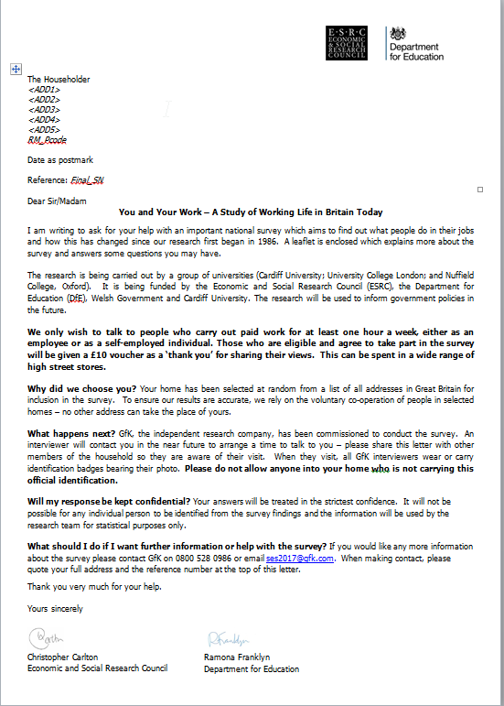
Advance letter and leaflet
- Your packs will contain pre-packed, stamped envelopes containing an advance letter and a leaflet. You should post these 3 – 4 days before you start work. If you wish – and we appreciate that this is a personal decision – you may add your name (and number if you feel this is appropriate) to the envelope.

- Please note: for Welsh points, the advance letter is provided bilingually, with Welsh on the reverse and there will be two leaflets in the envelope – one in English and one in Welsh.

- Both the letter and leaflet contain a freephone telephone number for people to call head office if they have any queries, if they think they are ineligible or if they wish to refuse in advance (there is a separate Freephone number for people who wish to communicate in Welsh and this is detailed in the Welsh version of the advance letter and leaflet). As a result of this mail out we may receive calls informing of ineligibility and you may not receive all 51/57 Reference Sheets. Please make sure that you are fully aware of the content of the letter and have spare copies in case some households do not remember receiving it. The leaflet explains in a little more detail what the survey is about and what the survey data is going to be used for. Please have spare copies of the letter and the leaflet to hand when you are making first calls.

Selected respondent letter
Your pack contains copies of a second letter. We would like you to use this in cases where the person who is selected to take part in the survey is not at home when you conduct the screening, and if there is any doubt about whether the selected person will be available for an appointment in the near future. You can use your discretion as to whether you (i) leave the follow-up letter with another person in the household with whom you’ve been talking or (ii) post the letter through the letterbox. Feedback from previous waves of the survey suggests that using this letter when appropriate could be advantageous in helping you to achieve an interview.

An example of (ii) might be someone living in a bedsit, where you have selected the ‘household’ according to the procedure, but the person you are talking to is a neighbour. Rather than rely on this person to pass on the letter to the respondent, write on the name and address of the selected respondent, and put it through their letterbox on another occasion.

There is a space for you to write in your name on the letter. You should also write in the name of the respondent, the date and reference number which is at the top of the Reference Sheet (this is important in cases where respondents want to call head office).

Further, whenever there will be any delay between selection and interview, it will probably be worthwhile putting the follow-up letter through the respondent’s letterbox on a future occasion (rather than leaving it with someone else in the household). NOTE: Welsh points have a Welsh Government logo and signatory instead of those for the Department for Education. In addition, the version for London points refers to a £15 voucher (rather £10 which applies across the rest of the sample).

- INTRODUCING THE STUDY AND ANSWERING QUESTIONS

At some addresses, you will need to explain the survey twice: first to the person who provides you with information on those living at the address to enable you to make your selection; and then to the selected individual. In general, you should keep your initial introduction brief, while responding to any points raised by the person you are talking to.

Introducing the study
As with other government surveys, there is no obligation to take part in this survey. However, the survey is very important, and you should use your skills to encourage respondents to take part. When you introduce the survey you should explain:

- Who you are

Please follow the text on the Doorstep Card, and show your copies of the advance letter and leaflet as follows:
Good morning/afternoon/evening. My name is …. from GfK, the independent research company. I am carrying out a survey about what people do in their jobs and how this is changing. You should have received a letter informing you that I would be calling. SHOW COPY OF LETTER & LEAFLET.

Before I carry out the survey, I need a few minutes of your time to ask a few questions about yourself and the people who live here with you. All the information we collect will be kept in the strictest confidence by GfK and used for research purposes only.
IF NECESSARY:
The research is being carried out by a group of universities (Cardiff University; University College London; and Nuffield College, Oxford) and is funded by the Economic and Social Research Council (ESRC), the Department for Education and the Welsh Government. They are interested in the experiences and attitudes of people who do any form of paid work, no matter what the job or where the job is done.
It will not be possible to identify any particular person, household or address in the results.

Please show your identity card at all addresses and to anyone who asks to see it.
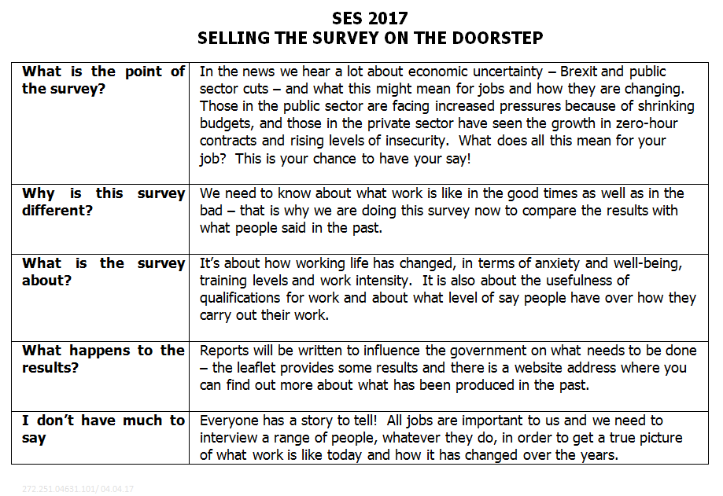
- What the survey is about
We do not want you to use the word ‘skills’ when introducing the survey to respondents. Use wording such as that in the letter, i.e. the survey is about “the things people do in their jobs”. You have a ‘crib sheet’ of selling points for the survey as shown to the right.

And here are a few more suggestions:

- The findings could well influence government and employers, as previous surveys have done in the past. It could help show employers ways of making the quality of working life better in the future. It could also help people make better use of their talents. For example, it will show how work is changing and whether enough training is being provided to help with the new demands involved in people's jobs

- Feedback from previous surveys in the series suggests that most people really enjoyed taking part, as it was an opportunity for them to express their opinions about the work they do (and to do this away from the workplace). An example of a question that most respondents found interesting to answer involves them considering whether they would continue working if they had enough money not to have to do so.

- This is a national study which is about the kinds of paid work people in Britain are doing - we aim to learn about the world of work and how it is changing.

- The results will be reported to the sponsors of the survey (ESRC, the Department for Education, Cardiff University and the Welsh Government), and will be published widely by colleagues in the Universities of Cardiff and Oxford and University College London. Interviewers working on the previous survey (in 2012) found that referring to the researchers responsible for the study was helpful: it reassured people that the study is serious research and not an exercise in selling them anything.

- We are asking respondents about their work in some detail – it is all about their own views and experiences. Other studies have collected this sort of information from personnel managers, so this study could well provide more accurate data.

- Work is organised somewhat differently in each country. This study will help to identify whether new practices are being introduced in organisations which are foreign-owned or part of global organisations. Similar questions have been asked in some other countries, so some of the analysis may involve seeing how the organisation of work in Britain compares with work in other countries.

- "How long will the survey take?"
The interview will take around an hour but there will be some variation around this typical length. We appreciate that a survey of this length requires a greater commitment than a short survey and we are giving those who complete the survey £10 worth of high street vouchers which can be spent in many high street stores (London points are being given £15 worth of vouchers). Please remember to mention this when introducing the survey and familiarise yourself with some examples of high street stores (examples are printed on the vouchers themselves). We appreciate that for some people, the payment of a voucher will not make any difference to their participation – indeed we may expect comments along the lines of ‘my time is worth more than that’. We know that incentives DO make a difference to response in certain demographic groups – if you feel that the person you are talking to is less likely to be swayed by the voucher payment, then please focus instead on the importance of the survey. While it is an hour long, it is their chance to take part in a very long running survey and to influence policy decisions in the future.

- “Who funds the survey?”
The research is being carried out by a group of universities (Cardiff University; University College London; and Nuffield College, Oxford) and is funded by the Economic and Social Research Council (ESRC), the Department for Education, Cardiff University and the Welsh Government.

- “Will the bodies who fund the survey know who took part?”
No, they will not know who said what. The names and addresses of those interviewed in this survey are known only to GfK and these details will not be passed on without the respondents’ permission.

- “How can I be sure you are a genuine interviewer?”
I have shown you my identity card. Also I have here a copy of the letter and leaflet explaining what the survey is about.

- “Why can’t you carry out the interview at another address?”
The address has been selected at random from the full list of residential addresses in Great Britain. We need to do the interview at this household to help ensure that the sample of households we interview represents of all employees in Great Britain. That is why I may need to keep coming back to your address to conduct the interview.

- “Why can’t you carry out with someone else in the household?”
In order to make the survey representative of employees in Great Britain we need to randomly select someone in the household to take part – otherwise we may not get a truly representative picture of the workforce. For example we would tend to talk to people who are easier to get hold of and they may be different in some way from other employees. This is very important – the person at the doorstep who you initially talk to may be keen to take part and may be baffled as to why they can’t do the survey if they are not selected. Please emphasise that it is not YOU making the decision, it is a random selection and we must stick to this in order to make sure that we speak to ALL types of respondent including those who are not immediately available and those who are more reluctant to participate.

Additional reassurances
Other reassurances that you can offer are as follows:
- Offer the MRS Freephone so respondents can verify that GfK is a bona fide market research agency – they dial the operator and ask for Freephone Market Research Society or they ring 0500 39 69 99;
- Offer the GfK Freephone number dedicated to the survey the number is 0800 528 0986; there is also a GfK email address dedicated to the survey which respondents may use if they wish to get in touch by email: ses2017@gfk.com (both are referenced in the advance letter and leaflet). Please note that for Welsh points, there is a dedicated Freephone number with a greeting in Welsh (this is referenced in the Welsh version of the letter and leaflet): 0800 528 0987.
- The client team have set up a dedicated website with more information about the survey (this is referenced in the leaflet) in both English and Welsh: http://www.cardiff.ac.uk/ ses2017
- Hand out a thank you leaflet at the end of your interview with your interviewer number written on it.

Making Appointments
It is important that respondents don’t feel they have to do the interview straightaway when you first call at an address, or indeed that they are under any compulsion to take part. Please be flexible and offer appointments to suit the respondent – it is VERY important that we speak to as many eligible people as possible. However, if a respondent is happy to do the interview straightaway, that’s fine – we don’t want you to risk losing interviews by making appointments unnecessarily. You have appointment cards in your pack.

Conducting the interview with privacy
Ideally the whole interview should be conducted in private, without others present. However, we do realise that this is often unavoidable, and therefore you should still complete the interview even if other people are nearby. Please be aware that there is a question at the end of the survey where we ask you to code whether the respondent was on their own during the survey or whether other members of the household or friends, etc were present.
Respondents with limited English
If the selected respondent does not have a sufficiently good command of English (or Welsh) to conduct the interview, please note that you can use another person as an interpreter for the interview, provided that the interpreter is aged 16 or over.

If you are unable to establish address eligibility due to language difficulties, you should use the language card to establish what language they speak. The language card has a range of languages and the householder can point to which language on the card they speak. Use outcome “Mother tongue required for screening” and write in the language of the respondent (from the language sheet) in the Contact Record box and in the ECS.

If you have got as far as selecting a respondent, but this person has insufficient English/Welsh to continue with the interview, and an interpreter is not available, state the final outcome code as “Mother tongue required for interview with respondent ”. Again the language card should be used to establish what their language is and this should be written in the Contact Record box (page 1 of the Reference Sheet) and in the ECS.

Respondents with visual impairments
If you encounter someone who is visually impaired you may use the large font version of the advance letter and leaflet included in your main pack (these are both printed in black and white).

- REFERENCE SHEET AND DOOR STEP CARD
All Reference Sheets are pre-printed with an address of the property you must visit. You must complete a Reference sheet for EVERY ISSUED ADDRESS, regardless of whether or not you achieve an interview.
The reference sheet is designed as a place to write notes on the outcomes from each household when you out in the field. You then can transfer this information into the ECS system on your CAPI machine.
You will enter all the information that we need from the Reference Sheet on the ECS during your assignment. We will not be asking for the Reference Sheets to be returned. The Reference sheet is two-sided and looks like this:
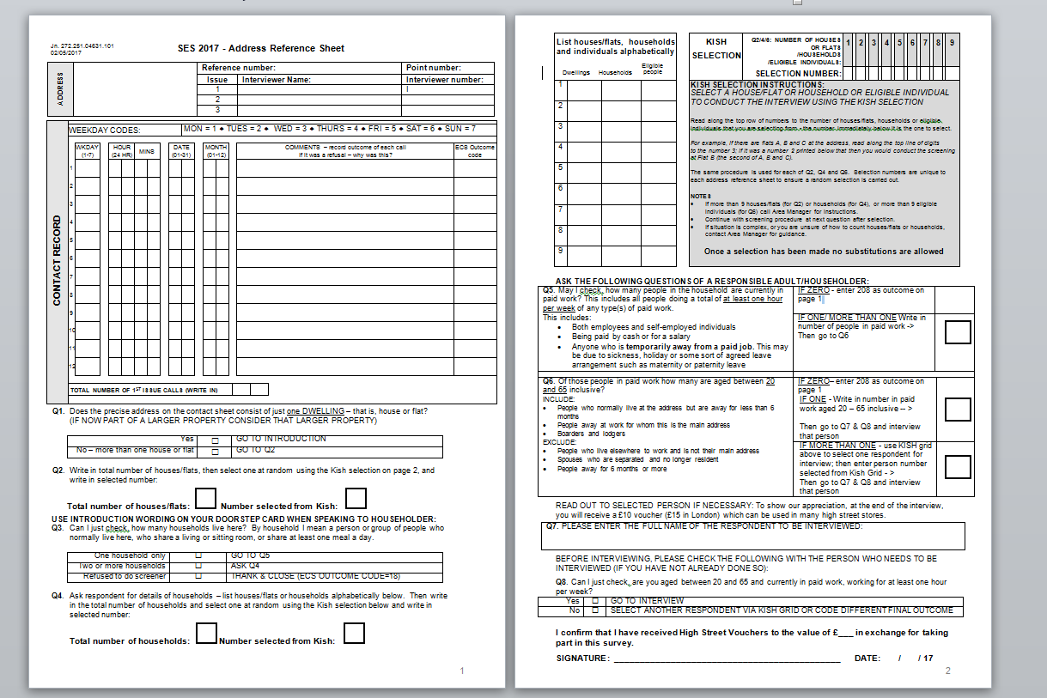
You will also be issued with a Doorstep Card to be used at all addresses. The Doorstep Card contains the wording to use when you introduce yourself on the doorstep. Please read this out once you have made contact with someone at the issued address (or if there is more than one dwelling at the address, at the one selected dwelling once you have used the Kish Grid to choose one). Make full use of the supporting materials supplied to you: the advance letter and leaflet and you also have reminder list of ‘Doorstep Selling Points’ for the survey which you may find useful to refer to.

The flipside of the Doorstep Card is the list of all interim and final outcome codes for you to refer to when entering each call outcome in the Electronic Contact Sheet (ECS). The Doorstep Card looks like this:

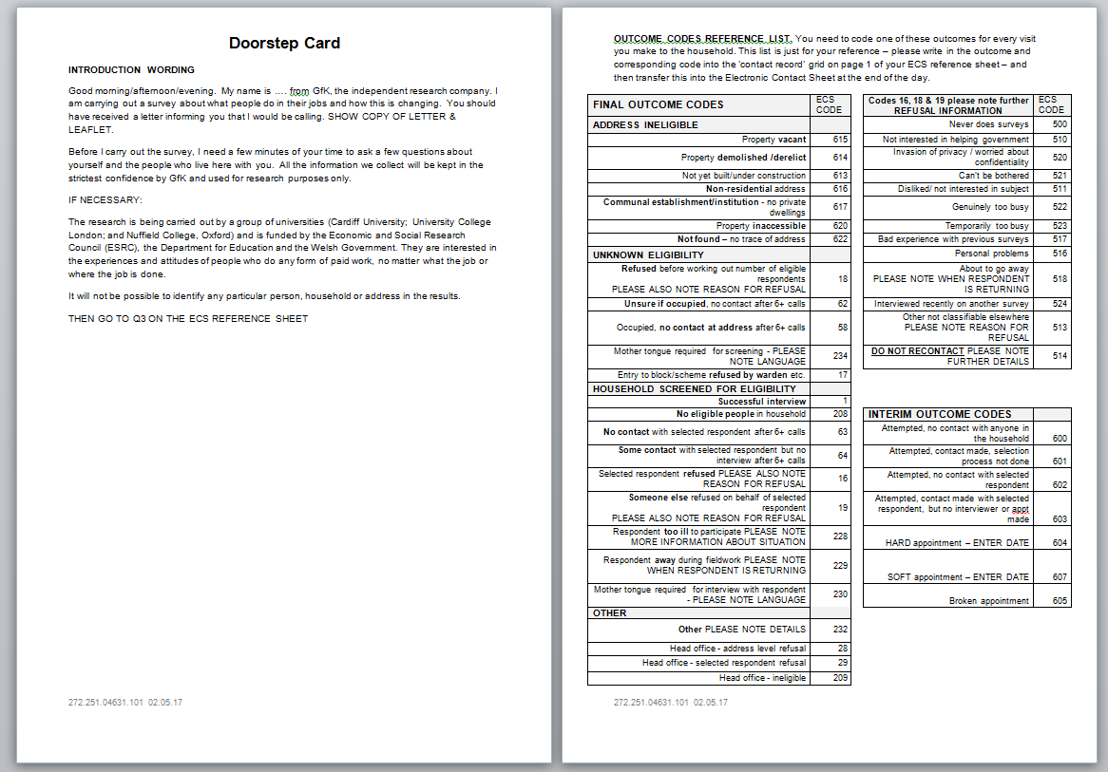
The following describes how you should fill in the address Reference Sheet. Below is the first page of the Reference Sheet, which contains the following information:
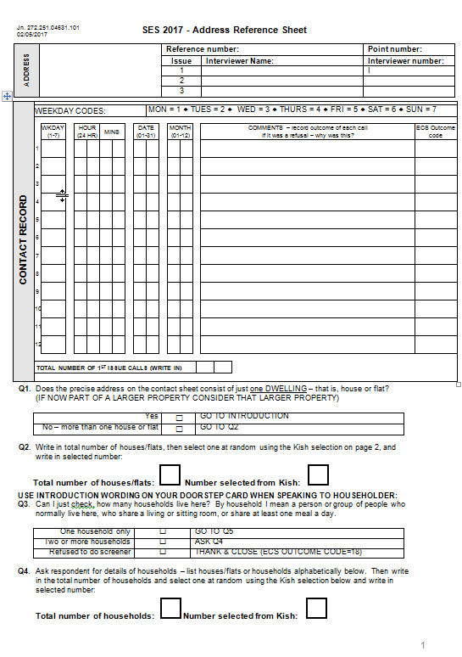
- ADDRESS INFORMATION
- Address – this is pre-printed on the Reference sheet
- Reference number - this is made up of a combination the sampling point number and an individual address reference number.
- Issue/Interviewer Name/Interviewer Number – this will be pre-printed with the name and number of the interviewer who was initially issued with that piece of sample. (Re-issues will only take place at the main stage).

- RECORDING CONTACT
- This is the area of the Reference sheet where you record details of all of the attempts that you make to contact the address. Please use the Weekday Contact Codes provided at the very top of the box to code in the WKDAY box which day of the week you made the call, and then enter the time, date and month in the following boxes. In the COMMENTS section you should enter all relevant comments about that particular call - this information will help you to code the appropriate interim or final outcome code for that case – please refer to the possible outcomes codes that are listed on the flipside of the Doorstep Card and record this code in the final column (ECS outcome code).
- When you have finished working with that particular contact sheet, whether that is because you have completed an interview, have had your request for an interview refused, or have completed your call pattern correctly and the address is a non-contact, please enter the number of calls that you made at the address in the box provided. This should tally exactly with the number of lines completed in the Contact Record box.
- DWELLING SELECTION (questions 1 and 2)
- The first thing that you need to do when you visit the address printed on the Reference Sheet is to establish whether it consists of just ONE house or flat (Q1). In the vast majority of cases, there will be just one house or flat.
- If you establish that there is more than one house or flat at the printed address, you must write in the total number of houses or flats at Q2 and then select one at random using the Kish selection on page 2 of the Reference Sheet. The method that you should follow to do this is described in detail later in these instructions.
- HOUSEHOLD SELECTION (questions 3 and 4)
- Even if you think that there is only one household living at the address that you were issued with (or that dwelling you have selected using Kish), you must still ask Q3 of a householder to be 100% sure that you don’t need to go through a selection process to choose a household. If you establish that there is only one household (again, this will be the case 99.5% of the time), then you can proceed straight to the RESPONDENT SELECTION section of the sheet (Q5). If there are two or more households present, for example bedsits with no shared facilities, you must proceed to Q4 in order to select a household to attempt to interview.
- The 2nd page of the Reference Sheet contains the Kish Selection Grid and establishes respondent eligibility.

- KISH SELECTION PROCESS
- If you discover either as soon as you visit the address, or once you have asked Q3, that the address that you have been issued with consists of more than one dwelling and/or household, you will need to use the KISH SELECTION to select a dwelling or household.

- You should start this by listing all of the dwellings or households alphabetically in the box on the left hand side of the page. So, for example, you could have Flat 1, Flat 2 and Flat 3, or Flat A, Flat B and Flat C listed, or you could enter the surnames of the households if you have them, for example Brown, Jones and Smith.

- Please list all flats; even if one or more is actually empty at the time you call (as it could be occupied in the near future). For example, if you turned up at an address and it was split into three then you would write the names of each flat into the grid on the left hand side:
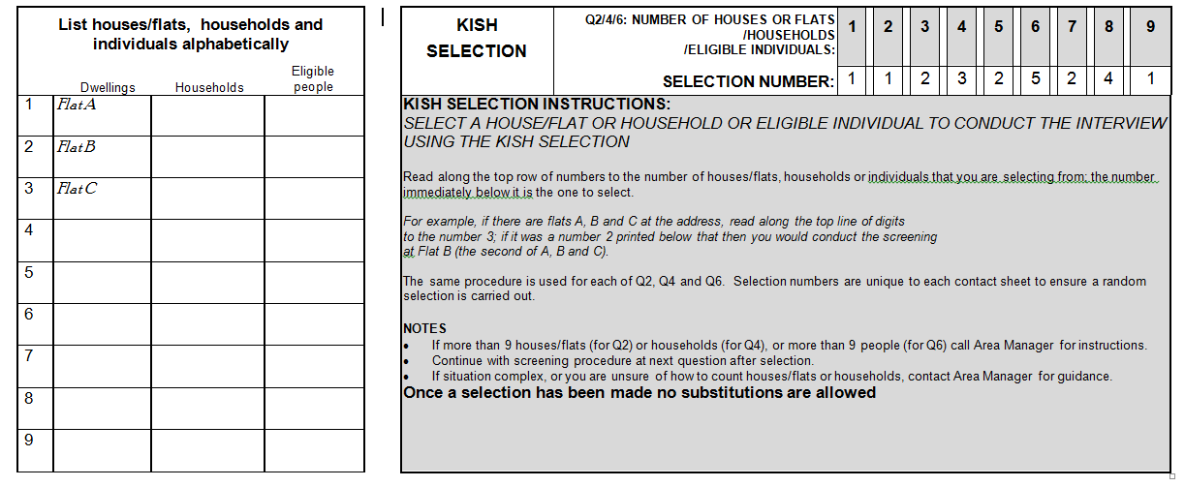

- On the right hand side of the page is a box labelled “Kish Selection”. You will see that the numbers 1-9 appear on the right hand side of the box in grey boxes. Beneath these are pre-printed, random numbers (selection numbers). You should read along the top row of numbers (in the grey boxes) and stop when you get to the number of houses or flats that you are trying to select from, and then look in the box immediately below that, where you will find a number. This is the number of the dwelling or household that you should select. The selection numbers are unique to each Reference Sheet and this will ensure that a random selection is carried out. So, in this example below, as you are selecting from three dwellings in total (Flat A, Flat B and Flat C) you would select the number of the dwelling in the box BELOW the number 3 – selection number is 2 – which is Flat B:
- If you are at all confused by this or in the extremely unlikely instance that you encounter an address where there are more than 9 dwellings or households present, please call your area manager for further guidance.

- PLEASE NOTE: **ONCE A SELECTION HAS BEEN MADE VIA KISH, NO SUBSTITUTES ARE ALLOWED IN ANY CIRCUMSTANCES**

- RESPONDENT ELIGIBILITY AND SELECTION
- Next you need to establish who is eligible to take part in the survey. To do this you need to speak to a responsible adult in the household (preferably a householder) who you think would be able to give you information about all adult members of the household. We strongly recommend that you carry out the eligibility check with a householder, rather than, for example, with a son/daughter or anyone else living at the address. If you do the screening with a non-householder, they must be aged at least 18.
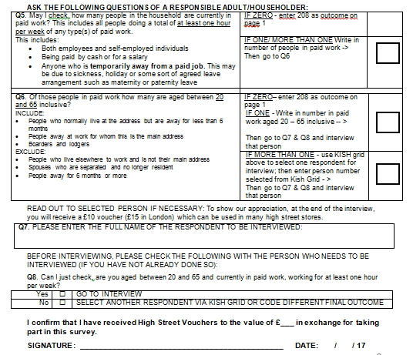
- Question 5 Firstly, at Q5, you need to establish with the person you speak to how many people within the household are currently in paid work – this includes all those who are doing at least one hour of work. Please enter the number clearly in the box at Q5.

Q5 - May I check, how many people in the household are currently in paid work? This includes all people doing a total of at least one hour per week of any type(s) of paid work.
This includes:
- Both employees and self-employed individuals /
- Being paid by cash or for a salary
- Anyone who is temporarily away from a paid job. This may be due to sickness, holiday or some sort of agreed leave arrangement such as maternity or paternity leave.

- If you find that no one is eligible (generally just under half of households), please thank the householder for their time and tell them that unfortunately no one is eligible to do the interview; in this case, please code the final outcome in the Contact Record box as no-one eligible and enter this into the ECS at the end of your working day.

- If the respondent requires clarification regarding who they should include as part of the household then please use the following guidelines:
INCLUDE:
- PEOPLE WHO NORMALLY LIVE AT THE ADDRESS BUT ARE AWAY FOR LESS THAN 6 MONTHS
- PEOPLE AWAY AT WORK FOR WHOM THIS IS THE MAIN ADDRESS
- BOARDERS AND LODGERS
EXCLUDE:
- PEOPLE WHO LIVE ELSEWHERE TO WORK AND IS NOT THEIR MAIN ADDRESS
- SPOUSES WHO ARE SEPARATED AND NO LONGER RESIDENT
- PEOPLE AWAY FOR 6 MONTHS OR MORE

- Question 6 If the answer is 1 or more then you need to ask question 6 to find out how many of those included at Q5 are aged between 20 and 65 inclusive. Please write this number in the box at Q6.
Depending on the answer at Q6 the following courses of action should be taken:
- If zero – please code the final outcome as no one eligible in the Contact Record box on the front page of the ECS reference sheet then transfer this information over to the ECS.
- If one – please fill in details at q7-q10 and interview that person
- If more than one - use the Kish grid on page 2 to select one respondent for interview and fill in details at q7-q10 and try to interview that person

NB – it is very important that you record the numbers at Q2, 4 and 6 as we need them to help us analyse the data. You will be asked to transfer this information from the Reference Sheet to the CAPI script at the end of the interview – so please have the reference sheet handy at the end of the interview.

Some respondents are wary about the selection grid and suspicious about why we are using it. You can reassure them by saying that this is standard procedure on surveys of this nature and the selection means that we choose someone at random rather than interviewing just those who are most keen to take part or who are easy to find at home – the people who are less keen or less often at home may have very different views so we have to go to some lengths to ensure we include them in our survey to make it representative of all employees in Great Britain.
It is worth noting some feedback from the Dress Rehearsal in which some interviewers said that they found it helpful to be totally transparent during the Kish selection process, allowing the respondent to see what they were doing or even talking them through the process - this alleviates suspicion and helps demonstrate the random nature of the selection.

Please note the reminder text after Question 6 about the ‘thank you’ gift of £10 high street vouchers (£15 in London); this will be given to the selected respondent when they complete the survey as a thank you. If you have not already mentioned it, then please do so at this point as it may tip the balance towards the selected respondent agreeing to take part there and then rather than ‘fobbing you off’ and requesting you call back at another time. We know that £10 will have little impact on some people’s decision to take part, but in the dress rehearsal we know it was a deciding factor for some respondents.

Questions 7 and 8
Questions 7 and 8 ask you to write in the name of the selected respondent. Q8 is a final check question and should be asked in instances where the household screening has not been carried out by the respondent who was selected to take part in the survey.

Collecting signatures
At the bottom of page 2 there is space for respondents to sign to say they have received their high street gift vouchers.

- RETURNING REFERENCE SHEETS
- For this survey there is no requirement to return Reference Sheets.

- CALL PATTERN
- Due to the nature of the sample (working people) we are expecting you to work evenings and weekends in order to achieve the highest number of interviews possible. However, we know that day times are productive for first calls in order to establish where addresses are and complete initial screening/ establish ‘deadwood’. You may also get some daytime interviews with people who work part time or work shifts. In the Dress Rehearsal interviewers also found that the hours of 4 – 6PM were popular with families with young children (after school pick up, before tea time).

- Please attempt a visit to each address in your sample within the first week. Calls must be made on different days of the week and at the weekend, spread over the dress rehearsal period. Non-contacts and screening failures will be paid for based on the information on the ECS.
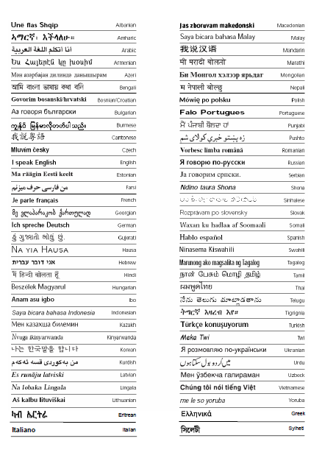

- LANGUAGE CARDS
- As noted in section 6, if you come to a household where no one speaks English and there is no means of informal interpretation, please use the language card to establish what language they speak. The language card has a range of languages and the householder can point to which language on the card they speak. This can be used when establishing eligibility and if the selected respondent (if you get that far) has insufficient English to participate.

CALLING/ APPOINTMENT CARDS
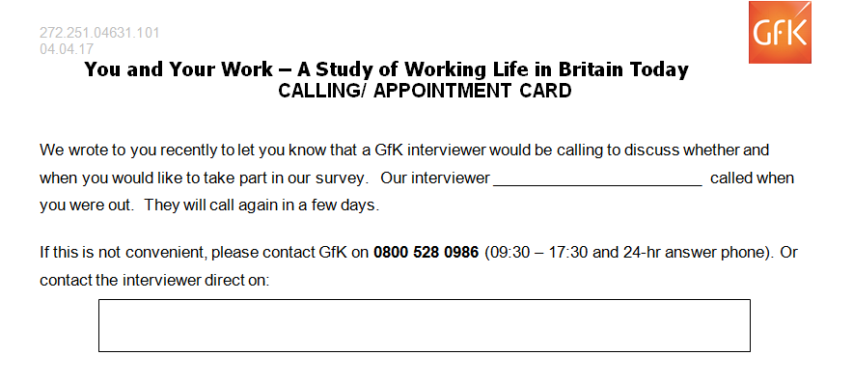
- We have also issued you with Calling/Appointment cards (double sided – calling card on one side and appointment card on the other). We recommend that these are used in two ways 1) to leave with a selected respondent when you agree a time to visit and interview them and 2) you may choose to put these through the letterboxes of households where you have a situation of a broken appointment. We don’t recommend using these before you have had any contact with the household (unless you have followed your 6+ call pattern and wish, as a last resort, to leave a record of your attempt to make contact). Some interviewers are happy to put their own phone number on the card, and some aren’t: we leave that decision up to you.

- **UNDER NO CIRCUMSTANCES IS IT PERMISSIBLE TO INTERVIEW PEOPLE WHO ARE KNOWN TO YOU**
- ECS OUTCOME CODES

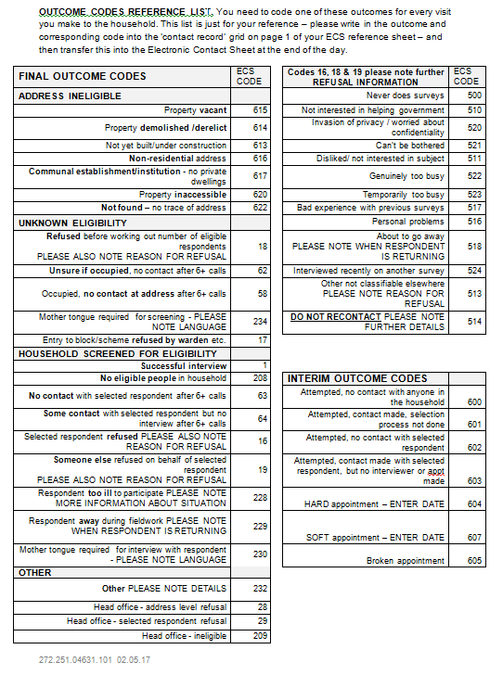
A very important part of your assignment is the timely completion of the Electronic Contact Sheet (ECS) – this should be done every day that you work on the assignment for all ‘live’ addresses. The ECS outcome codes are listed on the flipside of the Doorstep Card for reference – you can refer to these when you complete the Contact Record box on page 1 of the Reference Sheet, entering an interim or final outcome code for each call in the final column. These will then need to be transferred to the ECS at the end of the working day.

There are sub headings designed to help you find the correct outcome for each piece of sample. The first category is ‘address ineligible’. This contains seven codes that cover situations where an address cannot produce an interview with an eligible resident. The next category of final outcomes are those of ‘unknown eligibility. The third category of codes is for cases where you have been able to screen the household to find out if anyone is eligible. The fourth category of outcome codes are categorised under ‘other’. There are also interim outcome codes (where you are still visiting an address) and codes to classify the nature of refusals.

Notes are provided below for each code (in italics) to explain what is covered by each.

Address ineligible
Code | Code number | Further notes
Property vacant | 615 | When a property is completely empty and you do not expect it to be occupied during the fieldwork period. If you think it might be occupied in the near future, please hold on to your contact sheet and go back to the address when someone might be living there
Property demolished /derelict | 614
Property not yet built | 613 | There may be some cases where a property is already listed by Royal Mail in PAF but has not yet been built
Non-residential property | 616 | As well as business premises, this also includes holiday homes (which are not eligible for inclusion in the survey)
Property inaccessible | 617 | This is where you cannot gain access to an address e.g. because of a permanently locked gate
Institution – no private households | 620 | Including hotels, hostels, care homes, university halls of residence (although very few of these cases will occur)
Not found – no trace of address | 622 | If you cannot find the address, please check with your area manager who may be able to help you to trace the address. We do not expect many addresses issued to be coded this way.

Unknown eligibility
Code | Code number | Further notes
Refused before working out number of eligible respondents  PLEASE NOTE REASON FOR REFUSAL | 18 | When you cannot establish with someone in the household how many people there might be eligible for the survey because no one in the household will give you this information.  If this happens, please also give the reasons for refusal in the ECS. It is really important to get this information because it will help us to decide whether this piece of sample might be re-issued at a later date
Unsure if occupied, no contact after 6+ calls | 62 | You have called at the address 6 or more times with the correct call pattern and you are still unsure as to whether the property is occupied (although there seems to be furniture etc. in the house which distinguishes it from code 615 – property vacant)
Occupied, no contact at address after 6+ calls | 58 | When you are certain that there is someone living at the address but after 6 or more calls you have been unable to make contact with anyone at the address
Mother tongue required for screening – PLEASE NOTE LANGUAGE | 234 | You have made contact however the person you spoke to had inadequate English to provide you with enough information to establish whether there is anyone in household who is eligible to take part.  Please use the language card provided to establish with them which language they speak and write this on the contact sheet.
Entry to block/scheme refused by warden etc. | 17 | You have been unable to make contact with the actual address because entry to the block has been refused by a warden

Household screened for eligibility
Code | Code number | Further notes
Successful interview with selected respondent | 1 | If you get an interview with the selected respondent please code this outcome
No eligible people in household | 208 | If you screen the household for those working for one hour a week between the ages of 20 and 65 and find there is no one eligible, please use this code
No contact with selected respondent after 6+ calls | 63 | If you have been able to screen the household but have not been able to make any contact with the selected respondent please select this code
Some contact with selected respondent but no interview after 6+ calls | 64 | If you have been able to screen the household but have only been able to make limited contact with the selected respondent please select this code  If you have made some contact with the respondent, it is useful for us to know why you have not been able to get an interview so that if we re-issue that piece of sample, the next interviewer can use this information when they visit the house. Please add this information in the comments section at the end of the ECS entry for that address.
Selected respondent refused PLEASE ALSO NOTE REASON FOR REFUSAL | 16 | If you select a respondent from the household but they refuse to take part, then code here  If this happens, please also code the reason for refusal in the ECS. It is really important to get this information because it will help us to decide whether this piece of sample might be re-issued at a later date
Someone else refused on behalf of selected respondent PLEASE ALSO NOTE REASON FOR REFUSAL | 19 | If you select a respondent from the household but someone else in the household refuses on their behalf please use this code.  If this happens, please also code the reason for refusal in the ECS. It is really important to get this information because it will help us to decide whether this piece of sample might be re-issued at a later date
Respondent too ill to participate PLEASE NOTE MORE INFORMATION ABOUT SITUATION | 228 | If the respondent is too ill to take part in the survey please note why and we can use this information to help decide whether to re-issue this piece of sample
Respondent away during fieldwork NOTE WHEN RESPONDENT IS RETURNING | 229 | If you select the respondent and find out they are away during fieldwork use this code; please also write in the date they will be back to help us to decide if this can be re-issued
Mother-tongue required for interview with respondent – PLEASE NOTE LANGUAGE | 230 | Please use this code when you select a respondent who cannot complete the survey in English and no one can translate for you (see section 6 for further instructions). Please use the language card to establish which language they speak and note this

Other
Code | Code number | Further notes
Other PLEASE NOTE DETAILS | 232 | Please only use this code as a last resort if you really cannot code the situation under any of the other codes. Please note the reason why you had to use it.  If you come across a situation where someone has died since you selected them for interview, you should code that outcome here.
Head office – address level refusal | 28 | This may happen when the letter is received and the person at that house calls the survey helpline and does not want to take part at all. Your area manager will notify you about this if this is the case
Head office – selected respondent refusal | 29 | Again your area manager will inform you if the selected respondent has called the survey helpline to refuse to take part
Head office – ineligible | 209 | Your area manager will let you know if someone has called to say that cannot take part because they are not eligible

There are a number of interim outcome codes that you should use in the ECS for addresses at which you are still calling. These are self-explanatory and are summarised below.

INTERIM OUTCOME CODES
Attempted, no contact with anyone in the household | 600
Attempted, contact made, selection process not done | 601
Attempted, no contact with selected respondent | 602
Attempted, contact made with selected respondent, but no interviewer or appt made | 603
HARD appointment – ENTER DATE | 604 | We know that as interviewers you have a sense of when an appointment is firm or not. Use this code for instances where you feel you will definitely get an appointment
SOFT appointment – ENTER DATE | 607 | Use this code in instances where you are not certain that the interview will take place (e.g. you don’t have a firm appointment time)
Broken appointment | 605

As already stated if someone has REFUSED, we would like you to provide us with some refusal information. We would also like you to tell us, in your opinion, if you think that we should not attempt to re-contact the household. This may be used if you think the respondent would take offence if they were called on by someone else. If you feel that we should NOT attempt to re-contact them, (and this should only be used in appropriate circumstances) please use the DO NOT RECONTACT code (514).

Appendix D Reference sheet
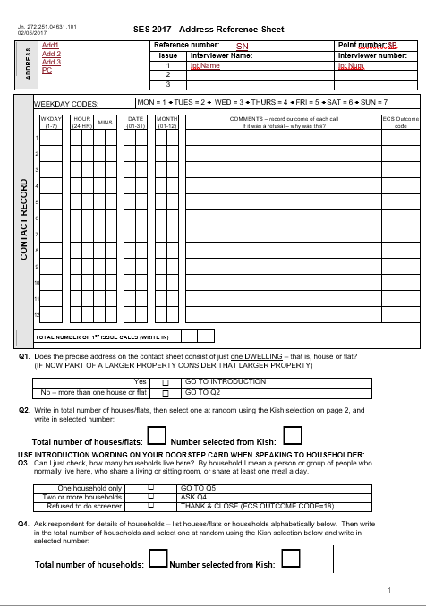
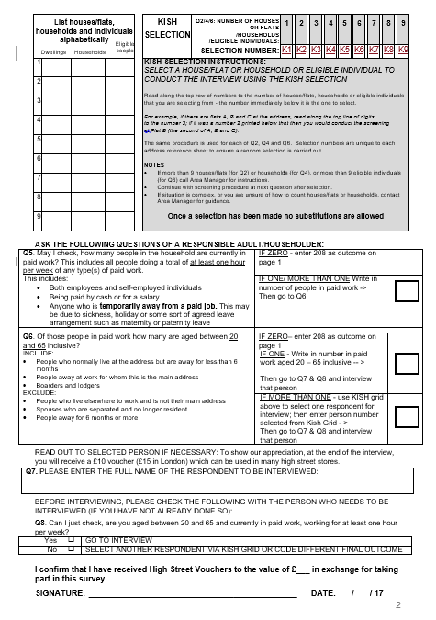

Appendix E Advance letters and leaflet
England (except London)
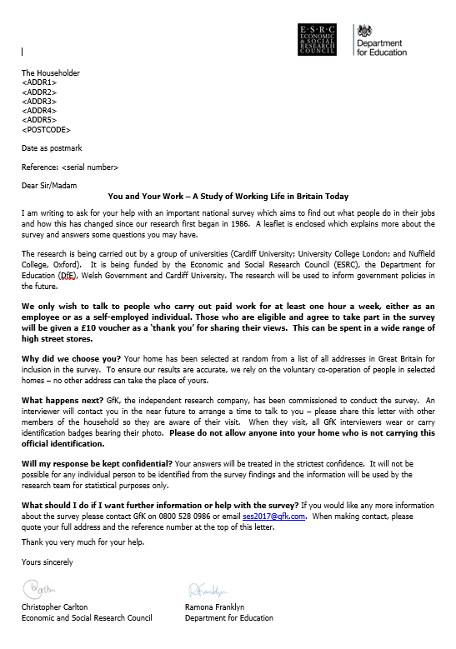

London
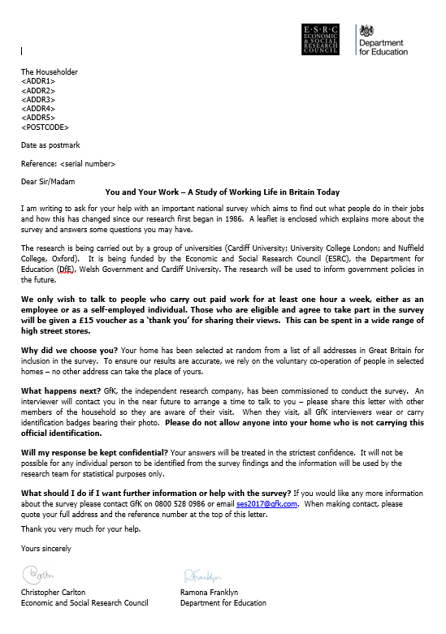

Scotland
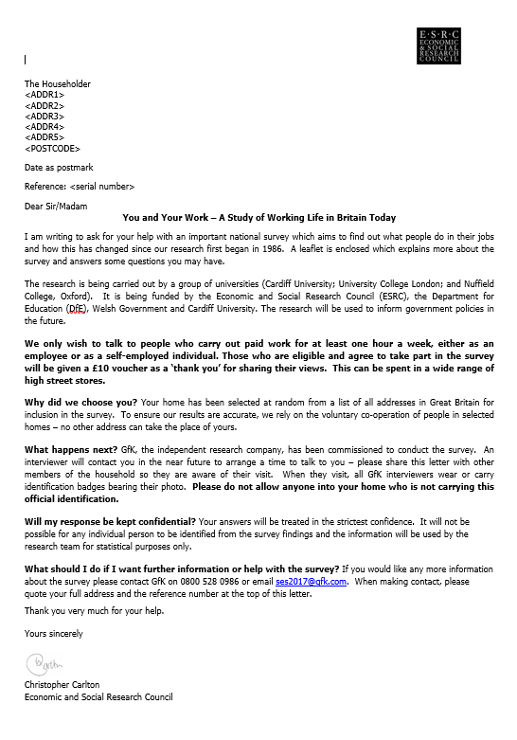

Wales (English)
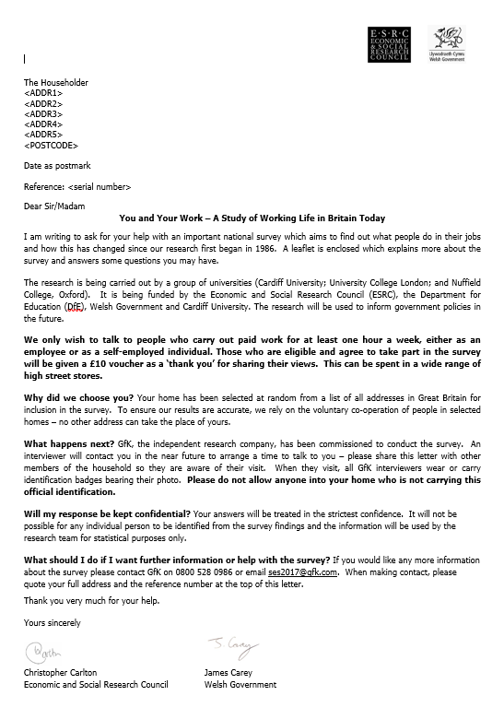

Wales (Welsh)
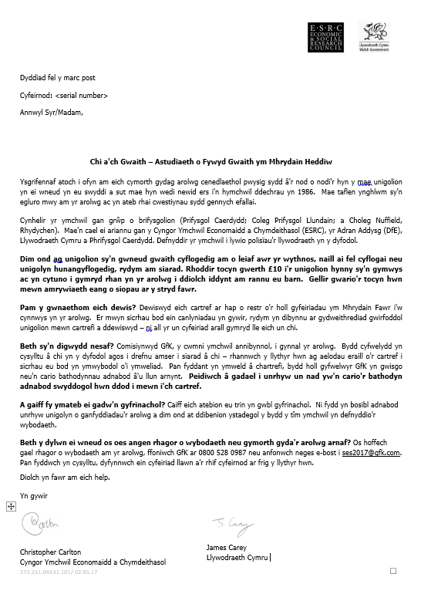

Leaflet (English)
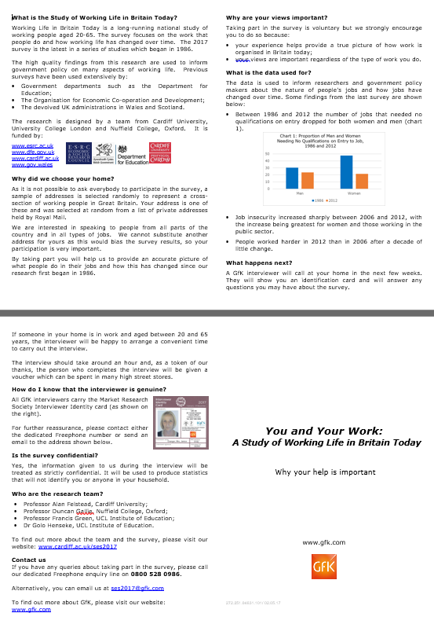

Leaflet (Welsh)
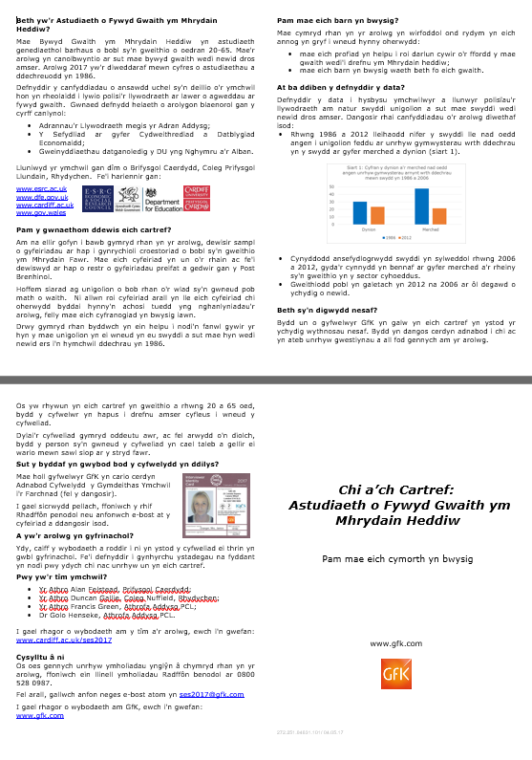

Appendix F Selected respondent letter
England (except London)

London

Scotland
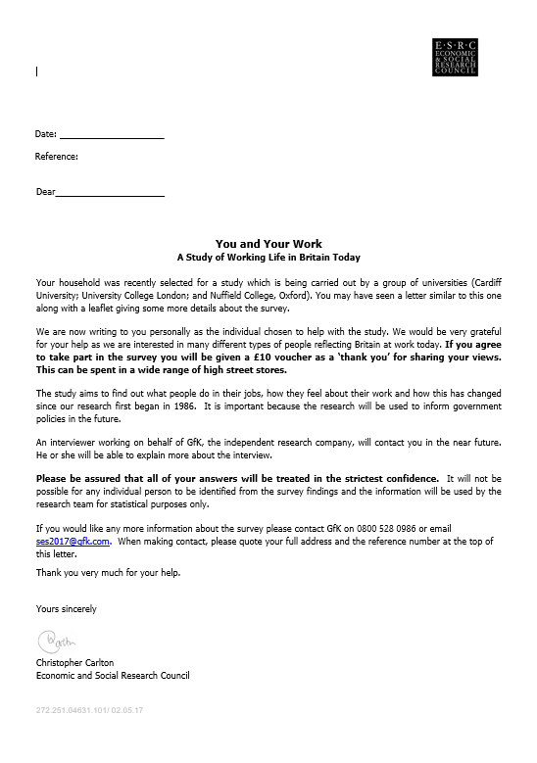

Wales (English)
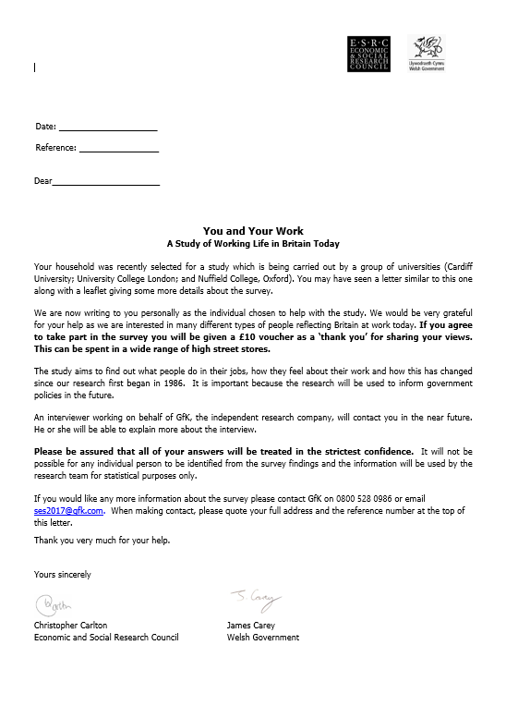

Wales (Welsh)
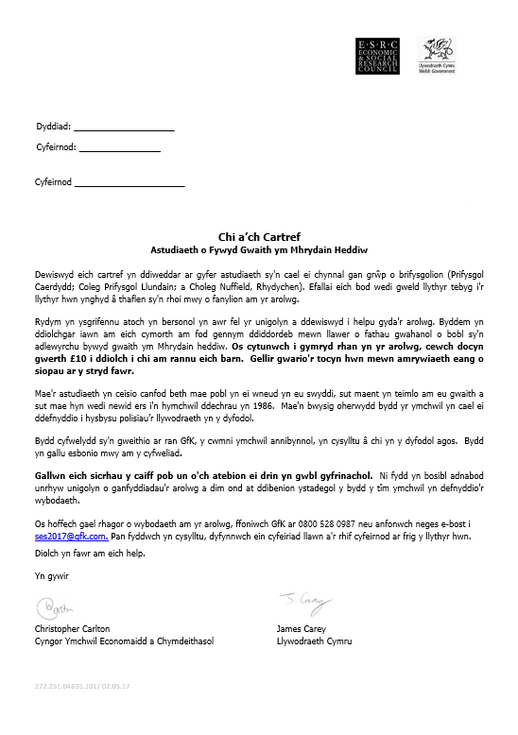

Appendix G Show cards
SHOW CARD B1

1. Paid a salary or a wage by an agency
2. Sole director of own limited business
3. Running a business or professional practice
4. A partner in a business or professional practice
5. Working for yourself
6. Working as a sub-contractor
7. Doing freelance work
8. None of these

SHOW CARD B2

A. At home
B. In the same grounds and buildings as home (eg, in adjoining property or surrounding land)
C. At a single workplace away from home (eg, office, factory or shop)
D. In a variety of different places of work (eg, working on clients' premises or in their homes)
E. Working on the move (eg, delivering products or people to different places)

SHOW CARD B2A

1. Essential
2. Very important
3. Fairly important
4. Not very important
5. Not at all important/Does not apply

SHOW CARD B3

1. Strongly agree
2. Agree
3. Disagree
4. Strongly disagree
SHOW CARD B3a

1. Never
2. Once
3. More than once

SHOW CARD B4

1. A great deal
2. A fair amount
3. Not much
4. Not at all

SHOW CARD B5

1. None/no qualifications
2. GCSE D-G/CSE below Grade 1/GNVQ Foundation
3. GCSE A*-C/GNVQ Intermediate/GCE 'O' Level/CSE Grade 1/School Certificate of Matriculation
4. GCE 'A' Level/GNVQ Advanced
5. SCE Standard (4-7)/Ordinary (below C)
6. SCE Standard (1-3)/Ordinary (A-C) or SLC/SUPE Lower
7. SCE Higher or SLC/SUPE Higher
8. Certificate of Sixth Year Studies
9. NVQ level 1 (or SNVQ1)
10. NVQ level 2 (or SNVQ 2)
11. NVQ level 3 (or SNVQ 3) or ONC/OND (or SNC/SND)
12. NVQ level 4 (or SNVQ 4) or HNC/HND (or SHNC/SHND)
13. University Certificate/Diploma (Not Degree)
14. SCOTVEC National Certificate
15. SCOTBEC/SCOTEC Certificate/Diploma
16. Clerical/commercial (eg typing or book-keeping)
17. Nursing (eg SCM, RGN, SRN, SEN)
18. Teaching
19. Other Professional (eg law, medicine)
20. University or CNAA Degree
21. Masters or PhD Degree
22. Completion of Trade Apprenticeship
23. Professional qualification without sitting exam
24. Other (SPECIFY)
SHOW CARD B6

1. Totally unnecessary
2. Not really necessary
3. Fairly necessary
4. Essential
SHOW CARD B8

1. Less than 1 week
2. Less than 1 month
3. 1 month and over, up to 3 months
4. 3 months and over, up to 6 months
5. 6 months and over, up to 1 year
6. 1 year and over, up to 2 years
7. 2 years and over
SHOW CARD B8a

1. Less than 1 week
2. Less than 1 month
3. 1 month or more, up to 3 months
4. 3 months or more, up to 6 months
5. 6 months or more, up to 1 year
6. 1 year or more, up to 2 years
7. 2 years or more
SHOW CARD B9

1. A machine or assembly line
2. Clients or customers
3. A supervisor or boss
4. Your fellow workers or colleagues
5. Your own discretion
6. Pay incentives
7. Reports and appraisals
8. None of these
SHOW CARD B10

1. Strongly agree
2. Agree
3. Disagree
4. Strongly disagree
SHOW CARD B11

1. A great deal
2. Quite a lot
3. To some extent
4. A little
5. Not at all
SHOW CARD B11a

1. Strongly agree
2. Agree
3. Disagree
4. Strongly disagree
SHOW CARD B13

1. Very True
2. True
3. Somewhat true
4. Not at all true
SHOW CARD B14

1. All the time
2. Almost all the time
3. Around three quarters of the time
4. Around half the time
5. Around quarter of the time
6. Almost never
7. Never
SHOW CARD B15

1. A great deal
2. A fair amount
3. Not much
4. None at all

SHOW CARD B16

1. Very easy
2. Quite easy
3. Quite difficult
4. Very difficult
SHOW CARD B17

1. Very likely
2. Quite likely
3. Evens
4. Quite unlikely
5. Very unlikely
SHOW CARD C1

1. Essential
2. Very important
3. Fairly important
4. Not very important
5. Not at all important/Does not apply

SHOW CARD C1A

1. There would be no significant difference
2. I would be able to do my job a little better
3. I would be able to do my job much better

SHOW CARD C1B

1. Strongly agree
2. Agree
3. Disagree
4. Strongly disagree

SHOW CARD C2

1. Essential
2. Very important
3. Fairly important
4. Not very important
5. Not at all important/Does not apply

SHOW CARD D2

1. STRAIGHTFORWARD (for example, using a computer for straightforward routine procedures such as printing out an invoice in a shop)
2. MODERATE (for example, using a computer for word- processing and/or spreadsheets or communicating with others by 'e-mail')
3. COMPLEX (for example, using a computer for analysing information or design, including use of computer aided design or statistical analysis packages)
4. or ADVANCED (for example, using computer syntax and/or formulae for programming)
SHOW CARD D4

1. None/no qualifications
2. GCSE D-G/CSE below Grade 1/GNVQ Foundation
3. GCSE A*-C/GNVQ Intermediate/GCE 'O' Level/CSE Grade 1/School Certificate of Matriculation
4. GCE 'A' Level/GNVQ Advanced
5. SCE Standard (4-7)/Ordinary (below C)
6. SCE Standard (1-3)/Ordinary (A-C) or SLC/SUPE Lower
7. SCE Higher or SLC/SUPE Higher
8. Certificate of Sixth Year Studies
9. NVQ level 1 (or SNVQ1)
10. NVQ level 2 (or SNVQ 2)
11. NVQ level 3 (or SNVQ 3) or ONC/OND (or SNC/SND)
12. NVQ level 4 (or SNVQ 4) or HNC/HND (or SHNC/SHND)
13. University Certificate/Diploma (Not Degree)
14. SCOTVEC National Certificate
15. SCOTBEC/SCOTEC Certificate/Diploma
16. Clerical/commercial (eg typing or book-keeping)
17. Nursing (eg SCM, RGN, SRN, SEN)
18. Teaching
19. Other Professional (eg law, medicine)
20. University or CNAA Degree
21. Masters or PhD Degree
22. Completion of Trade Apprenticeship
23. Professional qualification without sitting exam
24. Other (SPECIFY)
SHOW CARD E0

1. Essential
2. Very important
3. Fairly important
4. Not very important

SHOW CARD E1

1. Strongly agree
2. Agree
3. Disagree
4. Strongly disagree

SHOW CARD E2

1. Very well organised
2. Quite well organised
3. Quite poorly organised
4. Very poorly organised
SHOW CARD E3

1. A great deal
2. A fair amount
3. Not much
4. Not at all

SHOW CARD E5

1. Strongly agree
2. Agree
3. Neither agree nor disagree
4. Disagree
5. Strongly disagree

SHOW CARD E6

1. More than three-quarters
2. Half to three-quarters
3. About half
4. A quarter to half
5. Less than a quarter
6. None

SHOW CARD E7

1. Very high
2. High
3. Neither high nor low
4. Low
5. Very low
6. Not applicable

SHOW CARD E8

1. Strongly agree
2. Agree
3. Disagree
4. Strongly disagree

SHOW CARD E9

1. A great deal of help
2. Quite a lot of help
3. Of some help
4. A little help
5. Of no help at all

SHOW CARD E10

1. Strongly agree
2. Agree
3. Disagree
4. Strongly disagree

SHOW CARD G1

1. One hour
2. One week
3. Four weeks
4. Calendar month
5. Year
6. Other period (SPECIFY)
SHOW CARD J1

1. Much more efficient
2. Somewhat more efficient
3. Made no difference
4. Somewhat less efficient
5. Much less efficient

SHOW CARD J2

1. work much harder than before
2. work somewhat harder than before
3. work neither more nor less hard than before
4. work somewhat less hard than before
5. work much less hard than before

SHOW CARD J3

1. Received instruction or training from someone which took you away from your normal job
2. Received instruction whilst performing your normal job
3. Taught yourself from a book /manual /video /computer/ DVD /Internet
4. Followed a correspondence or Internet course (such as Open University)
5. Taken an evening class
6. Done some other work-related training
7. None of these
SHOW CARD J4

1. A great deal
2. Quite a lot
3. To some extent
4. A little
5. Not at all

SHOW CARD J5

1. Within a week
2. Within a month
3. Within 6 months
4. Within a year
5. More than a year

6. Never

SHOW CARD I2

1. Never
2. Occasionally
3. Some of the time
4. Much of the time
5. Most of the time

6. All of the time

SHOW CARD I3

1. Completely satisfied
2. Very satisfied
3. Fairly satisfied
4. Neither satisfied nor dissatisfied
5. Fairly dissatisfied
6. Very dissatisfied
7. Completely dissatisfied

SHOW CARD I4

1. Very anxious
2. Fairly anxious
3. Not very anxious
4. Not anxious at all

SHOW CARD I5

1. Disagree strongly
2. Disagree moderately
3. Disagree a little
4. Neither agree nor disagree
5. Agree a little
6. Agree moderately
7. Agree strongly

SHOW CARD K1

1. Not at all
2. Very little
3. To some extent
4. To a high extent
5. To a very high extent

SHOW CARD K2

1. White
2. Black – Caribbean
3. Black – African
4. Black – Other
5. Indian
6. Pakistani
7. Bangladeshi
8. Chinese
9. Mixed/multiple ethnic groups
10. Other

SHOW CARD K3

1. Completely satisfied
2. Very satisfied
3. Fairly satisfied
4. Neither satisfied nor dissatisfied
5. Fairly dissatisfied
6. Very dissatisfied
7. Completely dissatisfied

Appendix H Definition of Sub-region
GOR | County
East Midlands | DERBYSHIRE
East Midlands | LEICESTERSHIRE
East Midlands | LINCOLNSHIRE
East Midlands | NORTHAMPTONSHIRE
East Midlands | NOTTINGHAMSHIRE
Eastern | BEDFORDSHIRE
Eastern | CAMBRIDGESHIRE
Eastern | ESSEX
Eastern | HERTFORDSHIRE
Eastern | NORFOLK
Eastern | SUFFOLK
London | NORTH LONDON
London | SOUTH LONDON
North East | CLEVELAND
North East | DURHAM
North East | NORTHUMBERLAND
North East | TYNE & WEAR
North West | CHESHIRE
North West | CUMBRIA
North West | GREATER MANCHESTER
North West | LANCASHIRE
North West | MERSEYSIDE
Scotland | Aberdeen City
Scotland | Aberdeenshire
Scotland | Angus
Scotland | Argyll and Bute
Scotland | City of Edinburgh
Scotland | Clackmannanshire
Scotland | Dumfries and Galloway
Scotland | Dundee City
Scotland | East Ayrshire
Scotland | East Dunbartonshire
Scotland | East Lothian
Scotland | East Renfrewshire
Scotland | Falkirk
Scotland | Fife
Scotland | Glasgow City
Scotland | Highland
Scotland | Inverclyde
Scotland | Midlothian
Scotland | Moray
Scotland | North Ayrshire
Scotland | North Lanarkshire
Scotland | Perth and Kinross
Scotland | Renfrewshire
Scotland | Scottish Borders
Scotland | South Ayrshire
Scotland | South Lanarkshire
Scotland | Stirling
Scotland | West Dunbartonshire
Scotland | West Lothian
Scotland | Aberdeen City
South East | BEDFORDSHIRE
South East | BERKSHIRE
South East | BUCKINGHAMSHIRE
South East | EAST SUSSEX
South East | HAMPSHIRE
South East | ISLE OF WIGHT
South East | KENT
South East | OXFORDSHIRE
South East | SURREY
South East | WEST SUSSEX
South West | AVON
South West | CORNWALL AND ISLES OF SCILLY
South West | DEVON
South West | DORSET
South West | GLOUCESTERSHIRE
South West | SOMERSET
South West | WILTSHIRE
West Midlands | DERBYSHIRE
West Midlands | HEREFORD AND WORCESTER
West Midlands | SHROPSHIRE
West Midlands | STAFFORDSHIRE
West Midlands | WARWICKSHIRE
West Midlands | WEST MIDLANDS
Yorkshire & Humber | HUMBERSIDE
Yorkshire & Humber | NORTH YORKSHIRE
Yorkshire & Humber | SOUTH YORKSHIRE
Yorkshire & Humber | WEST YORKSHIRE
Wales | Blaenau Gwent
Wales | Bridgend
Wales | Caerphilly
Wales | Cardiff
Wales | Carmarthenshire
Wales | Ceredigion
Wales | Conwy
Wales | Denbighshire
Wales | Flintshire
Wales | Gwynedd
Wales | Isle of Anglesey
Wales | Merthyr Tydfil
Wales | Monmouthshire
Wales | Neath Port Talbot
Wales | Newport
Wales | Pembrokeshire
Wales | Powys
Wales | Rhondda, Cynon, Taff
Wales | Swansea
Wales | the Vale of Glamorgan
Wales | Torfaen
Wales | Wrexham

Appendix I Definitions of Region and Travel to Work Area (2011)
The region variable included in the datafile (‘region’) is based on Government Office Region (GOR). GORs are built up of complete counties/unitary authorities in England. Scotland and Wales are not subdivided into GORs but are listed with them as regions in GB-wide statistical comparisons.
Table 7 Regions included in the datafile
1 | North East
2 | North West
3 | Yorkshire and the Humber
4 | East Midlands
5 | West Midlands
6 | East of England
7 | London
8 | South East
9 | South West
10 | Wales
11 | Scotland

The Travel to Work Areas (TTWAs) included in the datafile (‘homettwa’) are based upon those defined by ONS in 2011. ONS defined these areas using 2001 Census information on home and work addresses, they are based on Lower Layer Super Output areas (LSOAs) in England and Wales and data zones in Scotland.
Table 8 Travel to Work Areas
Code | Name
E30000234 | London
E30000266 | Slough and Heathrow
E30000239 | Manchester
E30000284 | Warrington and Wigan
E30000233 | Liverpool
E30000168 | Birkenhead
E30000004 | Barnsley
E30000201 | Doncaster
E30000261 | Sheffield
E30000245 | Newcastle
E30000275 | Sunderland
E30000169 | Birmingham
E30000195 | Coventry
E30000202 | Dudley
E30000288 | Wolverhampton and Walsall
E30000018 | Bradford
E30000229 | Leeds
E30000029 | Halifax
E30000219 | Huddersfield
E30000283 | Wakefield and Castleford
E30000294 | York
E30000214 | Harrogate
E30000215 | Hartlepool
E30000093 | Middlesbrough and Stockton
E30000199 | Darlington
E30000170 | Blackburn
E30000171 | Blackpool
E30000220 | Hull
E30000177 | Bridlington
E30000211 | Grimsby
E30000260 | Scunthorpe
E30000200 | Derby
E30000230 | Leicester
E30000108 | Peterborough
E30000249 | Nottingham
E30000216 | Hereford
E30000236 | Ludlow
K01000005 | Cinderford and Ross-on-Wye
E30000278 | Telford
E30000273 | Stoke-on-Trent
E30000165 | Bath
E30000180 | Bristol
E30000285 | Weston-super-Mare
E30000253 | Plymouth
E30000279 | Torquay and Paignton
E30000175 | Bournemouth
E30000110 | Poole
E30000276 | Swindon
E30000237 | Luton
E30000268 | Southend
E30000242 | Medway
E30000256 | Reading
E30000212 | Guildford and Aldershot
E30000164 | Basingstoke
E30000244 | Newbury
E30000218 | High Wycombe and Aylesbury
E30000243 | Milton Keynes
E30000179 | Brighton
E30000254 | Portsmouth
E30000267 | Southampton
E30000070 | Isle of Wight
E30000166 | Bedford
E30000272 | Stevenage and Welwyn Garden City
E30000224 | Kettering and Wellingborough
E30000250 | Oxford
E30000186 | Cambridge
E30000287 | Wisbech
E30000221 | Huntingdon
K01000011 | Chester
E30000197 | Crewe
E30000232 | Liskeard
E30000270 | St Austell and Newquay
E30000051 | Falmouth
E30000257 | Redruth and Truro
E30000282 | Wadebridge
E30000227 | Launceston
E30000181 | Bude
E30000252 | Penzance
E30000290 | Workington
K01000010 | Carlisle
E30000163 | Barrow-in-Furness
E30000286 | Whitehaven
E30000064 | Hexham
E30000106 | Penrith
E30000223 | Kendal
E30000240 | Mansfield
E30000190 | Chesterfield
E30000291 | Worksop and Retford
E30000185 | Buxton
E30000183 | Burton upon Trent
E30000263 | Sidmouth
E30000206 | Exeter
E30000277 | Taunton
E30000162 | Barnstaple
E30000226 | Kingsbridge and Dartmouth
E30000167 | Bideford
E30000258 | Salisbury
E30000172 | Blandford Forum and Gillingham
E30000046 | Dorchester and Weymouth
E30000178 | Bridport
E30000293 | Yeovil
E30000203 | Durham and Bishop Auckland
E30000204 | Eastbourne
E30000061 | Hastings
E30000196 | Crawley
E30000281 | Tunbridge Wells
E30000188 | Chelmsford
E30000193 | Colchester
E30000192 | Clacton
E30000189 | Cheltenham
E30000205 | Evesham
E30000228 | Leamington Spa
E30000209 | Gloucester
K01000013 | Newport
E30000159 | Andover
E30000191 | Chichester and Bognor Regis
E30000160 | Ashford
E30000187 | Canterbury
E30000208 | Folkestone and Dover
E30000241 | Margate and Ramsgate
E30000182 | Burnley
E30000255 | Preston
E30000076 | Lancaster and Morecambe
E30000054 | Grantham
E30000174 | Boston
E30000264 | Skegness and Louth
E30000231 | Lincoln
E30000124 | Spalding
E30000135 | Thetford and Mildenhall
E30000248 | Norwich
E30000225 | King's Lynn
E30000210 | Great Yarmouth
E30000198 | Cromer and Sheringham
E30000235 | Lowestoft
E30000194 | Corby
E30000247 | Northampton
E30000161 | Banbury
E30000173 | Blyth and Ashington
K01000009 | Berwick
E30000039 | Skipton
E30000246 | Northallerton
E30000238 | Malton
E30000259 | Scarborough
E30000147 | Whitby
E30000262 | Shrewsbury
K01000014 | Oswestry
E30000274 | Street and Wells
E30000280 | Trowbridge
E30000176 | Bridgwater
E30000095 | Minehead
E30000271 | Stafford
E30000222 | Ipswich
E30000184 | Bury St Edmunds
E30000292 | Worthing
E30000289 | Worcester and Kidderminster
N12000002 | Belfast
N12000001 | Ballymena
N12000004 | Cookstown and Magherafelt
N12000005 | Craigavon
N12000007 | Dungannon
N12000003 | Coleraine
N12000009 | Newry and Banbridge
N12000006 | Derry
N12000008 | Enniskillen
N12000010 | Omagh and Strabane
S22000047 | Aberdeen
S22000081 | Turriff and Banff
S22000084 | Fraserburgh
S22000075 | Peterhead
S22000060 | Elgin
S22000056 | Dundee
S22000049 | Arbroath and Montrose
S22000073 | Oban
S22000054 | Dumbarton and Helensburgh
S22000058 | Dunoon and Rothesay
S22000005 | Campbeltown
S22000086 | Lochgilphead
S22000032 | Mull and Islay
S22000063 | Galashiels and Peebles
S22000067 | Hawick and Kelso
S22000059 | Edinburgh
S22000061 | Falkirk and Stirling
S22000065 | Glasgow
S22000055 | Dumfries
S22000053 | Dalbeattie and Castle Douglas
S22000072 | Newton Stewart
S22000079 | Stranraer
S22000051 | Ayr
S22000069 | Kilmarnock and Irvine
S22000070 | Livingston
S22000057 | Dunfermline and Kirkcaldy
S22000078 | St Andrews and Cupar
S22000074 | Perth
S22000050 | Aviemore and Grantown-on-Spey
S22000083 | Wick
S22000080 | Thurso
S22000068 | Inverness
S22000062 | Fort William
S22000048 | Alness and Invergordon
S22000082 | Ullapool
S22000052 | Broadford and Kyle of Lochalsh
S22000077 | Portree
S22000066 | Golspie and Brora
S22000085 | Greenock
S22000071 | Motherwell and Airdrie
S22000035 | Orkney Islands
S22000076 | Pitlochry and Aberfeldy
S22000039 | Shetland Islands
S22000064 | Girvan
S22000013 | Western Isles
W22000022 | Bangor and Holyhead
W22000030 | Pwllheli and Porthmadog
W22000033 | Tywyn and Dolgellau
W22000031 | Rhyl
W22000026 | Colwyn Bay
W22000034 | Wrexham
W22000032 | Swansea
W22000015 | Newtown and Welshpool
W22000011 | Llandrindod Wells and Builth Wells
W22000023 | Brecon
W22000029 | Merthyr Tydfil
W22000021 | Aberystwyth
W22000025 | Cardigan
W22000016 | Pembroke and Tenby
W22000009 | Haverfordwest and Milford Haven
W22000028 | Llanelli
W22000003 | Bridgend
W22000024 | Cardiff

Outliers likely due to machine errors or CAPI scripts not properly closed after the end of an interview were excluded from these calculations.
Computer Assisted Structured Coding Tool.

